Some interesting magazine items and comments from John Saunders

1. Destination – Alpha Centauri

Alpha Centauri is the closest star system to ours and thus our nearest neighbour. Therefore it would make sense to consider it as the star we should first visit if we wish to “Go, Where No Man Has Gone Before” as Captain Kirk of the Star ship Enterprise would say.

However, this may not be as sensible as it may seem. Alpha Centauri is just 4.37 light years away which is 277,600 Astronomical Units or AU (One AU is the distance from Earth to the Sun) and the distance is kilometres is 415,500,000,000,000 or 415.5 trillion km’s. It has been estimated that it would take approximately 50,000 years for our fastest spacecraft to-date to reach Alpha Centauri. It’s not like popping over for a cup of tea….and this is our nearest star.

Although when we look up at the two pointers two the Southern Cross (Alpha & Beta Centauri – Alpha being the brightest) what we don’t realise is that Alpha Centauri is actually a double or binary star. In other words, it is not one but two stars and they rotate around each others centre of gravity every 80 years and separated from each other by 3.75 billion km’s (25 AU)

Although the Kepler space observatory is doing a tremendous job as a detector of exoplanets (planets going round other stars) and has now found over four hundred planets orbiting stars relatively close to us, it has not yet detected any planets in the Alpha Centauri system. However the 1.5 metre Cerro Tololo Inter-American observatory in Chile is presently concentrating on just that problem and is in the process of assembling over 100,000 observations of the Alpha Centauri system to do just that – look for planets going round both of the Alpha Centauri stars. We will have to wait and see what they find.

Just one point – the Alpha Centauri system also has a third, very small red dwarf star going round both Alpha Centauri A and Alpha Centauri B called Proxima. Proxima is actually a huge distance from the two main stars at 8,500 AU minimum distances. Due to its huge orbit, it is Proxima that is actually our nearest star. As Proxima is a very small red dwarf tar (which means it is a dying star), it is even less likely to have a habitable planet in orbit round it.

In February 2009, ASSA Chairman Dr. Ian Glass came to the HAC to give a lecture on his book “Proxima – Our Nearest Star”

So if we want to travel to our nearest star at the speed of light (which is impossible) it will take us at least 4.5 years. So, it “Warp Factor Five, please Mr. Sulu” and away we go. I hope they are in when we get there……..

Most of this is in my own words but paragraph 4 detail - Reference (Astronomy
Now magazine January 2012 edition – author Joseph Baneth Allen.

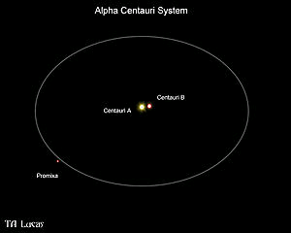

2. Did an Impact knock Uranus on its side?

The giant planet Uranus does not rotate around the Sun like all of the other planets in the Solar System but rolls around the Sun on its side. It is 98 degrees off the perpendicular line through its orbital plane around the Sun.

New research suggests that the planet suffered a series of impacts that knocked it off kilter. Astronomers speculated that a massive body collided with Uranus, thus knocking it on its side.

But now computer simulations by Alessandro Morbidelli from the Cote d’Azur Observatory in Nice, France has shown that Uranus’ tilt and moon orbits only makes sense if the planet suffered at least two impacts while it was still young. and had a protoplanetary disc.

Sky At Night December 2011 magazine. Ref: www.oca.eu

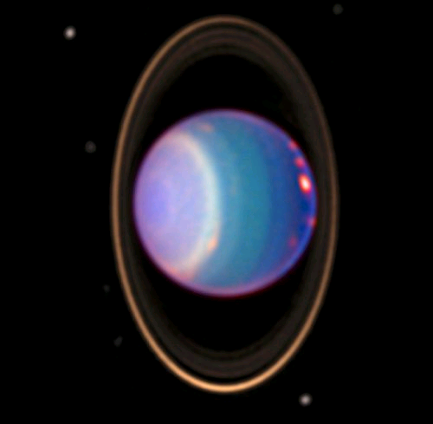

Uranus, its rings and its moons

3. Transit of Venus

The first recorded transit of Venus took place on 4 December 1639 by Jeremiah Horrocks from his home, “Carr House” in the village of Hoole (now renamed Much Hoole) just north of Liverpool in England. After studying Kepler’s tables, Horrocks determined that the transit of Venus would not occur in 1761, as Kepler had predicte,d but on 4 December 1639.

Horrocks set up his small telescope in his room as, according to his calculations, it would enter the Sun’s disk at 3.57 pm on 4 December. But just in case he might have erred, he began his vigil on the previous day. 4 December came and went and so did 5 December. Unfortunately for Horrocks, at 1.00 pm on 6 December, he had to leave his post to attend his official church duties at St. Michael’s Church in Hoole. He returned at 3.15 pm and although he had missed the beginning of the transit, he made history. Racing against time he made drawings of the transit until 3.50 pm when the sun set.

Aside from its rarity, the original scientific interest in observing a transit of Venus was that it could be used to determine the size of the solar system by employing the parallax method and Kepler's third law. The technique involved making precise observations of the slight difference in the time of either the start or the end of the transit from widely separated points on the Earth's surface. The distance between the points on the Earth was then used as a baseline to calculate the distance to Venus and the Sun via triangulation.

Jeremiah Dixon served as assistant to Charles Mason in 1761 when the Royal Society selected Mason to observe the transit of Venus from Sumatra. However, their passage to Sumatra was delayed, and they landed instead at the Cape of Good Hope where the transit was observed on 6 June 1761.

Dixon and Mason have gone down in history for an entirely different reason. The famous Mason Dixon line segregating the South from the North in the American Civil War is named after their survey carried out to assist with resolving a boundary dispute between the two provinces of Pennsylvania and Maryland.

The next transit of Venus will be on 5 June 2012, but will only visible in the eastern provinces of South Africa. You will then have to wait until 11 December 2117 before it will be seen again. Although this year’s transit will not be able to be seen in Hermanus, I am sure that it will be well reported on the news around the world. I am sure my good friend and committee colleague Johan Retief will tell us later in the year where you will have to be in South Africa if you wish to observe the transit on 5 June.

January 2012 edition of Sky and Telescope magazine. Authors Eli Maor concerning Jeremiah Horrocks and Fred Espenak & Jay Anderson for the times and dates of the transit in 2012.

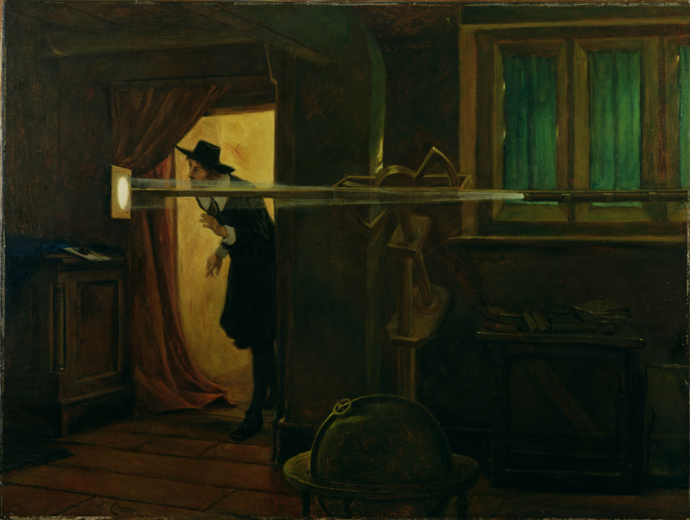

Painting of Jeremiah Horrocks recording the transit of Venus hangs in the Walker Gallery in Liverpool, England. It was
painted in 1891 by artist Eyre Crowe, 250 years after Horrocks death.

