Ancient (non-Western) astronomy Part 1: The second oldest profession?

Recent interest in the Mayan calendar has highlighted the fact that astronomy is important in most, if not all, cultures. The earliest of the sciences, it was the backbone of the social, political, economic and religious systems of most early civilisations. If the skies had been static and uneventful, it probably would have aroused little interest, but its dynamic nature, with its obvious effects on Earth led people to see a strong, direct connection between the heavens and human affairs.

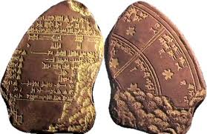
The Western astronomy which today dominates the
science, owes a huge debt to the work done over the
years within a number of other cultures. Before the
invention of the telescope, and the development of
modern mathematics and physics, and modern scientific
methods, early civilisations were still able to discover an
Babylonian star calendar amazing amount of astronomical informationfrom careful, repeated observation with the naked eye and early scientific methods. For example, the ancient Egyptians were able to accurately calculate the length of a year based on motion of the Sun and the flooding of the Nile. The Greeks were able to estimate the diameter of a circular Earth to within 32 km, long before Europeans decided that they ‘knew’ the Earth was flat.


This series will explore astronomy in cultures outside
Renaissance Europe, some which built the foundations
on which the science as it exists today stands, and
others which exist independently of Western influence.
Visible records exist in markings etched into clay
tablets, characters carved into stoned, the design and
Ancient Chinese observatory uses of stone in buildings themselves, and in characters written on papyrus, on animal skin (vellum) and on paper. In some cultures, records are verbal, having been passed down by word of mouth for many generations.

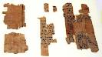
A useful basis for understanding the nature of
astronomy in ancient cultures is to consider the
three phases proposed by the English scientist and
amateur astronomer Sir Norman Lockyer (1836 –
1920), co-discover of helium, and founder of the
journal Nature. The first stage was the worship
Astronomical papyrus fragment phase, during which astronomical objects were often
seen as gods, and celestial phenomena like eclipses and comets were viewed as the actions, moods and signs from the gods. Ancient astronomers were often priests, whose power existed because their ability to predict planetary and stellar positions enabled them to act as interpreters for the gods.

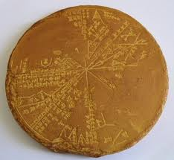
This was followed, or accompanied, by a phase during
which astronomy is also used for earthly purposes, like
agriculture and navigation. A logical result of the
observations made for these two phases was the
development of the calendars known to have existed, in
some form, in all cultures, either written or verbal,
detailed or general.
Sumerian star chart


Finally, astronomy is studied purely for the sake of gaining
knowledge and gaining an understanding of the universe.
While modern Western astronomy exemplifies the latter,
the presence of the first two phases, and sometimes
elements of the final one, can be found in the astronomy of
older cultures.

Islamic observatory

The next six part parts of this series will consider the cultures on which Renaissance European and later modern Western astronomy were built – Mesopotamian, ancient Egyptian, ancient Greek, Indian, Chinese and Islamic. The final parts will give an overview of the astronomy developed independently in other parts of the world – Native North American, Mayan, Inca and Aztec, Aboriginal and Polynesian, and African. Some noticeable parallels illustrate the co mmonality among humans, while unique elements also show how people can be different, as well as able to adapt to particular local circumstances.

Sources http://en.wikipedia.org, www.filer.case.edu, www.starteachastronomy.com

