“The Southern Cross”

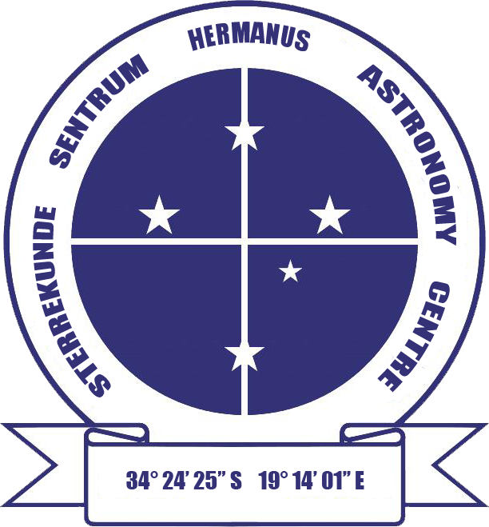

HERMANUS ASTRONOMY CENTRE NEWSLETTER

JUNE 2013

DID YOU KNOW?
Ancient astronomy Part 9: Mayan astronomy: where time was central and calendars were embodied in stone

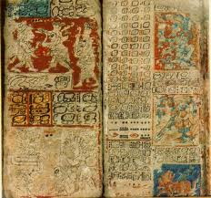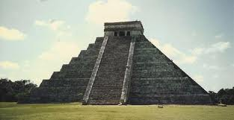
Mayan codice Mayan calendar temple

Astronomy was central to Mayan civilisation. It was believed that this science reflected the order and inherent harmony in the universe and the gods’ place in it. Capturing the essence of time was fundamental, as, in their cosmology, space and time were intertwined. This association is embodied in their complex calendar system, which combined spatial attributes of the universe and nature, like plants and animals, with the temporal movements of astronomical objects. They did not invent clocks or other time-keeping devices, using the sky as their method for measuring the passage of time.

Mayan cosmology held that Earth was flat with four corners, each of which represented a cardinal direction also associated with a colour: east-red, north-white, west-black, south-yellow. The centre of the flat Earth was green. At each corner was a jaguar, the four animals supporting the sky. Mayan astronomy included astrology, the motion of constellations and other objects across the sky being seen as the connection between celestial events and human affairs. Particular celestial objects represented certain deities, whose divine lives were portrayed in the daily, monthly and yearly changes in their appearance. Celestial events like eclipses were believed to be direct, specific communications from the gods.

As was the case for many other ancient cultures, Mayan astronomy was directly linked with their agriculture, the appearance of certain constellations at different times of the years being linked with activities like planting. The importance of astronomy in many aspects of Mayan life granted great power in the small number of priest-astronomers appointed to study and interpret the sky. Unlike Western astronomy, which starts the day in the middle of the night, the Mayan day usually started at sunrise and the priests were required to be able to accurately calculate that moment each day.

Fortunately, the Mayans enshrined some of their astronomy in their public buildings, in both their positioning and design, and glyphs carved into them, because the Spaniards destroyed almost all of their written records. The latter, called codices, have identified a multi-layered universe consisting of thirteen levels in the heavens and nine in the underworld, with Earth sandwiched between them and belonging to both. The heavenly layers represented features of the skies including stars and other celestial bodies, different components of weather eg. wind, thunder, and different colours. Some are also the home of particular gods. The Milky Way was seen as a road which souls travelled to the underworld.

Despite their wide-ranging interest in the heavens, Mayan astronomy focused on certain constellations and star clusters as well as the Sun and the Moon. The Mayans not only calculated the times of sunrise and sunset through the year, but also the length of the solar year – 365 days. They recognised that this was not entirely accurate and built in measures to accommodate this error, their calendars remaining accurate throughout the generations. The Moon was seen as a female god, a waxing moon being a young, fertile woman, and the waning moon an old woman who ruled over childbirth. Astronomers recorded the synodic cycle (the intervals between successive full Moons), calculating a duration of 29.53086 days, a value later shown to be accurate to three decimal points.

Venus was also important to the Mayans and they calculated its orbit to 584 days, only fractionally more than modern calculations (583.92). Venus rising in the morning was bad luck and the Mayans stayed indoors until its evil light was no longer visible. However, this was also seen as a prediction of success in their many raids and battles. They also calculated the orbits of Mars and Mercury, but there is no evidence that they studied Jupiter or Saturn.

Pleides was an important start cluster as it appears in the mornings around planting time in late April. Knowing when this would happen allowed the Mayans to prepare for the start of the new growing season. The Mayans appeared to consider Pleides the centre of the sky, rather than the pole star, with cities often aligned to the cluster.

Intermittent celestial events were seen as direct links with the human world. Comets foretold the death of a noble person. Solar eclipses were terrifying events, and the ability to predict them enabled the Mayans to prepare for them. This required the development of complicated mathematics which records found of eclipse events show they possessed. The Mayans started developing their complex mathematics during the 6th century CE, when Europe was languishing in the Dark Ages. In addition to a power based decimal system, they also developed the concept of zero.

Perhaps the most important application of their astronomy and mathematics was the development of their calendar. The essentials are based on a system used in Meso-America dating back to the 5th century BCE. However, they developed and refined it to a very sophisticated level which itself influenced the calendars of later groups like the Aztecs. The Mayan calendar is not a single entity, but a system of calendars consisting of several cycles or counts of different lengths.

Two interconnected calendars are a 260 day calendar which included thirteen 20-day periods, and a solar 365 day calendar made up of eighteen 20-day months plus five extra days which were considered unlucky. The start of these two calendars coincided every 52 years, this creating its own longer cycle, the so-called ‘calendar round’, a system still used in parts of Guatemala. A different calendar tracked longer periods of time than 52 years. The ‘Long count’ is a count of days since a mythological starting point. Even longer cycles were included, the longest being around 63 million years, which was subdivided into units of approximately 20, 400, 8,000, 158,000 and 3,000,000 years, depending on the number of cycles which had been passed through. The allegedly important date of 21 December 2012 was merely the start of the next 8,000 year cycle, not the doomsday event suggested by some.

The influence of astronomy on Mayan culture extended into their architecture. Many cities and their buildings and temples have astronomical orientations usually relating to events at the horizon. For example, one building with an arrow shape points at the location at which five of the brightest stars at the time set. Some of the buildings were observatories and had windows specifically positioned to allow visibility of particular events during the year. eg rising of Sirius or the setting of Pleides

Sources http://en.wikipedia.org, www.starteachastronomy.com,
www.crystalinks.com, www.incamera.as.arizona.edu, www.filer.case.edu

