[From SGAS 2019 P. 13]
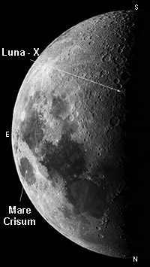
Spotting LUNA X
The line separating the light and dark parts of the moon, the “terminator”, takes some two weeks to move across the visible lunar surface. Where it crosses the terrain of high relief a complex interplay of features lit by the sun and those still bathed in deep shadow can result. These high-contrast vistas are sometimes known as the “clair-obscur effects” and have been given evocative names including Cassini’s Moon Maiden and Gruithuisen’s Lunar City.
Around the time of first quarter, as the Moon’s terminator sweeps across the lunar landscape along more or less selenographic longitude 0º, a particularly striking clair-obscur effect can be seen: a high-lighted X (lat. -25.8º, long +1.1º) created by sunlight falling on the ridges between the craters la Caille, Blanchinus and Purbach. When the sun has an elevation of about -0.84º as seen from the lunar surface, the Luna X is a striking feature and can be viewed even with binoculars.
Luna X remains visible for about 2 hours so some care in planning is called for.
Predictions for the visibility of Lunar X (see table below) have been kindly supplied by Dana Thomson who gives the approximate start time of the fully formed feature.
Jan 13 | 14h35 | May 11  June 10  Jul 9  Aug 8 | 18h25 | Sep 6 | 17h47
Feb 12 | 04h13 |  | 06h17 | Oct 6 | 06h17
Mar 13 | 17h26 |  | 17h58 | Nov 4 | 19h18
Apr 12 | 06h10 |  | 05h43 | Dec 4 | 08h44

