THE FISHERHAVEN ASTRONOMER
METEORS, METEORITES, METEOROIDS AND METEOR SHOWERS
Ever so often, someone observes a “shooting star” in the night sky. Of course, tradition has it that observing such an event brings the observer luck and he or she should actually make a wish.
Small solid particles in interplanetary space, if such particles are less than 1 metre in diameter, are called “meteoroids” (if they are larger they are commonly known as “asteroids”). Once such a particle enters the Earth’s atmosphere it vaporizes and, due to friction in the atmosphere glows brightly and leaves a trial of glowing ions in its wake. Such a phenomenon is called a “meteor”. Most meteors eventually burn out in the atmosphere and, if large enough, may be observed as a fire ball at the end of its flight. Some do, however, strike the Earth’s surface and the remaining remnant is called a “meteorite”
Once a meteorite lands on South African soil, it belongs to the State (Act 25 of 1999 refers) and the meteorite is protected by the South African Heritage Resources Agency.
A number of meteorite events have happened in Southern Africa. The largest known meteorite that is still in one piece, fell on what is now the farm “Hoba” near Grootfontein in Namibia. It is estimated that this event took place some 80 000 years ago. The meteorite is estimated to be about 60 tonnes in mass and 3m x 3m x 1m in size. It was found by chance while the farmer was ploughing the field with a plough and oxen. This meteorite is composed of 84% iron and 16% nickel.  The most recent meteorite fall happened in 2011 at Thuathe in Lesotho. This fall, which happened in daylight, was witnessed by many, ended as a “fireball”. Some 500 fragments were recovered with a total mass of 30 kg, it is estimated that this meteoroid may have had a mass of one tonne. | 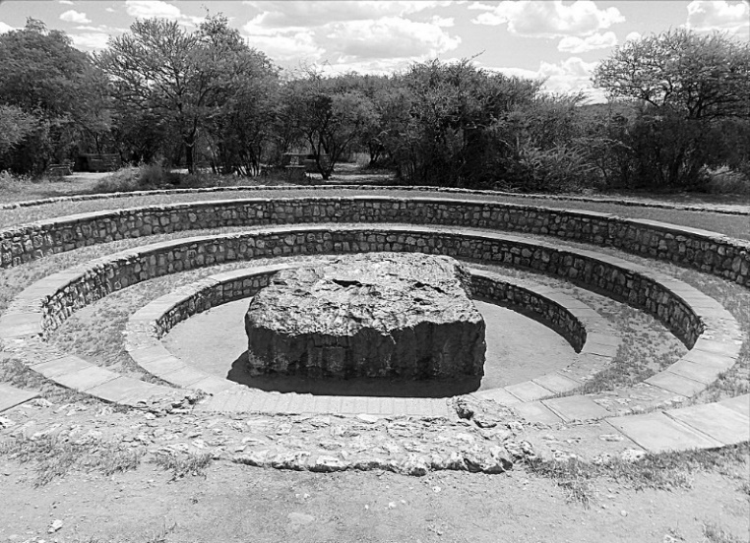  Hoba Meteorite photo Wikipedia
The largest known crater caused by a gigantic meteorite is visible as the “Vredefort Structure” and is a gigantic crater estimated to be 250 to 300km in diameter. The central dome of the crater is near Parys in the Free State. This meteorite rivalled Table Mountain in size.
On the right is a photo of the meteorite crater at Tswaing, some 40 km north of Pretoria. The crater is 1 400m in diameter and it is thought to be the result of an impact about 220 000 years ago. This crater was caused by the impact of a stony meteorite of about 40m in diameter. The crater is rich in salt deposits, probably from the meteorite itself, and has been mined for salt from as long as 100 000 years ago. Recently it was mined commercially between 1912 and 1956. It is locally also known as the “Salt Pan”.  A meteor shower occurs when the Earth’s orbit intersects with a stream of meteoroids previously formed by the disintegration of a larger body like a comet. A meteor shower recurs at the same time each year. The meteors seem to radiate from a single point in the sky (called the “radiant”) corresponding to the direction in | Tswaing Crater  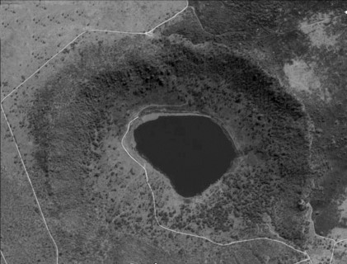  Photo by Kobus Retief
from which the meteors appear. Meteor showers are named for the constellation that coincides with the position of the radiant. For example the “Orionids” radiate from a position in the constellation Orion. For the Southern Hemisphere, the Sky Guide Africa South (SGAS) forecasts the meteor showers annually expected visible from our latitude. The table in SGAS will tell us when to expect to see this shower, the best dates and times to look out for the shower, the radiant, as well as a prediction of the observing prospect. It should be borne in mind that meteor showers mainly consist of small particles, some as small as a grain of sand. Darkness is important and trying to observe during a full or gibbous moon is normally a lost cause. The higher the radiant above the horizon and the darker the night, the better is one’s chances to enjoy the spectacle. Maximum rates can vary between 5 and 50 meteors per hour and is predicted by SGAS.
[ Source: Wikipedia and Sky Guide Africa South 2017 edition]

