“The Southern Cross”

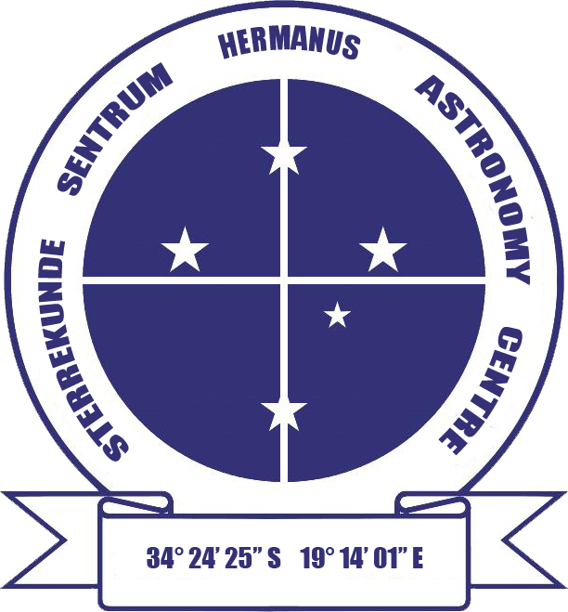

HERMANUS ASTRONOMY CENTRE NEWSLETTER

JULY 2016

This month’s Centre meeting

This takes place on Monday 18 July in the Scout Hall starting at t 19.00. Case Rijsdijk, a popular presenter, will be asking 'Are we alone?' Further details below.

Stargazing – 'Stars and Soup' evening on Friday 29 July

Join us for a fun evening of 'Stars and Soup'' on the evening of Friday 29 July at the NG Kerk, Berg Street, Onrus, starting at 18.00. Further details will be circulated soon.

WHAT’S UP?
Sagittarius Mid-winter is the best time to observe the constellation of the Archer. Almost overhead, Sagittarius’s most distinctive feature, the teapot can be found lying at right angles below Antares, the bright red heart of Scorpius. This feature is only a relatively small part of the large constellation of Sagittarius, which is the 15th largest of the 88 named constellations. Because it lies in our line of sight to the centre of the Milky Way, there are many dense starfields, clusters and nebulae which can be observed in the areas in and around the teapot, many visible to the naked eye and/or through binoculars. On a clear winter night, it is also possible to spot the ‘steam’ arising from the spout of the teapot. This is the Lagoon Nebula (M8), a patch of glowing gas which extends for 3 times the apparent width of the full Moon. One of the largest nebulae, some of the individual stars and an open cluster can be observed with binoculars.

LAST MONTH’S ACTIVITIES
Monthly centre meeting On 20 May, Hannes Breytenbach, a doctoral student at UCT talked on 'Cataclysmic variables', which are the subject of his PhD. In a very interesting presentation, he explained that, unlike the Sun, most stars have one or more close neighbours. His focus is on binary stars, specifically the life cycle of cataclysmic variables, stars which exhibit sudden large outbursts of energy which present as large, intermittent increases in brightness, a characteristic which defines them as 'variables'.

These binaries are so close to each other that they interact and influence each other directly. Hannes showed how material is actually transferred between them, overflowing from a cool active star to its white dwarf (small, dense remnant of medium-sized stars like the Sun). This material forms an accretion disk round the white dwarf. Much hotter close to the star's surface, the disk material can initiate powerful local thermonuclear fusion events. It is the energy released during this process which produces the sudden outbursts of light which are the main characteristic of cataclysmic variables. Hannes described how his research, which is focussing on magnetic white dwarfs whose poles, as on Earth, tend to be the focus of inflowing energy, is building up a picture of the processes which take place at these regions.

Interest groups
Cosmology Fourteen people (10 members, 4 visitors) attended the meeting on 6 June. They viewed the tenth pair of episodes of the 24 part DVD series on Time, given by Prof Sean Carroll from CalTech. The topics were: Lecture 19: ‘Time travel’ and Lecture 20: ‘Black hole entropy'.

Astro-photography At the meeting on 13 June, members agreed to adopting a more hands-on approach at future meetings, taking and processing their own images.

Other activities
Stargazing Karin de Bruin reports on the first Stars and Soup evening: “It was with great excitement that the first monthly Stargazing event was held on Friday 24 June at the Dutch Reformed Church in Onrus. The day started out with banks of clouds, but there was a back-up plan should it remain cloudy or rain. As about 45 stargazers gathered in the hall, Karin welcomed them and introduced Pierre de Villiers, who proceeded to inform newcomers to all the events organized by the Hermanus Astronomy Centre. Derek Duckitt then showed a few apps and websites people are able to access and use for stargazing and related information.

A trio of delicious soups and freshly baked bread was then served, after which Johan Retief took centre stage and spoke about how to read star maps. ith a beautiful image taken two days earlier, Johan explained what we are able to see around the Southern Cross. It was at this time that the group was truly blessed when the sky opened and all the stars came out to play! With NO cloud cover at all, stargazers were able to enjoy what they could observe through Pierre, Peter and Karin’s telescopes, as well as their own binoculars. What an excellent night it was!

Keep your eyes (and e-mails) open for the next event on Friday 29 July and happy stargazing this month.

For more information, please contact Karin on 084 305 2086 or at kdb4stars@gmail.com

Mercury transit On 9 May, two successful events, with dedicated sun filters attached to telescopes, were held in Hermanus. Clearing cloud allowed for observation of both the transit and sunspots at Curro School (»100 learners and a few parents) and Gearing's Point (+/- 30 visitors, 12 members).

Educational outreach
Hawston Secondary School Astronomy Group Weekly meetings continued in June until the end of term.
Lukhanyo Youth Club Fourteen Grade 6 and 7 learners and 2 teachers attended a very successful stargazing evening on Rotary Way on 8 June. Clear skies enabled them to see much, incl the Moon, Jupiter, Southern Cross, Saturn, Mars, Jewel Box, Eta Carinae and Omega Centauri.

Article in Whale Talk An article by Jenny Morris titled 'The Southern Cross: our 'diamond-tipped kite'' was published in the June/July issue of the magazine.

THIS MONTH’S ACTIVITIES
Monthly centre meeting This will take place on Monday 18 July at the Scout Hall at 19.00. Case Rijsdijk, from the Garden Route Centre, will be addressing the question 'Are we alone?'. Case has given several talks on a wide range of topical issues in astronomy to the Hermanus Centre in the past, and this one promises to be just as interesting. Case's talks are always very informative, with his accessible style of presentation helping to also make them enjoyable experiences for those who attend.

There is an entrance fee of R10 per person for members, R20 per person for non-members, and R10 for children, students and U3A members.

Interest group meetings
The Cosmology group meets on the first Monday of each month at 19.00. This month’s meeting will take place on 4 July at the Scout Hall. Attendees will view the eleventh pair of episodes of the new DVD series on Time by Prof Sean Carroll from CalTech. The topics for this month are: Lecture 21: ‘Evolution of the Universe’ and Lecture 22: ‘The Big Bang'.

There is an entrance fee of R10 per person for members, R20 per person for non-members, and R10 for children, students and U3A members. For further information on these meetings, or any of the group’s activities, please contact Pierre Hugo at pierre@hermanus.co.za

Astro-photography This group meets on the third Monday of each month. The next meeting will take place on 11 July. Deon Krige will give a summary on practical astro-photography.

To find out more about the group’s activities and the venue for particular meetings, please contact Deon Krige at astronomy.hermanus@gmail.com

Stargazing A 'Stars and Soup' event will take place on Friday 29 July at the NG Kerk, Onrus starting at 18.00. Details will be circulated and advertised in due course.

Hermanus Youth Robotic Telescope Interest Group Technology permitting, organisers are hoping to start working with learners during the coming school term.

For further information on both the MONET and Las Cumbres projects, please contact Deon Krige at deonk@telkomsa.net

FUTURE ACTIVITIES

Possibilities are being explored. Details will be circulated when arrangements have been finalised.

2016 MONTHLY MEETINGS
Unless stated otherwise, meetings take place on the third Monday of each month at the Scout Hall beginning at 19.00. Details for 2016 are:
18 July, 'Are we alone?'. Presenter: Case Rijsdijk, Garden Route Centre
18 Aug, Topic: TBA. Presenter: Kevin Govender, Office for Astronomy Development, International Astronomical Union, Cape Town. HAC and SANSA will be joint hosts. Venue: SANSA
19 Sept Topic TBA. Presenter: Dr Bruce Bassett, UCT and AIMS
17 Oct ‘Dark skies: the unseen Universe’’. Presenter: Jenny Morris, Committee member
21 Nov 'Science we have learned from space telescopes'. Presenter, Pierre de Villiers, Chairman, HAC committee
12 Dec Xmas party

ASTRONOMY EDUCATION CENTRE AND AMPHITHEATRE (AECA)
The window for public responses to the updated planning application closed on 10 June. Committee members are currently compiling formal responses to objections submitted to Overstrand Municipality. In the meantime, the Friends of the Observatory pledge fund continues to be an important source of funds to cover associated costs.

The Friends of the Observatory campaign was launched several years ago when preliminary work began on plans to construct an astronomical observatory in Hermanus. Over the years, members have been very generous, for which we are deeply grateful. It may seem logical to assume that, now money has been awarded by the National Lotteries Board, pledge monies are no longer needed. Unfortunately, that is not the case. NLC funds can only be used once the plans have been formally approved by the Municipality, something which is still awaited.

We would, therefore, be very grateful if members could either continue to contribute to the campaign or start becoming a contributor. Both single donations and small, regular monthly donations, of any amount, are welcome. Contributions can take the form of cash (paid at meetings), or online transfer, The Standard Bank details are as follows:
Account name – Hermanus Astronomy Centre
Account number – 185 562 531
Branch code – 051001
If you make an online donation, please include the word ‘pledge’, and your name, unless you wish to remain anonymous.

Science Centre The committee continues to work on the project.

ASTRONOMY NEWS

Jupiter’s clouds hide huge pillars of ammonia gasses 2 June: When NASA’s Galileo mission sent a probe down into Jupiter’s clouds, it sent back an unusual find: The probe seemed to be plummeting into a thick stew of slow-moving ammonia, in contrast to the more varied upper atmosphere. Now, a Berkeley-led team may have unravelled the mystery. The researchers think that Galileo plunged into a “storm” of ammonia just below the surface of the upper atmosphere, happening onto just the right spot to descend into one of the “hot spots” faintly visible from the surface.
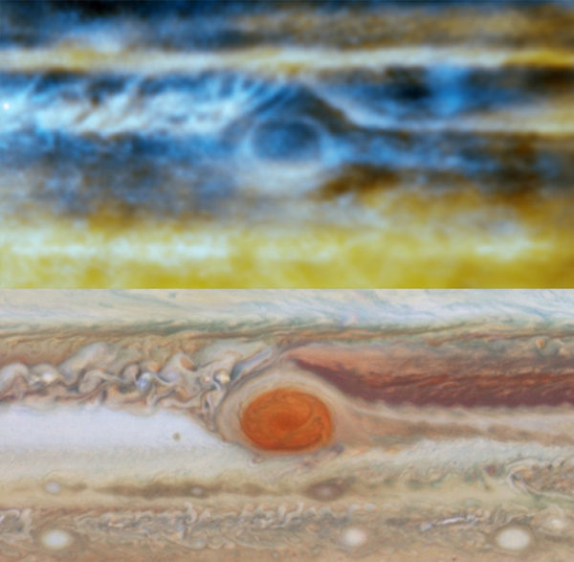 A contrast of maps from the Hubble Space Telescope and the Very Large Array showing distinct patterns in the clouds indicating the presence of the ammonia hot spots. Michael H. Wong, Imke de Pater (UC Berkeley), Robert J. Sault (Univ. Melbourne). Optical: NASA/ESA/A.A. Simon (GSFC)/M.H. Wong (UC Berkeley)/G.S. Orton (JPL-Caltech)
Imke de Pater, said that the Galileo probe showed the columns to be made of four to five times the amount of ammonia seen in the 'solar abundance'. That is a term for the spectrum emanated from the Sun displaying the elements its fusing. She is quick to point out that in the Sun, similar spectral lines radiate as nitrogen, but nitrogen bonds with hydrogen in the much cooler atmosphere of Jupiter to become ammonia.
However, that is not the case for Jupiter’s violent surface gasses, in which ammonia is much more dispersed over the visible upper atmosphere, but more compressed down below. There was some sort of disharmony there. After mapping the entire surface of Jupiter, the team was able to find small oval shapes that corresponded to high concentrations of ammonia. These columns reach right up to the highest cloud layers, then disperse the ammonia at these lower pressure levels. “That explains why, on average, Jupiter's atmosphere seems to be depleted in ammonia gas while in some places it's quite abundant,” de Pater said.
Still, she said, they have not yet identified a cause. Something deep in Jupiter’s clouds is causing the convection effect, but the lower levels of Jupiter’s atmosphere are, as yet, poorly understood. It is also not well known if similar structures appear on the other gas giants, which may also have ammonia left over from the solar system’s formation.
By: John Wenz

NASA’s Hubble finds universe is expanding faster than expected 3 June: Astronomers using NASA’s Hubble Space Telescope have discovered that the universe is expanding five to nine percent faster than expected. “This surprising finding may be an important clue to understanding those mysterious parts of the universe that make up 95 percent of everything and don’t emit light, such as dark energy, dark matter, and dark radiation,” said Adam Riess of the Space Telescope Science Institute and The Johns Hopkins University, both in Baltimore, Maryland.
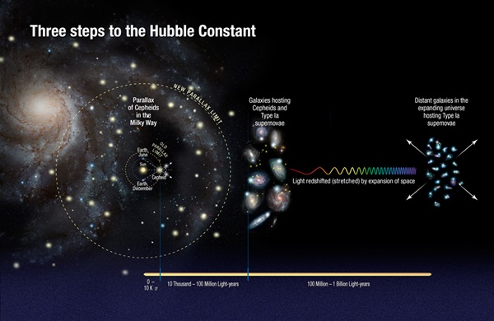 This illustration shows the three steps astronomers used to measure the universe's expansion rate to an unprecedented accuracy, reducing the total uncertainty to 2.4 percent. NASA/ESA/A. Feild (STScI)/A. Riess (STScI/JHU)
Riess’ team made the discovery by refining the universe’s current expansion rate to unprecedented accuracy, reducing the uncertainty to only 2.4 percent. The team made the refinements by developing innovative techniques that improved the precision of distance measurements to faraway galaxies. The team looked for galaxies containing both Cepheid stars and type Ia supernovae. Cepheid stars pulsate at rates that correspond to their true brightness, which can be compared with their apparent brightness as seen from Earth to accurately determine their distance. Type Ia supernovae, another commonly used cosmic yardstick, are exploding stars that flare with the same brightness and are brilliant enough to be seen from relatively longer distances.
By measuring about 2,400 Cepheid stars in 19 galaxies and comparing the observed brightness of both types of stars, they accurately measured their true brightness and calculated distances to roughly 300 type Ia supernovae in far-flung galaxies. The team compared those distances with the expansion of space as measured by the stretching of light from receding galaxies. They used these two values to calculate how fast the universe expands with time, or the Hubble constant. The improved Hubble constant value is 73.2 km per second per megaparsec. (A megaparsec equals 3.26 million light-years.) The new value means the distance between cosmic objects will double in another 9.8 billion years.
This refined calibration presents a puzzle, however, because it does not quite match the expansion rate predicted for the universe from its trajectory seen shortly after the Big Bang. Measurements of the afterglow from the big bang by NASA’s Wilkinson Microwave Anisotropy Probe (WMAP) and the European Space Agency’s Planck satellite mission yield predictions for the Hubble constant that are five and nine percent smaller, respectively.
“If we know the initial amounts of stuff in the universe, such as dark energy and dark matter, and we have the physics correct, then you can go from a measurement at the time shortly after the Big Bang and use that understanding to predict how fast the universe should be expanding today,” said Riess. “However, if this discrepancy holds up, it appears we may not have the right understanding, and it changes how big the Hubble constant should be today.”
Comparing the universe’s expansion rate with WMAP, Planck, and Hubble is like building a bridge, Riess explained. On the distant shore are the cosmic microwave background observations of the early universe. On the nearby shore are the measurements made by Riess’ team using Hubble. “You start at two ends, and you expect to meet in the middle if all of your drawings are right and your measurements are right,” Riess said. “But now the ends are not quite meeting in the middle and we want to know why.”
There are a few possible explanations for the universe’s excessive speed. One possibility is that dark energy, already known to be accelerating the universe, may be shoving galaxies away from each other with even greater - or growing – strength. Another idea is that the cosmos contained a new subatomic particle in its early history that travelled close to the speed of light. Such speedy particles are collectively referred to as 'dark radiation' and include previously known particles like neutrinos. More energy from additional dark radiation could be throwing off the best efforts to predict today’s expansion rate from its post-Big Bang trajectory. The boost in acceleration could also mean that dark matter possesses some weird unexpected characteristics. Dark matter is the backbone of the universe upon which galaxies built themselves up into the large-scale structures seen today. And finally, the speedier universe may be telling astronomers that Einstein’s theory of gravity is incomplete.
By: STScl, Baltimore, Maryland, NASA's Goddard Space Flight Center, Greenbelt, Maryland

Universe’s first life might have been born on carbon planets 7 June: Earth consists of silicate rocks and an iron core with a thin veneer of water and life. However, the first potentially habitable worlds to form might have been very different. New research suggests that planet formation in the early universe might have created carbon planets consisting of graphite, carbides, and diamond. Astronomers might find these diamond worlds by searching a rare class of stars.
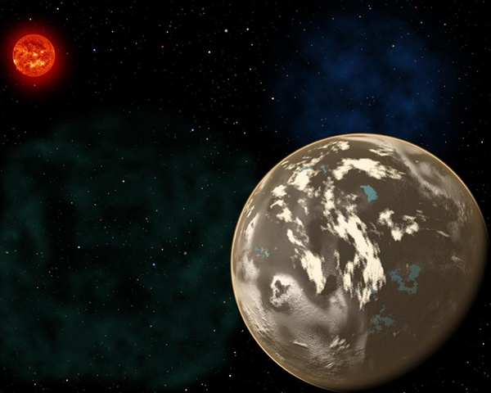 In this artist's conception, a carbon planet orbits a sunlike star in the early universe. Young planetary systems lacking heavy chemical elements but relatively rich in carbon could form worlds made of graphite, carbides and diamond rather than Earth-like silicate rocks. Blue patches show where water has pooled on the planet's surface, forming potential habitats for alien life. Christine Pulliam (CfA)/Sun image: NASA/SDO
The primordial universe consisted mostly of hydrogen and helium and lacked chemical elements like carbon and oxygen necessary for life as we know it. Only after the first stars exploded as supernovae and seeded the second generation did planet formation and life become possible. Natalie Mashian from Harvard University and Avi Loeb from the Harvard-Smithsonian Centrer for Astrophysics examined a particular class of old stars known as carbon-enhanced metal-poor stars, or CEMP stars. These anaemic stars contain only one hundred-thousandth as much iron as our Sun, meaning they formed before interstellar space had been widely seeded with heavy elements. "These stars are fossils from the young universe," said Loeb. "By studying them, we can look at how planets, and possibly life in the universe, got started."
Although lacking in iron and other heavy elements compared to the Sun, CEMP stars have more carbon than would be expected given their age. This relative abundance would influence planet formation as fluffy carbon dust grains clump together to form tar-black worlds. From a distance, these carbon planets would be difficult to tell apart from more Earth-like worlds. Their masses and physical sizes would be similar. Astronomers would have to examine their atmospheres for signs of their true nature. Gases like carbon monoxide and methane would envelop these unusual worlds. Mashian and Loeb argue that a dedicated search for planets around CEMP stars can be done using the transit technique. "This is a practical method for finding out how early planets may have formed in the infant universe," said Loeb.
By: Harvard-Smithsonian Center for Astrophysics, Cambridge, Massachusetts

Water may be hiding in the most unlikely of places 9 June: Water is a hot topic in the study of exoplanets, including 'hot Jupiters', whose masses are similar to that of Jupiter, but which are much closer to their parent star than Jupiter is to the Sun. They can reach a scorching 1,100 degrees Celsius, meaning any water they host would take the form of water vapour and they may be harbouring atmospheric water shrouded by thick haze layers.
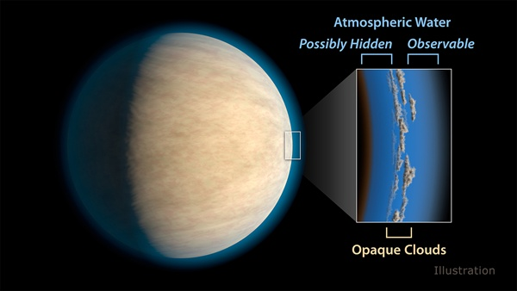 Hot Jupiters, exoplanets around the same size as Jupiter that orbit very closely to their stars, often have cloud or haze layers in their atmospheres. This may prevent space telescopes from detecting atmospheric water that lies beneath the clouds. NASA/JPL-Caltech
Astronomers have found many hot Jupiters with water in their atmospheres, but others appear to have none. Scientists at NASA’s Jet Propulsion Laboratory, Pasadena, California, wanted to find out what the atmospheres of these giant worlds have in common. Researchers focused on 19 hot Jupiters studied by NASA’s Hubble Space Telescope. They found that the atmospheres of about half of the planets were blocked by clouds or haze could be preventing a substantial amount of atmospheric water from being detected by space telescopes. The clouds themselves are likely not made of water, as the planets in this sample are too hot for water-based clouds. “Clouds or haze seem to be on almost every planet we studied,” said said Aishwarya Iyer, a JPL intern who led the study.. “In some of these planets, you can see water peeking its head up above the clouds or haze, and there could still be more water below. You have to be careful to take clouds or haze into account, or else you could underestimate the amount of water in an exoplanet’s atmosphere by a factor of two.” Scientists do not yet know the nature of these clouds or hazes, including what they are they made of. The implications of this result agree with findings published in the 14 December 2015 issue of the journal Nature. These two sets of results are also important for figuring out how planets form, scientists say. “Did these planets form in their current positions or migrate toward their host stars from farther out? Understanding the abundances of molecules such as water helps us answer those questions,” said Robert Zellem, a postdoctoral fellow at JPL and co-author of the study..
By: Jet Propulsion Laboratory, Pasadena, California

One-Third of Humanity Can't See the Milky Way 13 June: The Milky Way, the brilliant river of stars that has dominated the night sky and human imaginations since time immemorial, is but a faded memory to one-third of humanity and 80 percent of Americans, according to a new global atlas of light pollution produced by Italian and American scientists. It has reached levels where many people cannot see the 'arms' of our home galaxy.
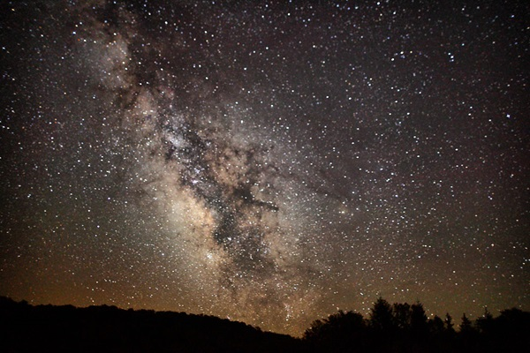 Forest Wander / Wikimedia Commons
Light pollution is one of the most pervasive forms of environmental alteration. In most developed countries, the ubiquitous presence of artificial lights creates a luminous fog that swamps the stars and constellations of the night sky. “We’ve got whole generations of people in the United States who have never seen the Milky Way,” said Chris Elvidge, a scientist with NOAA’s National Centers for Environmental Information. “It’s a big part of our connection to the cosmos - and it’s been lost.”
Light pollution is most extensive in countries like Singapore, Italy and South Korea, while Canada and Australia retain the most dark sky. In Western Europe, only small areas of night sky remain relatively undiminished, mainly in Scotland, Sweden and Norway. Despite the vast open spaces of the American west, almost half of the US experiences light-polluted nights. “In the U.S., some of our national parks are just about the last refuge of darkness -- places like Yellowstone and the desert southwest,” said co-author Dan Duriscoe of the National Park Service. “We’re lucky to have a lot of public land that provides a buffer from large cities.”
Light pollution does more than rob humans of the opportunity to ponder the night sky. Unnatural light can confuse or expose wildlife like insects, birds and sea turtles, often with fatal consequences. Fortunately, light pollution can be controlled by shielding lights to limit shine to the immediate area, reducing lighting to the minimum amount needed -- or by simply turning them off. By: NOAA

Could dark matter really be first generation black holes? 15 June: Alexander Kashlinsky of NASA’s Goddard Space Flight Center has an idea. It is a bit of a gamble, but, if it’s true, it could be the solution to one of the biggest mysteries of the cosmos: dark matter.
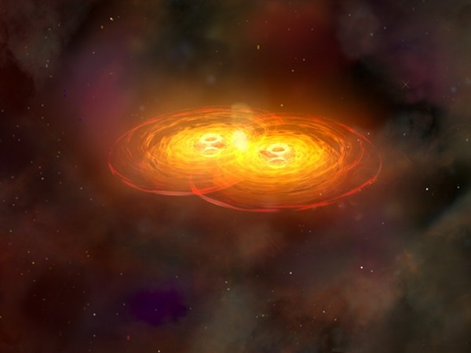 This artist's depiction of black holes is similar to the events detected by LIGO, with the merger of two black holes. A NASA Goddard physicist believes black holes of this size could be the culprit behind "dark matter." NASA/CXC/A.Hobart
For decades, mass estimates of the universe have had a problem. In order for any model of inflation, the motion of galaxies, and galactic interactions to work, there’s about 27 percent of mass that is not accounted for by known stars, galaxies, and other structures in the universe. It has taken on the name dark matter because it is something we, thus far, cannot see. Physicists have searched for so-called WIMPs as the source of dark matter: weakly interacting massive particles, those that seem to pass right through standard matter without interacting, yet still exert gravitational influence. According to www.space.com. 35 interactions between dark matter and matter may happen in your body per year, compared to a constant bombardment of photons.
Kashlinsky says WIMPs are not necessary. All you need to account for the missing mass associated with dark matter are objects called primordial black holes. Rather than forming from collapsed stars, they formed shortly after the Big Bang through high-energy particle interaction. By Kashlinsky’s estimates, dark matter could be entirely accounted for with 3 trillion solar masses’ worth of black holes.
However, they may be as hard to find as WIMPs, since black holes are almost impossible to detect unless they are actively gobbling up material, heating up a disk of infalling matter and spewing it out in energetic jets. “There's no gas there in significant quantities to fall in these black holes at present,” Kashlinsky says. “They would not be easily visible there. Future observations with advanced LIGO are the key.”
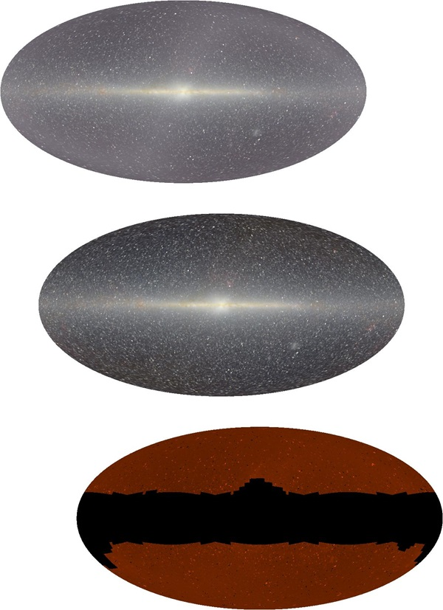 This image shows red, green, and blue channels of the cosmic infrared background, where some evidence of primordial black holes may be hiding. UCLA / Edward L. Wright
They may already have been detected once. Maybe twice, depending how you look at it. The Laser Interferometer Gravitational-Wave Observatory (LIGO) found gravitational waves via the merger of two primordial black hole candidates, each about 30 solar masses. These 30-solar-mass black holes - and subsequent merged generations - would have come about in the early universe, created in the mess of expansion in the first few milliseconds after the Big Bang, in an exotic process called quark hadron phase transition. This effect can only happen in very dense areas, such as at the centre of a pulsar. In the early universe, just milliseconds old, matter was dense enough to already break holes in expanding space-time. Now, they are sleeping giants, having cleared out most of their nearby matter. One part of Kashlinsky’s paper addresses how researchers might find evidence of them: odd discrepancies in the cosmic microwave background. This creates what is called soft X-ray excess, which create halos of x-ray light in the cosmic infrared background. Kashlinsky believes these could only be caused by black holes.
By: John Wenz
Small asteroid is Earth’s constant companion 16 June: A small asteroid has been discovered in an orbit around the Sun that keeps it as a constant companion of Earth, and it will remain so for centuries to come. Researchers’ calculations indicate 2016 HO3 has been a stable quasi-satellite of Earth for almost a century.
As it orbits the Sun, this new asteroid appears to circle around Earth as well. It is too distant to be considered a true satellite of our planet, but it is the best and most stable example to date of a 'quasi-satellite'. "Since 2016 HO3 loops around our planet, but never ventures very far away as we both go around the Sun, we refer to it as a quasi-satellite of Earth," said Paul Chodas from NASA's Centre for Near-Earth Object (NEO) Studies at the Jet Propulsion Laboratory in Pasadena, California. "One other asteroid - 2003 YN107 - followed a similar orbital pattern for a while over 10 years ago, but it has since departed our vicinity. This new asteroid is much more locked onto us. Our calculations indicate 2016 HO3 has been a stable quasi-satellite of Earth for almost a century, and it will continue to follow this pattern as Earth's companion for centuries to come."
In its yearly trek around the Sun, asteroid 2016 HO3 spends about half of the time closer to the Sun than Earth and passes ahead of our planet, and about half of the time farther away, causing it to fall behind. Its orbit is also tilted a little, causing it to bob up and then down once each year through Earth's orbital plane. In effect, this small asteroid is caught in a game of leap frog with Earth that will last for hundreds of years.
The asteroid's orbit also undergoes a slow back-and-forth twist over multiple decades. "The asteroid's loops around Earth drift a little ahead or behind from year to year, but when they drift too far forward or backward, Earth's gravity is just strong enough to reverse the drift and hold onto the asteroid so that it never wanders farther away than about 100 times the distance of the Moon," said Chodas. "The same effect also prevents the asteroid from approaching much closer than about 38 times the distance of the Moon. In effect, this small asteroid is caught in a little dance with Earth."
Asteroid 2016 HO3 was first spotted on 27 April 2016 by the Pan-STARRS 1 asteroid survey telescope on Haleakala, Hawaii, operated by the University of Hawaii's Institute for Astronomy. The size of this object has not yet been firmly established, but it is likely larger than 40 metres and smaller than 100 metres.
By: Jet Propulsion Laboratory, Pasadena, California
Electric winds turn Venus into even more of a hellscape 21 June: A new study from the European Space Agency suggests one culprit for why Venus remains a dry, hot hellscape: electric winds in the upper atmosphere zap even the smallest hint of water vapour out of its skie. While the lower levels are already bone dry, electric winds make sure the upper atmosphere stays cooked too.
While Venus lies in the habitable zone of our solar system, something happened in its past to take it from a more lush, verdant world into a dry planet with a runaway greenhouse effect from the abundance of carbon dioxide in the atmosphere. Those gasses trap in a lot of heat. However, the electric winds seem to go a step further in depleting the world of water. The Sun plays a factor in these winds, as solar winds conduct electricity. This, so to say, leads the charge through the atmosphere, with the electric winds further breaking down water compounds as they form. Water compounds in the lower parts of the atmosphere were likely long ago depleted and broken apart into hydrogen and oxygen, with the hydrogen floating away and the oxygen pummelled into the surface and into carbon dioxide.
NASA further says that electric winds may play a role on Mars as the possible culprit behind the depletion of its atmosphere, which eventually evaporated the oceans and left it in its present state. It has also been suggested that, in the search for habitable planets, electric winds would need to be taken into account as a possible deterrent to life. After all, in a perfect scenario, both Venus and Mars would be habitable worlds alongside Earth. While we may find plenty of planets in the habitable zones of their stars, actually habitability could depend on a lot of factors. By: John Wenz
We now know a little about the stars that made gravitational wave black holes 22 June: Gravitational waves made big rumbles through the astronomy community earlier this year when it was revealed that these ripples in time-space itself had been detected. While we knew the source of the waves - the merger of two 30 solar mass black holes - we did not know where they came from. While primordial black holes that formed seconds after the universe was expanding outward were suggested, a new study in Nature points to another possible scenario: a pair of giant stars that wormed as binaries and both exploded as supernovae.
The stars were between 40 and 100 solar masses each, according to the study. That puts it in the realm of hypergiant stars, which live fast and die hard, often in a few million years. They would have possibly been like the Eta Carinae system, which has two hypergiant stars in a binary orbit. The stars probably formed around 11 billion years ago, and exploded shortly after that. Each of the stars subsequently formed into black holes, which converged around 1.4 billion years ago. There's a small chance, as suggested in the paper, that the stars are only around 2 billion years old, which would give an even smaller time table for the formation of the merger. One of the stars was likely slightly more massive, upwards of 100 solar masses, while the smaller of the pair would have topped out at 80 solar masses.
The authors of the paper also conclude that, with the right instrumentation, we might hear up to 1,000 black hole mergers per year and be able to study the gravitational waves. Perhaps the era of gravitational wave astronomy really is upon us. By: John Wenz

New dark spots appear on Neptune's cloud layers 23 June: It's not every day that a planet sprouts a new feature, but Hubble seems to have found a brand new "spot" on the blue ice giant Neptune.
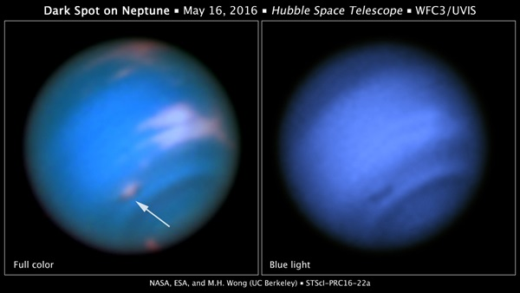 NASA, ESA and EH Wong
Neptune's "Great Dark Spot" discovered by the Voyager 2 spacecraft in 1989 revealed a storm battering around the atmosphere, like Jupiter's red spot in miniature. The anticyclone cleared up by 1994, as had a smaller storm. The new spot is likely a related phenomenon. "The fact that this dark spot has bright companions does suggest it is similar to the Great Dark Spot seen by Voyager, and the dark spot seen by Hubble in 1994," Heidi Hammel, a researcher at the Space Science Institute, said.
The storms form when air below is disrupted and pushed upward, where it freezes into ice crystals made mostly of methane. There have been indications since last year that such an event might be taking place on the ice giant, but Hubble is the only telescope with the capabilities to make the necessary observations. Hammel says there's some evidence of structure within the storm, with an opening in the cloud layers leading to a raging storm below. Follow-up observations could give insight into how they form and how they break apart. Hubble will have to do the heavy lifting, especially since no spacecraft has visited Neptune since 1989 "We speculate that these dark spots on Neptune (which are most visible at blue wavelengths) are probably 'clear' areas, openings in the cloud decks that see to deeper layers," she says. "The bright companions (which are most visible at redder wavelengths) are thought to be higher-altitude clouds." By: John Wenz
Source of these and further astronomy news items: www.astronomy.com/news

DID YOU KNOW?
The Sun Part 4 Earth-Sun distance calculation 2

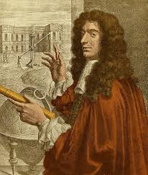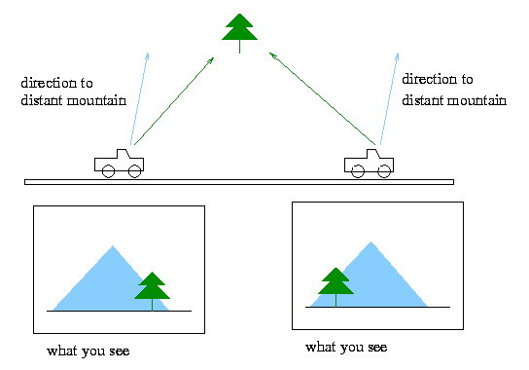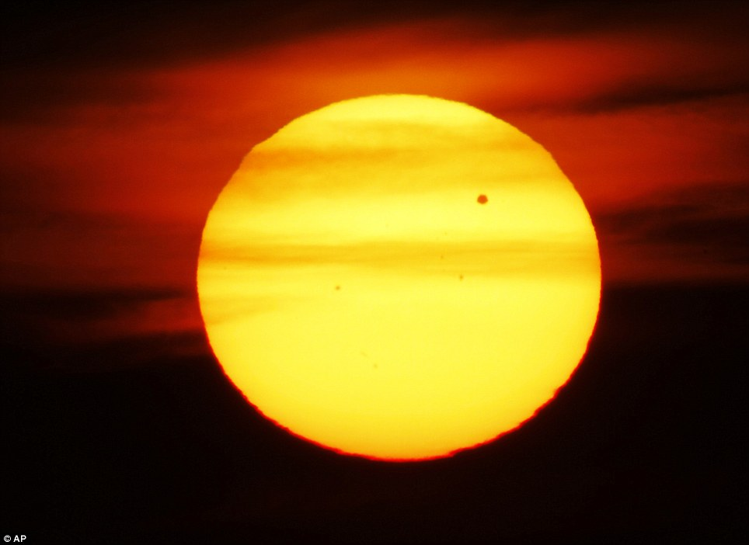
Giovanni Cassini Parallax Transit of Venus

Christiaan Huygens was the first person to scientifically calculate almost the correct value of the Sun-Earth distance. However, because his method involved some guesswork and was not completely scientifically grounded, he usually does not get the credit. This tends to go to Giovanni Cassini and Jean Richter. In 1672, using a completely different method from Huygens, one with no lucky element to produce the correct result, the two French astronomers accurately determined the distance of Mars from Earth. They were then able to use the same method to refine the then accepted dimensions of the solar system, including the distance of the Sun from Earth.

The method Cassini and Richter used was that of parallax, the angular shift in position of an object caused by a shift in the observer’s position. If you use one eye to line up your thumb with a distant object, and then use the other eye, keeping your thumb still, the alignment will appear to have been lost. The angle between the two measurements can be resolved trigonometrically to calculate the distance to the far object. The further away the object, the smaller the parallax angle. To use this method to calculate the Earth-Mars distance, Cassini sent Richter to French Guyana while he stayed in Paris. They took measurements of the position of Mars relative to background stars, then triangulated these with the known distance between the two locations. Once they had calculated the distance to Mars, they could also calculate the distance from Earth to the Sun. They obtained a value which was only 7% short of the modern calculation.

In 1716, Edmund Halley published a way to use a transit of Venus to accurately measure solar parallax and test Cassini and Richter’s value. With observers positioned at different latitudes, Venus would appear to move along chords of different length over the isk of the Sun. As Venus’s motion is nearly uniform, the length of each chord would be equivalent to the duration of the transit at each site. So, observers would not have to measure anything, only time the transit at each site. However, at the next transit, in 1761, for several reasons, it was not possible to precisely time the start and finish of the transit. Fortunately, the method was refined in time for the transit of 1769. Calculations based on data collected in Norway, Canada and Tahiti resulted in a value of Sun-Earth distance very close to the modern figure. The latter was calculated during the 1960s, using radar and spacecraft.

Astronomical unit (AU)
The astronomical unit is a unit of length, the mean distance of the Sun from Earth. Earth’s orbit is slightly elliptical, so actual distances from the Sun vary during a year. At it closest, at perihelion, in January, the distance is approximately 146 million km, while at aphelion, in June, it is approximately 152 million km. The AU is the mean distance, specifically 149,597,870.7 km. For general purposes, the Sun-Earth distance is rounded up to 150,000,000 km.

Initially, the AU value was the outcome of a calculation, but this could vary, depending on an observer’s location in the solar system. In 2012, the International Astronomical Union agreed a number for the AU based on the speed of light, a fixed distance unrelated to other factors.

The unit is used to measure distances throughout solar system eg Jupiter is 5.2 AU and Neptune 30.07 AU from the Sun. The outer edges of the solar system are around 100,000 AU from the Sun and the distance to our nearest star, Proxima Centauri, is about 250,000 AU. Light years (ly) are used to measure longer distances eg Proxima Cantauri is about 4.3 ly away.

Sources: Ridpath, I (Ed) (2012) Oxford dictionary of astronomy 2nd ed rev, www.en.wikipedia.org,

For more information on the Hermanus Astronomy Centre and its activities, visit our website at www.hermanusastronomy.co.za

COMMITTEE MEMBERS
Pierre de Villiers (Chairperson, observatory, youth club) 028 313 0109
Laura Norris (Treasurer) 028 316 4453
Peter Harvey (Secretary, monthly sky maps) 028 316 3486
Jenny Morris (Vice-chairperson, newsletter) 071 350 5560
Karin de Bruin (Observing) 028 316 2080
Derek Duckitt (Website editor) 082 414 4024
Bennie Kotze (Outreach co-ordinator) 128 316 3666
Deon Krige (Youth robotics project, astro-photography) 028 314 1045
John Saunders (Guest speakers and events) tibouchina286@gmail.com
Non-committee members with roles:
Pierre Hugo (Cosmology interest group) 028 312 1639
Johan Retief (Hawston School Youth Club) 028 315 1132

