“The Southern Cross”

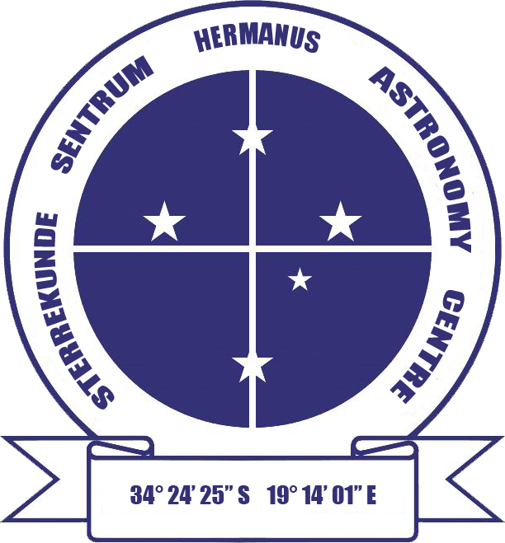

HERMANUS ASTRONOMY CENTRE NEWSLETTER

JUNE 2016

|  |
| --- |
| **This month’s Centre meeting**  This takes place on **Monday 20 June** in the **Scout Hall** starting at t **19.00**. Hannes Breytenbach, a PhD student at UCT will be talking about 'Cataclysmic variables' Further details below. |

|  |
| --- |
| **Stargazing – Soup and stars evening on Friday 24 June**  Join us for a fun evening of 'Soup and stars' on the evening of **Friday 24 June** at the **NG Kerk, Berg Street, Onrus**, starting at **18.00**. Book early, as places are limited. The price of R50 per person will include soup and refreshments, star map, newsletter and binocular and telescope stargazing. **Bookings** Book your places with Laura Norris at [dun@whalemail.co.za](mailto:dunorris@whalemail.co.za) or on 028 316 4453 or 083 651 7721. |

WHAT’S UP?

**A heavenly trio** During the evenings in the middle of this month, the waxing Moon can be seen taking part in a trio with Mars and Saturn. Reddish Mars and bright Saturn will be found framing the head of Scorpius. Although features on the Moon are less easy to see when it is close to full, it would still be interesting to study through binoculars. The white areas are rugged uplands, pockmarked with impact craters, some distinctive because of their size. There are over 330,000 impact craters with a diameter of over 1km on the Moon, and many thousands of smaller ones. The dark, relatively smooth lowland areas were thought, in the past, to be seas and are still called mare (Latin for ‘sea’). It is the mare which create the image, seen from the southern hemisphere, of the ‘Rabbit on the Moon’. The darker colour of the mare reflects the fact that they are formed from basalt released during volcanic eruptions in the young satellite. Younger than the highlands, they have fewer impact craters. First and last quarter are the best times to observe the Moon, as the features are lit more from the side and more clearly highlighted by sunlight. This month, these are on the 12th and 27th.

LAST MONTH’S ACTIVITIES

**Monthly centre meeting**  On 16 May, the Centre's most frequent presenter, Johan Retief, gave a fascinating talk on 'The order of the planets. Earth and its history'. After outlining how the solar system evolved from collapse within a giant molecular cloud, Johan summarised the classical model of solar system development, based on understanding of our own one. Then he explained how recent discoveries of the large variety and arrangements of exoplanets and their solar systems are challenging the standard model, leading to hypotheses of a much more dynamic, sometimes seemingly illogical process which eventually resulted in the present arrangement of our solar system's planetary order. In the second part of his talk, Johan correlated these larger scale events with the geological history of Earth, particularly those of the earliest geological eons. Attendees left the meeting with intriguing concepts like 'the ice line', 'the grand tack' and 'the great killing' on their minds.

**Interest groups**

**Cosmology** Fifteen people (14 members, 1 visitor) attended the meeting on 2 May. They viewed the ninth pair of episodes of the 24 part DVD series on Time, given by Prof Sean Carroll from CalTech. The topics were: Lecture 17: ‘Time and relativity’ and Lecture 18: ‘Curved spacetime and black holes'.

**Astro-photography** There was no meeting in May.

**Other activities**

**Stargazing** No public events took place in May.

**Educational outreach**

**Hawston Secondary School Astronomy Group** Meetings, including practical observation secessions, continue to take place weekly.

**Lukhanyo Youth Club** No meetings took place in May.

**Article in Whale Talk** An article by Jenny Morris titled 'The pulling power of the Great Attractor – the veil has been lifted' was published in the May/June issue of the magazine.

THIS MONTH’S ACTIVITIES

Monthly centre meeting This will take place on **Monday 20 June** at the **Scout Hall** at **19.00.** The presenter is Hannes Breytenbach, a PhD student at UCT, and his topic is 'Cataclysmic variables'. Cataclysmic Variables (CVs) are an enigmatic class of interacting binary stars typified by semi-regular outbursts that increase the brightness of the system by 10-10,000 fold over the course of a few days. This talk will present a graphic storyboard of the life and times of CVs providing a glimpse into their diversified lives: How they are born, how and why they vary, their eventual spectacular demise.

There is an entrance fee of R10 per person for members, R20 per person for non-members, and R10 for children, students and U3A members.

Interest group meetings

The **Cosmology** group meets on the first Monday of each month at 19.00. This month’s meeting will take place on **6 June** at the Scout Hall. Attendees will view the tenth pair of episodes of the new DVD series on Time by Prof Sean Carroll from CalTech. The topics for this month are: Lecture 19: ‘Time travel’ and Lecture 20: ‘Black hole entropy'.

There is an entrance fee of R10 per person for members, R20 per person for non-members, and R10 for children, students and U3A members. For further information on these meetings, or any of the group’s activities, please contact Pierre Hugo at [pierre@hermanus.co.za](mailto:pierre@hermanus.co.za)

**Astro-photography** This group meets on the third Monday of each month. The next meeting will take place on **13 June.** Members will discuss future topics.

To find out more about the group’s activities and the venue for particular meetings, please contact Deon Krige at [astronomy.hermanus@gmail.com](mailto:astronomy.hermanus@gmail.com)

**Stargazing** A **'Soup and stars'** event will take place on **Friday 24 June** at the **NG Kerk, Onrus** starting at **18.00**. Places are limited, so book early. The price of **R50 per** **person** will include soup and refreshments, star map, newsletter and binocular and telescope stargazing. **Bookings** Book your places with Laura Norris at [dun@whalemail.co.za](mailto:dunorris@whalemail.co.za) or on 028 316 4453 or 083 651 7721.

**Hermanus Youth Robotic Telescope Interest Group** The organisers continue to work towards being able to start undertaking activities with learners.

For further information on both the MONET and Las Cumbres projects, please contact Deon Krige at [deonk@telkomsa.net](mailto:deonk@telkomsa.net)

FUTURE ACTIVITIES

None is currently being planned.

2016 MONTHLY MEETINGS

Meetings take place on the **third Monday** of each month at the Scout Hall beginning at 19.00. Details for 2016 are:

20 June 'Cataclysmic variables'. Presenter: Hannes Breytenbach, UCT

18 July, Topic TBA. Presenter: Case Rijsdijk, Garden Route Centre

15 Aug, TBA

19 Sept Topic TBA. Presenter: Dr Bruce Bassett, UCT and AIMS

17 Oct ‘Dark skies: the unseen Universe’’. Presenter: Jenny Morris, Committee member

21 Nov 'Science we have learned from space telescopes'. Presenter, Pierre de Villiers, Chairman, HAC committee

19 Dec Xmas party

ASTRONOMY EDUCATION CENTRE AND AMPHITHEATRE (AECA)

The updated planning application was published in the 5 May issue of Hermanus Times. The public has one month in which to respond, after which formal responses will be made to any objections raised. In the meantime, the Friends of the Observatory pledge fund continues to be an important source of funds to cover associated costs.

The **Friends of the Observatory campaign** was launched several years ago when preliminary work began on plans to construct an astronomical observatory in Hermanus. Over the years, members have been very generous, for which we are deeply grateful. It may seem logical to assume that, now money has been awarded by the National Lotteries Board, pledge monies are no longer needed. Unfortunately, that is not the case. NLC funds can only be used once the plans have been formally approved by the Municipality, something which is still awaited.

We would, therefore, be very grateful if members could either continue to contribute to the campaign or start becoming a contributor. Both single donations and small, regular monthly donations, of any amount, are welcome. Contributions can take the form of cash (paid at meetings), or online transfer, The Standard Bank details are as follows:

Account name – Hermanus Astronomy Centre

Account number – 185 562 531

Branch code – 051001

If you make an online donation, please include the word ‘pledge’, and your name, unless you wish to remain anonymous.

**Science Centre** The committee continues to work on the project.

ASTRONOMY NEWS

**Ancient volcanoes point to extensive ice on Mars** 3 May: Volcanoes erupted beneath an ice sheet on Mars billions of years ago, far from any ice sheet on the Red Planet today, new evidence from NASA's Mars Reconnaissance Orbiter suggests.

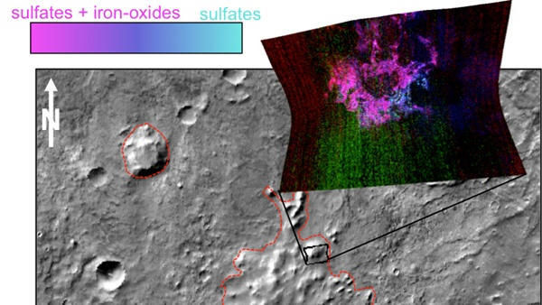 Ancient Volcanoes on Mars This graphic illustrates where Mars mineral-mapping from orbit has detected minerals that can indicate where a volcano erupted beneath an ice sheet. The site is far from any ice sheet on modern Mars, in an area where unusual shapes have been interpreted as a possible result of volcanism under ice. NASA/JPL-Caltech/JHUAPL/ASU

The research about these volcanoes helps show there was extensive ice on ancient Mars. It also adds information about an environment combining heat and moisture, which could have provided favourable conditions for microbial life.

Sheridan Ackiss of Purdue University, West Lafayette, Indiana, and collaborators used the orbiter's mineral-mapping spectrometer to investigate surface composition in an oddly textured region of southern Mars called "Sisyphi Montes." The region is studded with flat-topped mountains. Other researchers previously noted these domes' similarity in shape to volcanoes on Earth that erupted underneath ice.

When a volcano begins erupting beneath a sheet of ice on Earth, the rapidly generated steam typically leads to explosions that punch through the ice and propel ash high into the sky. For example, the 2010 eruption of ice-covered Eyjafjallajökull in Iceland lofted ash that disrupted air travel across Europe for about a week.

Characteristic minerals resulting from such subglacial volcanism on Earth include zeolites, sulphates and clays. Those are just what the new research has detected at some flat-topped mountains in the Sisyphi Montes region examined with the spacecraft's Compact Reconnaissance Imaging Spectrometer for Mars (CRISM), providing resolution of about 18 metres per pixel.

The Sisyphi Montes region extends from about 55 degrees to 75 degrees south latitude. Some of the sites that have shapes and compositions consistent with volcanic eruptions beneath an ice sheet are about 1,600 km from the current south polar ice cap of Mars. The cap now has a diameter of about 350 km. By: [NASA/JPL](http://www.astronomy.com/authors/nasa-jpl)

# Pluto’s interaction with the solar wind is unique, study finds4 May: Pluto behaves less like a comet than expected and somewhat more like a planet like Mars or Venus in the way it interacts with the solar wind — a continuous stream of charged particles from the Sun. This is according to the first analysis of Pluto’s interaction with the solar wind, funded by NASA’s New Horizons mission.

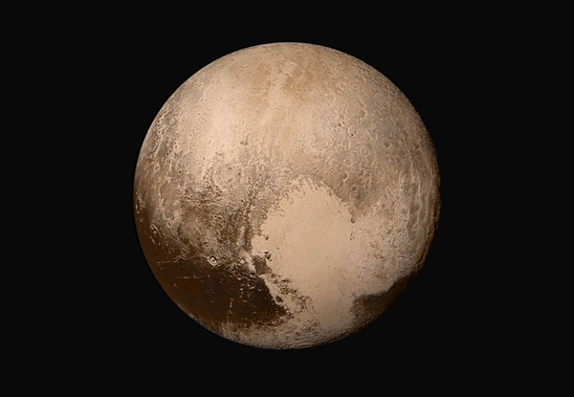 Four images from New Horizons’ Long Range Reconnaissance Imager (LORRI) were combined with colour data from the Ralph instrument to create this global view of Pluto. The images, taken when the spacecraft was 450,000 km away from Pluto, show features as small as 2.2 km. Credits: NASA/JHUAPL/SwRI

“This is a type of interaction we’ve never seen before anywhere in our solar system,” said David J. McComas from Princeton University in New Jersey. “The results are astonishing.” Space physicists say that they now have a treasure trove of information about how Pluto’s atmosphere interacts with the solar wind. Solar wind is the plasma that spews from the Sun into the solar system at a supersonic 160 million km, bathing planets, asteroids, comets, and interplanetary space in a soup of mostly protons and electrons.

Previously, most researchers thought that Pluto was characterised more like a comet, which has a large region of gentle slowing of the solar wind, as opposed to the abrupt diversion solar wind encounters at a planet like Mars or Venus. Instead, like a car that’s part gas- and part battery-powered, Pluto is a hybrid, researchers say. So Pluto continues to confound. “These results speak to the power of exploration. Once again we’ve gone to a new kind of place and found ourselves discovering entirely new kinds of expressions in nature,” said Alan Stern from SwRI.

Since it’s so far from the Sun - an average of about 3.7 billion miles - and because it is so small, scientists thought Pluto’s gravity would not be strong enough to hold heavy ions in its extended atmosphere. However, “Pluto’s gravity clearly is enough to keep material relatively confined,” McComas said. The researchers were able to separate the heavy ions of methane, the main gas escaping from Pluto’s atmosphere, from the light ions of hydrogen that come from the Sun.

Among additional Pluto findings: 1. Like Earth, Pluto has a long ion tail that extends downwind at least a distance of about 100 Pluto radii (118,700 km) - almost three times the circumference of Earth - loaded with heavy ions from the atmosphere and with “considerable structure.” 2. Pluto’s obstruction of the solar wind upwind of the planet is smaller than had been thought. The solar wind is not blocked until about the distance of 3,000 km. 3. Pluto has a thin boundary of Pluto’s tail of heavy ions and the sheath of the shocked solar wind that presents an obstacle to its flow.

Heather Elliott from SwRI noted, “Comparing the solar wind-Pluto interaction to the solar wind interaction for other planets and bodies is interesting because the physical conditions are different for each, and the dominant physical processes depend on those conditions.”  
By: [American Geophysical Union, Washington,](http://www.astronomy.com/authors/american-geophysical-union) [D.C.](http://www.astronomy.com/authors/american-geophysical-union),[Princeton University, Princeton, New Jersey](http://www.astronomy.com/authors/princeton-university)

# The Kepler mission just doubled its catalogue of exoplanet finds 10 May: Today, researchers on NASA’s Kepler planet hunting mission didn’t announce one new interesting planet, as they usually do. Instead, they announced about 1,200 of them.

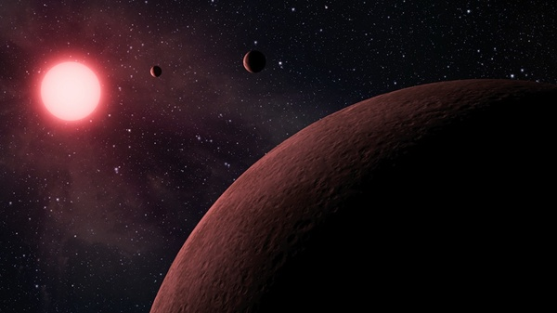 An illustration of Kepler-42, one of thousands of exoplanets found by the craft. NASA

That more than doubles the number of confirmed planets in the catalogue. As of yesterday, the listed number stood at 1,041 confirmations. The new planets are not a result of the K2 mission, though. Instead, it is about new software that enabled Kepler researchers to parse out the signal from noise in candidate planets.

Jeff Coughlin, a SETI Institute researcher who helps NASA put together the Kepler catalogue, said that the 1,284 new planets are validated to 99 percent certainty. This means that they are all almost certainly planets. “Adding in these 1,200 really doubles our sample of really high confidence planets,” Coughlin says.

The refinement techniques account for any star in the region that might give a false transit signal, as well as accounting for the size of any transiting object to rule out image artefacts or flaws in Kepler’s imaging. However, the new software’s true strength is its ability to sort through hundreds of candidates at once. “People have done this for single targets in the past, but it was very computationally intensive,” Coughlin said.

While Kepler has often touted finding the latest “most Earth-like planet,” or systems of planets in strange orbital configurations, the sheer volume means the researchers are still combing through the dataset for intriguing planets. Results put the number of potentially habitable worlds in the dataset around nine total. Coughlin said the new catalogue also includes long-period planets. One such planet, Kepler-1638b, has a period of 259 days, placing its year somewhere in between Venus and Earth.

Long-period planets are important because they’re more in line with what we know from our solar system. Kepler has a bias toward short period planets, those that complete an orbit within a few days. The original Kepler data set comes from a little under four years of observation. So if an alien civilization had been staring at our Sun with their own Kepler, they probably would have detected Mercury and Venus, maybe detected Earth and Mars, and not detected any of the larger planets, as some of the dips in light may have happened only twice, once, or not at all. Kepler requires three transits to prove a planet’s status as real. A total of 84 have orbital periods of longer than 100 days, with the longest orbital period at 510 days.

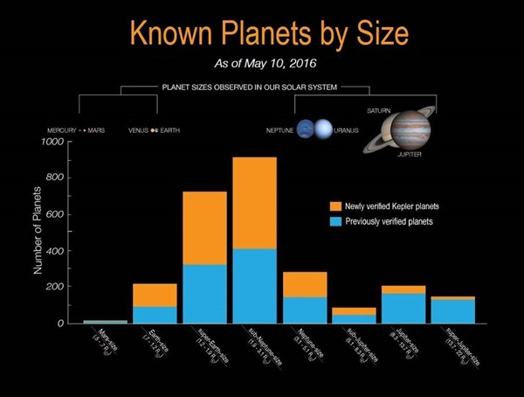

There’s still more work to do. For instance, there are more than 3,000 candidate planets left in the Kepler data that are believed to be possible planets. This is in addition to a list of 'Kepler Objects of Interest' that’s sort of the roll call of candidates-to-be-candidates. Using the new method, 428 candidates were validated as very likely not being planets.

Most of the 1,284 validated planets are mini-Neptunes, planets at the lower limits of gas giant size. The next biggest sample is super-Earths, with some planets found that are roughly Earth sized and about as many roughly Neptune sized.

Further refinement techniques could find more truly Earth-sized objects, rather than the bevy of super-Earths (and mini-Neptunes and hot Jupiters) in the catalogue. Both NASA’s TESS and ESA’s GAIA mission, the next generation of planet finders, will bolster the cases for some of these planets. By: [John Wenz](http://www.astronomy.com/authors/john-wenz)

**Clues to ancient giant asteroid found in western Australia** 17 May: Scientists have found evidence of a huge asteroid that struck Earth early in its life with an impact larger than anything humans have experienced.

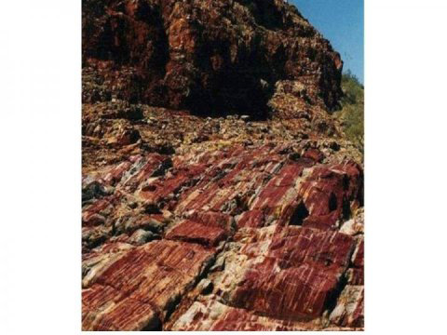 Sediments at Marble Bar, Western Australia. A. Glikson

Tiny glass beads called spherules, found in northwestern Australia, were formed from vaporised material from the asteroid impact, said Andrew Glikson from The Australian National University (ANU). “The impact would have triggered earthquakes orders of magnitude greater than terrestrial earthquakes, it would have caused huge tsunamis, and would have made cliffs crumble,” said Glikson. “Material from the impact would have spread worldwide. These spherules were found in sea floor sediments that date from 3.46 billion years ago.”

The asteroid is the second oldest known to have hit Earth and one of the largest. Glikson said the asteroid would have been 20 to 30 km across and would have created a crater hundreds of kilometres wide. About 3.8 to 3.9 billion years ago, the Moon was struck by numerous asteroids, which formed the craters, called maria, that are still visible from Earth “Exactly where this asteroid struck the Earth remains a mystery,” Glikson said. “Any craters from this time on Earth’s surface have been obliterated by volcanic activity and tectonic movements.”

Glikson and Arthur Hickman from Geological Survey of Western Australia found the glass beads in a drill core from Marble Bar, in northwestern Australia, in some of the oldest known sediments on Earth. The sediment layer, which was originally on the ocean floor, was preserved between two volcanic layers, which enabled precise dating of its origin. Subsequent testing found the levels of elements such as platinum, nickel, and chromium matched those in asteroids.

There may have been many more similar impacts, for which the evidence has not been found, said Glikson. “This is just the tip of the iceberg. We’ve only found evidence for 17 impacts older than 2.5 billion years, but there could have been hundreds. Asteroid strikes this big result in major tectonic shifts and extensive magma flows. They could have significantly affected the way the Earth evolved.”

By: [Australian National University in Canberra](http://www.astronomy.com/authors/australian-national-university-in-canberra)

# Astronomers confirm the faintest early galaxy ever detected19 May: An international team of scientists has detected and confirmed the faintest early-universe galaxy ever using the W M Keck Observatory on the summit on Mauna Kea, Hawaii.

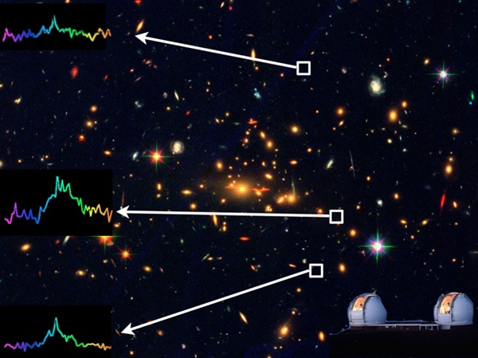 Coloru image of the cluster taken with Hubble Space Telescope (images in three different filters were combined to make an RGB image). In the inset we show three spectra of the multiply imaged systems. They have peaks at the same wavelength, hence showing that they belong to the same source. Bradac/HST/W M Keck Observatory

The team detected the galaxy as it was 13 billion years ago, or when the universe was a toddler on a cosmic time scale. The detection was made using the DEIMOS instrument fitted on the ten-meter Keck II telescope, and was made possible through a phenomenon predicted by Einstein in which an object is magnified by the gravity of another object that is between it and the viewer. In this case, the detected galaxy was behind the galaxy cluster MACS2129.4-0741, which is massive enough to create three different images of the object.

“If the light from this galaxy was not magnified by factors of 11, five and two, we would not have been able to see it,” said Kuang-Han Huang from UC Davis. “It lies near the end of the reionisation epoch, during which most of the hydrogen gas between galaxies transitioned from being mostly neutral to being mostly ionised - and lit up the stars for the first time. That shows how gravitational lensing is important for understanding the faint galaxy population that dominates the reionisation photon production.”

“We now have good constraints on when the reionisation process ends - at redshift around 6 or 12.5 billion years ago - but we don’t yet know a lot of details about how it happened,” Huang said. “The galaxy detected in our work is likely a member of the faint galaxy population that drives the reionisation process.”

“This galaxy is exciting because the team infers a very low stellar mass, or only one percent of one percent of the Milky Way Galaxy,” Kassis said. “It’s a very, very small galaxy, and at such a great distance, it’s a clue in answering one of the fundamental questions astronomy is trying to understand: What is causing the hydrogen gas at the very beginning of the universe to go from neutral to ionised about 13 billion years ago? That’s when stars turned on and matter became more complex.”

By: [W. M. Keck Observatory, Kamuela, Hawaii](http://www.astronomy.com/authors/w,-d-,-m,-d-,-keck-observatory)

# Astronomers discover fresh lunar craters24 May: A Southwest Research Institute-led (SwRI) team of scientists has discovered two geologically young craters — one 16 million, the other between 75 and 420 million, years old — in the Moon’s darkest regions.

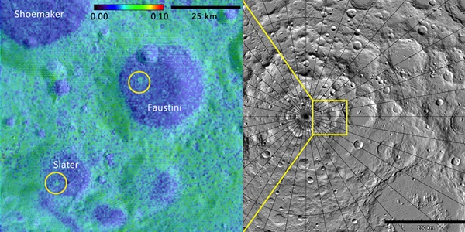 Using data from the LAMP instrument aboard the Lunar Reconnaissance Orbiter, a Southwest Research Institute-led team of scientists discovered two geologically young craters — one (right) 16 million, the other (left) between 75 and 420 million, years old — in the Moon’s darkest regions. One lies within Slater Crater, named for the late Dr. David C. Slater, a former SwRI space scientist who designed and built the LAMP instrument.

Albedo map credit: NASA GSFC/SwRI; Topographic map credit: NASA GSFC/ASU Jmoon

“These ‘young’ impact craters are a really exciting discovery,” said Kathleen Mandt from SwRI. “Finding geologically young craters and honing in on their age helps us understand the collision history in the solar system.” Key to this discovery was the SwRI-developed Lyman-Alpha Mapping Project (LAMP) instrument aboard NASA’s Lunar Reconnaissance Orbiter (LRO). LAMP uses the far-ultraviolet Lyman-alpha band skyglow and light from ultraviolet-bright stars LAMP to 'see' in the dark and image the permanently shaded regions of the Moon. Using LAMP and LRO’s Mini-RF radar data, the team mapped the floors of large deep craters near the lunar south pole. These deep craters are difficult to study because sunlight never illuminates them directly. Tiny differences in reflectivity, or albedo, measured by LAMP allowed scientists to discover these two craters and estimate their ages.

Collisions in space have played an important role in the formation of the solar system, including the formation of the Moon. Impact craters tell the history of collisions between objects in the solar system. Because the Moon has been peppered with impacts, its surface serves as a record of its past. Determining when collisions occurred helps scientists map the motion of objects in the solar system throughout its history. Craters that are young on geological timescales (millions of years) also provide information on the frequency of collisions.

When a small object collides with a larger object, such as the Moon, the impact creates a crater on the larger body. Craters can be a few feet in diameter or several miles wide. During the impact, the material ejected forms a blanket of material surrounding the crater. The ejecta blankets of 'fresh', relatively young craters have rough surfaces of rubble and a sprinkling of condensed, bright dust. Over millions of years, these features undergo weathering and become covered with layers of fluffy dark dust.

Scientists determined that the areas around the two craters were brighter and rougher than the surrounding landscape. The team estimated the age of one crater at about 16 million years. The other crater’s rough extended ejecta blanket had faded, showing that this crater must be at least 75 million years old. However, time would have completely covered the ejecta blanket in fluffy dust within 420 million years, providing an upper limit on its age. Other images produced using laser altimetry and sunlight scattered off crater walls provided details about topography, surface features, and material properties.

“Discovering these two craters and a new way to detect young craters in the most mysterious regions of the Moon is particularly exciting,” said Mandt. “This method will be useful not only on the Moon, but also on other interesting bodies, including Mercury, the dwarf planet Ceres, and the asteroid Vesta.”

By:[Southwest Research Institute, San Antonio, Texas](http://www.astronomy.com/authors/southwest-research-institute)

# Spirit in memoriam25 May: Five years ago today, NASA officially ceased recovery efforts for the Spirit rover. They didn’t give up without a fight. The rover had been silent since March of 2010, more than a year earlier, and stationary since 2009, when it drove into a patch of soft Martian soil.

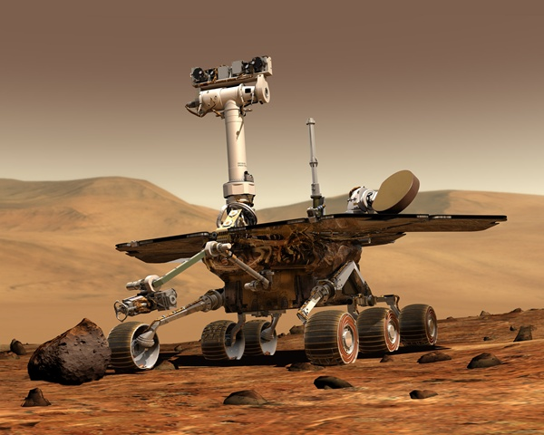 The Spirit rover explored the Red Planet for more than five years, well past its original mission lifetime. NASA

With Spirit’s twin rover, Opportunity, driving merrily along to this day (though not without signs of ageing), it is tempting, in hindsight, to consider Spirit the disappointing sibling. Certainly it is difficult not to dream about the wealth of images and data Spirit might have returned had it not become mired in a soft patch of Martian soil. However, we would be ungrateful not to look back on what was still a spectacular science mission lifetime for Spirit. L

Touchdown Spirit landed on Mars on 4 January 2004. Like its twin, Opportunity, Spirit was assigned an initial mission of only 90 sols. (A sol is one Martian day, or 24 hours and 39 minutes, just slightly longer than an Earth day.) It exceeded this mission lifetime by more than 20 times, delivering invaluable science as it explored the Red Planet. It made its home in Gusev Crater, an ancient impact site and likely a giant dried lakebed as well.

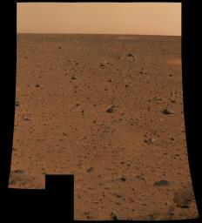 The first image Spirit returned was also the highest resolution image ever taken on another planet. NASA/JPL/Cornell

Dust devils In 2005, Spirit caught sight of Martian dust devils. The earlier Pathfinder mission had also spotted such phenomena, but this was the first for the new rover mission. Aside from a spectacular sighting, the wind had the benefit of clearing off Spirit’s solar panels, which had already begun to accumulate a layer of dust that decreased their efficiency.

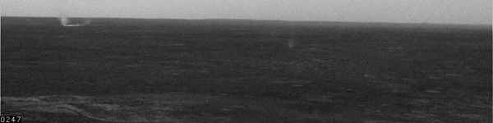 In 2005, Spirit spied dust devils in Gusev Crater. NASA/JPL

Water: the good kind Also in 2005, Spirit investigated an outcrop of rocks called 'Comanche'. It took scientists nearly five years to understand what the rover had uncovered, but the result was powerful. The rocks had high concentrations of carbonate, which can only form in wet, non-acidic environments. The rovers had previously uncovered signs of acidic water, but this was their first clear evidence that Mars once hosted water might have been hospitable to life.

Improv In 2006, one of Spirit’s front wheels, which had been giving its engineering team trouble, ceased to drive completely. Undeterred, the team instructed Spirit to drive backwards on five wheels, dragging its unresponsive sixth behind it. Spirit successfully roved on for years in this handicapped condition.

Volcanoes and water On 3 May 2007, Spirit discovered signs of an ancient volcanic eruption - and not some sleepy seeping magma, but an epic explosion that implies the lava made contact with water.

Silica hints at ancient hospitality Continuing to uncover signs that Mars was once highly active, on 10 December 2007, researchers announced that Spirit’s dragging dead wheel had serendipitously scraped clear a patch of almost pure silica. On Earth, such material typically forms near hot springs or in regions where acidic steam forces its way through narrow spaces. Both environments on Earth are popular with microbial life, so the Martian silica points to habitable regions in Mars’ past.

Hunkering down for the storm Spirit spent much of 2008 weathering massive dust storms that covered its solar arrays and decreased the power available for science activities. In 2009, it regained enough energy to resume driving, but on 1 May, the rover drove into soft soil at Troy, on the west side of 'Home Plate', and became mired.

Final resting spot The rover team would spend more than a year attempting to free Spirit, but to no avail. In January 2010, the rover team declared Spirit a stationary research station. As the Red Planet moved into winter, Spirit readied for low sunlight levels and the associated decrease in available power. But Spirit never woke up from its hibernation. The team heard the rover’s last call on 22 March. They waited patiently, sending more than 1,300 signals to the rover as spring and then summer passed on the Red Planet, which should have woken the rover. Finally, on 25 May 2011, after more than an Earth year since Spirit’s last communication, the team ended their search.

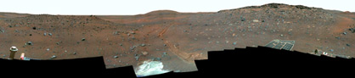

Spirit still sits at Troy, where it became mired in 2009. NASA/JPL-Caltech/Cornell University

By: [NASA](http://www.astronomy.com/authors/nasa-jpl)

# NASA’s Juno spacecraft crosses Jupiter/Sun gravitational boundary27 May: Since its launch five years ago, there have been three forces tugging at NASA's Juno spacecraft as it speeds through the solar system. The Sun, Earth, and Jupiter have all been influential - a gravitational trifecta of sorts. At times, Earth was close enough to be the frontrunner. More recently, the Sun has had the most clout when it comes to Juno's trajectory. Today, it can be reported that Jupiter is now in the gravitational driver's seat, and the basketball court-sized spacecraft is not looking back.

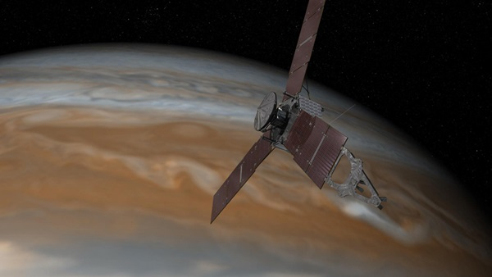 This artist's rendering shows NASA's Juno spacecraft making one of its close passes over Jupiter. NASA/JPL-Caltech

"Today the gravitational influence of Jupiter is neck and neck with that of the Sun," said Rick Nybakken from NASA's Jet Propulsion Laboratory in Pasadena, California. "As of tomorrow, and for the rest of the mission, we project Jupiter's gravity will dominate as the trajectory-perturbing effects by other celestial bodies are reduced to insignificant roles."

Juno was launched on 5 August 2011. On 4 July this year, it will perform a Jupiter orbit insertion manoeuvre - a 35-minute burn of its main engine, which will impart a mean change in velocity of 542 meters per second)on the spacecraft. Once in orbit, the spacecraft will circle the Jovian world 37 times, skimming to within 5,000 km above the planet's cloud tops. During the flybys, Juno will probe beneath the obscuring cloud cover of Jupiter and study its auroras to learn more about the planet's origins, structure, atmosphere, and magnetosphere.

Juno's name comes from Greek and Roman mythology. The mythical god Jupiter drew a veil of clouds around himself to hide his mischief, and his wife -the goddess Juno - was able to peer through the clouds and reveal Jupiter's true nature. By: [NASA/JPL](http://www.astronomy.com/authors/nasa-jpl)

Source of these and further astronomy news items: [www.astronomy.com/news](http://www.astronomy.com/news)

DID YOU KNOW?

**The Sun** Part 3 **Earth-Sun distance calculation 1**

Christiaan Huygens

In the 3rd century BCE, the Greek polymath Eratosthenes calculated Earth’s circumference via comparison of the Sun’s declination between places of known distance apart. Knowledge of Earth’s radius created a baseline to determine greater distances. A century later, Hipparchus worked out the Earth-Moon distance indirectly, but accurately, from the geometry of lunar eclipses.

Aristarchus then used Hiapprchus’s calculations to determine the sizes of Moon and Sun, and distance to the Sun. When the Moon is seen from Earth to be exactly half illuminated (at first and last quarter), there is a right angle between Earth, Moon and Sun, with the Moon at the right angle. From this, Aristarchus, using geometry, was able to measure the angular distance in the sky between Sun and Moon, add it to the known Earth-Moon distance, and calculate the Earth-Sun distance. However, a small inaccuracy in assumption of Sun-Moon-Earth angle led to a calculated result equivalent to only 8 million kilometres, which was known to be much too small.

In the 1st century CE, Ptolemy estimated Sun-Earth distance as 1,210 times Earth’s radius, approx 7.71 million km, but it was, again, far too small. At best, the earlier calculations were best estimates. It was not until 1653 that the Dutch physicist Christiaan Huygens first accurately measured the distance to the Sun. He used the phases of Venus to find the angles in a Venus-Sun-Earth triangle. He knew that actual Venusian phase depended on the angle it made with Sun as seen from Earth. When Venus appears half lit, Earth, the Sun and Venus form a right angle.

If any two internal angles and the length of one side of a triangle are known, the length of another side can be calculated. Huygens knew the Sun-Venus-Earth angle (from the phases), and could directly measure the Sun-Earth-Venus angle. He also needed the Venus-Earth distance to be able to use trigonometry to obtain the Earth-Sun distance. Huygens knew that if you measure the apparent size of an object, and know its true size, the distance to that object can be calculated. He thought he knew Venus’s size, but from unscientific techniques like numerology and mysticism. However, through pure luck, he correctly thought that Venus and Earth were similar sizes. Using this assumption, he was able to determine the distance of Venus from Earth and, knowing that distance, plus the angles made by the triangle, he calculated the distance to the Sun.

Huygens was the first to scientifically calculate almost the correct value of the Sun-Earth distance. However, because his method involved some guesswork and was not completely scientifically grounded, he usually does not get the credit. This tends to go to Giovanni Cassini and Jean Richter. In 1672, using a completely different method from Huygens, one with no lucky element to produce the correct result, the two French astronomers accurately determined the distance of Mars from Earth. They were then able to use the same method to refine the then accepted dimensions of the solar system, including the distance of the Sun from Earth.

Sources: Ridpath, I (Ed) (2012) Oxford dictionary of astronomy 2nd ed rev, [www.en.wikipedia.org](http://www.en.wikipedia.org/)

For more information on the Hermanus Astronomy Centre and its activities, visit our website at [www.hermanusastronomy.co.za](http://www.hermanusastronomy.co.za/)

COMMITTEE MEMBERS

Pierre de Villiers (Chairperson, observatory, youth club) 028 313 0109

Laura Norris (Treasurer) 028 316 4453

Peter Harvey (Secretary, monthly sky maps) 028 316 3486

Jenny Morris (Vice-chairperson, newsletter) 071 350 5560

Karin de Bruin (Observing) 028 316 2080

Derek Duckitt (Website editor) 082 414 4024

Bennie Kotze (Outreach co-ordinator) 128 316 3666

Deon Krige (Youth robotics project, astro-photography) 028 314 1045

John Saunders (Guest speakers and events) tibouchina286@gmail.com

Non-committee members with roles:

Pierre Hugo (Cosmology interest group) 028 312 1639

Johan Retief (Hawston School Youth Club) 028 315 1132