“The Southern Cross”

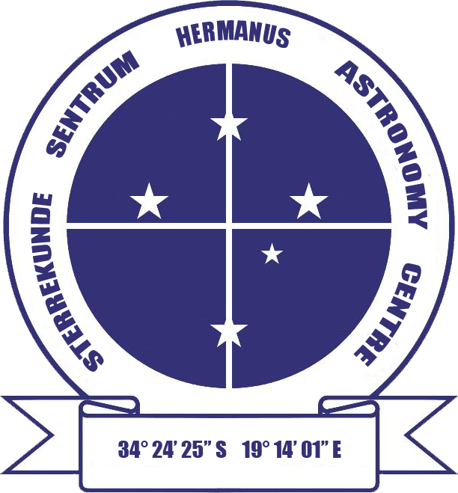

HERMANUS ASTRONOMY CENTRE NEWSLETTER

MAY 2016

This month’s Centre meeting

This takes place on Monday 16 May in the Scout Hall starting at t 19.00. Centre member, Johan Retief will be talking on 'Our solar system and the order of the planets'. Further details below.

New newsletter series Part 2 of the news series on the Sun can be found in the 'Did you know?' section towards the end of the newsletter.

WHAT’S UP?
Meteor shower – Aquariids Meteor showers occur when Earth passes through the path of a stream of meteoroids which has been left as the remnant of the disintegration of an object, usually a comet, but sometimes an asteroid. Several showers occur at the same time each year, their location in the same place (identified by the closest named star). This month offers the best opportunity this year for observe a meteor shower, assuming that you are an early riser. The Eta (η) Aquariids shower takes place from 21 April to 12 May, but is at maximum on the morning of 5 May from around 03.30 until dawn. At that time, Aquarius will be found towards the north-ease, lowish in the sky. The meteors in this shower are usually bright and fast, tending to leave persistent trains. They also tend to appear in large numbers – well worth an early night and setting the alarm for the early hours of the morning.

LAST MONTH’S ACTIVITIES
Monthly centre meeting The presenter at the meeting on 18 April was Prof Mike Kosch, Chief Scientist at SANSA. Mike gave am engrossing presentation on 'Travel to South Pole: space science and astronomy'. Using fascinating images, Mike described his recent visit to the US McMurdo station on Ross Island from where he flew to the South Pole to lead the installation of new space science equipment, two Scanning Doppler Imagers. Flying to Antarctica fro New Zealand in a Hercules transport aircraft without any trimmings, even basic seats, is a challenge in itself. One there, people and planes have to cope with sub-zero temperatures (around -31°C at the height of summer, in Mike's case). For example, while at rest on the ice, if aircraft engines are not left running, they freeze up and a whole maintenance crew and a wide range of equipment have to be flown in. at great expense, if the affected plane is to be able to function again. Despite the rigours of Antarctic life, including the risk of snow blindness if strong sunglasses are not worn at all times when outside, Mike's was a rare opportunity which many would like to experience. For example, using the pole which marks the true South Pole, he was able to show that one can travel round the world in under ten seconds!

Apart from the few, rich tourists who are able to visit the site for a day or so, South Pole station is populated by up to 200 scientists and technicians, the numbers dependent on the time of year. One of the installations which Mike described is the Ice Cube Laboratory, the largest neutrino detector in the world. The 5,160 detectors in the array, which are buried many metres deep in the ice, detect neutrinos travelling through the planet from the North Pole. The elusive nature of neutrinos means that this multi-million dollar installation detects only ten or so neutrinos a year. There are also three microwave telescopes at the site.

Interest groups
Cosmology Fourteen people (11 members, 3 visitors) attended the meeting on 4 April. They viewed the eighth pair of episodes of the 24 part DVD series on Time, given by Prof Sean Carroll from CalTech. The topics were: Lecture 15: ‘Perception of time’ and Lecture 16: ‘Memory and consciousness'. Although concerned more with psychology than astrophysics, they illustrated how the way we perceive and experience time is influenced by the flexible and malleable nature of the human brain.

Astro-photography There was no meeting in April.

Other activities
Sidewalk astronomy No public events took place in March.

Educational outreach
Hawston Secondary School Astronomy Group Weekly meetings, including practical observation secessions, continue to take place weekly. Last week, they also undertook the painting of the gas planet models for use in the forthcoming Cliff Path solar system installation.
Lukhanyo Youth Club Learners painted the rocky planet models for the solar system installation.

Homeschoolers star gazing On 9 April, committee members led an evening of star-gazing with around 50 homeschoolers and their families. A warm, clear evening enabled them to view the crescent Moon, Jupiter and the four Galilean moons, the Orion nebula, Omega Centauri and the Jewel box through binoculars and/or telescopes. Naked eye observations included Orion, the Southern Cross, Leo and the Large Magellanic Cloud.

THIS MONTH’S ACTIVITIES
Monthly centre meeting This will take place on Monday 16 May at the Scout Hall at 19.00. Johan Retief will be talking on 'Our solar system and the order of the planets' A long time Centre member, Johan has given more presentations than any other speaker. His talks are always entertaining as well as carefully prepared and informative, and, doubtless, this one will be the same.

There is an entrance fee of R10 per person for members, R20 per person for non-members, and R10 for children, students and U3A members.

Interest group meetings
The Cosmology group meets on the first Monday of each month at 19.00. This month’s meeting will take place on 2 May at the Scout Hall. Attendees will view the ninth pair of episodes of the new DVD series on Time by Prof Sean Carroll from CalTech. The topics for this month are: Lecture 17: ‘Time and relativity’ and Lecture 18: ‘Curved spacetime and black holes'.

There is an entrance fee of R10 per person for members, R20 per person for non-members, and R10 for children, students and U3A members. For further information on these meetings, or any of the group’s activities, please contact Pierre Hugo at pierre@hermanus.co.za

Astro-photography This group meets on the third Monday of each month. The next meeting will take place on 9 May. Work will continue on image processing.

To find out more about the group’s activities and the venue for particular meetings, please contact Deon Krige at astronomy.hermanus@gmail.com

Sidewalk astronomy No public events have been scheduled for this month. Details will be e-mailed out if this situation changes.

Hermanus Youth Robotic Telescope Interest Group The organisers continue to work towards being able to start undertaking activities with learners.

For further information on both the MONET and Las Cumbres projects, please contact Deon Krige at deonk@telkomsa.net

FUTURE ACTIVITIES

None is currently being planned.

2016 MONTHLY MEETINGS
Meetings take place on the third Monday of each month at the Scout Hall beginning at 19.00. Details for 2016 are:
16 May 'Our solar system and the order of the planets'. Presenter: Johan Retief, Centre member
20 June 'Cataclysmic variables'. Presenter: Hannes Breytenbach, UCT
18 July, Topic TBA. Presenter: Case Rijsdijk, Garden Route Centre
15 Aug, TBA
19 Sept Topic TBA. Presenter: Dr Bruce Bassett, UCT and AIMS
17 Oct ‘Dark skies: the unseen Universe’’. Presenter: Jenny Morris, Committee member
21 Nov 'Science we have learned from space telescopes'. Presenter, Pierre de Villiers, Chairman, HAC committee
19 Dec Xmas party

ASTRONOMY EDUCATION CENTRE AND AMPHITHEATRE (AECA)
Publication of the updated plans for public consultation continues to be awaited. In the meantime, the Friends of the Observatory pledge fund continues to be an important source of funds to cover associated costs.

The Friends of the Observatory campaign was launched several years ago when preliminary work began on plans to construct an astronomical observatory in Hermanus. Over the years, members have been very generous, for which we are deeply grateful. It may seem logical to assume that, now money has been awarded by the National Lotteries Board, pledge monies are no longer needed. Unfortunately, that is not the case. NLC funds can only be used once the plans have been formally approved by the Municipality, something which is still awaited.

We would, therefore, be very grateful if members could either continue to contribute to the campaign or start becoming a contributor. Both single donations and small, regular monthly donations, of any amount, are welcome. Contributions can take the form of cash (paid at meetings), or online transfer, The Standard Bank details are as follows:
Account name – Hermanus Astronomy Centre
Account number – 185 562 531
Branch code – 051001
If you make an online donation, please include the word ‘pledge’, and your name, unless you wish to remain anonymous.

Science Centre The committee continues to work on the project.

ASTRONOMY NEWS

An oasis in the brown dwarf desert 1 April: Most stars in our galaxy have a travelling companion. Often, these companions are stars of similar mass, as is the case for our nearest stellar neighbours, the triple star system Alpha Centauri. Stars, like the Sun, often have companions of their own - planets. Planetary companions are vastly different from stellar companion. They are much smaller, and do not shine with their own light created through nuclear fusion. Even the largest planet in our solar system, Jupiter, would need to be 80 times more massive to even begin to shine this way. Stuck in the middle are 'brown dwarfs', much bigger than Jupiter but still too small to be shining stars. These brown dwarfs give off merely a dim glow as they slowly cool. The Universe is full of stars, and now we know that it is full of planets, too. Astronomers expected that the Universe would also be teeming with brown dwarfs.

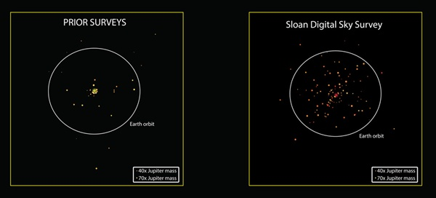 The 'before' and 'after' comparison of the number of known brown dwarfs orbiting other stars. For each of the 41 close-in brown dwarf companions detected previously, the left panel shows the distance to its host star. The right panel shows the 112 brown dwarfs discovered in the new study. In both panels, the sizes of the brown dwarfs indicate their masses, and the circle shows the distance to Earth’s orbit. The larger dot (yellow or red) in the centre of each panel represents the host star (not to scale). All the companions were discovered in different systems; they are shown together for comparison only. N. Troup (Univ. of Virginia) and the Sloan Digital Sky Survey
However, strangely, that is not what they had been finding. Although astronomers have found plenty of brown dwarfs floating through space on their own, they found very few as stellar companions. Even in recent years, as new and sensitive detection techniques have allowed them to discover thousands of extrasolar planets, brown dwarfs have remained elusive, in spite of the fact that they should be easier to find than planets. In fact, until recently, so few brown dwarfs have been found orbiting close to other stars that astronomers refer to the phenomenon as the 'brown dwarf desert'. This, in turn, created a problem for theorists who have been scrambling to explain why astronomers have found so few. Therefore, when SDSS astronomers started sifting through their data looking for brown dwarf companions to stars, they were hoping not to come up completely dry.
“We were shocked to find that so many of the stars in our sample have close-orbiting brown dwarf companions,” said Nick Troup of the University of Virginia in Charlottesville. “We never expected to triple the total number of known brown dwarf companions with only a few years’ worth of observations.” The team’s success is due to an unlikely tool in the race to find low-mass stellar companions. The Apache Point Observatory Galactic Evolution Experiment (APOGEE) was designed as a substantial survey of stars in our Milky Way to make a large-scale map of their motions and chemical compositions. However, the instrument built for the APOGEE project is so sensitive to small stellar motions that companions orbiting these stars can be detected with APOGEE data.
When an object orbits a star, it tugs at it, causing the star to move on a little orbit of its own. For example, Jupiter tugs on the Sun enough to make it wobble around in space by more than its own diameter. To a distant observer, this wobble can be detected and the mass of the tugging object can be determined through changes in the motion of the star. This motion is seen through the Doppler effect, the same phenomenon that is the basis of the patrol officer’s speed gun and the meteorologist’s Doppler radar rain map. While APOGEE was designed to measure the grand motions of stars speeding around the galaxy, it was never intended to do so at the subtle precisions needed to detect the much tinier wobbles induced by small sub-stellar companions. “This level of precision was a serendipitous bonus of the design of the APOGEE spectrograph,” said John Wilson, also from the University of Virginia.
“Even with the first data obtained a few years ago, it was clear that we could use APOGEE to detect the motions of planet-sized objects around our target stars,” said David Nidever of the University of Arizona, Tucson. “It definitely opened our eyes to the possibilities of doing a more systematic search for planets and brown dwarfs.” To undertake such a search, the team started with the 150,000 stars that APOGEE had observed. The astronomers winnowed that collection of stars down to a 'prime sample' of about four hundred representing the best examples of stars with companions in the APOGEE data. Among these, they identified about 60 stars with evidence for planetary-mass candidates, which was already exciting. However, the real surprise came with the researchers’ extraordinary haul of 112 brown dwarf candidates - wice as many than had been found in the previous 15 years.
Why has the APOGEE team been so lucky in finding this oasis of brown dwarfs? Troup thinks it may have to do with the types of host stars that they are looking at. “Most people doing planet searches have been interested in finding the next Earth, so they’ve focused their efforts on stars similar to the Sun,” Troup said. “But we had to work with the stars that APOGEE surveyed, which are mostly giant stars.” The reasons why brown dwarf companions are more common around giant stars is just one of many new questions raised by this new study that the Sloan team is investigating. “It’s completely unprecedented that this many brown dwarf companions have been found at once, so we are anxious to see if the trend persists as the APOGEE sample grows to several times larger,” Troup said. By: Sloan Digital Sky Survey Press Office in Baltimore, Maryland
Young super-Jupiter found wandering without a parent 7 April: A team of astronomers has discovered one of the youngest and brightest free-floating, planet-like objects within relatively close proximity to the Sun. At an age of only 10 million years, which means it is practically a baby on a galactic time scale, the object identified as 2MASS J1119–1137 is between four and eight times the mass of Jupiter, and hence falls in the mass range between a large planet and a small brown dwarf star.
Using data from NASA's Wide-field Infrared Survey Explorer (WISE) and other ground-based telescopes, 2MASS J1119–1137 was identified by its unique light signature using a combination of optical and infrared images from large-area surveys of the sky.
According to Carnegie’s Jacqueline Faherty, the challenge with identifying such rare objects is distinguishing them from a multitude of potential interlopers. "Much more commonly, distant old and red stars residing in the far corners of our galaxy can display the same characteristics as nearby planet-like objects," says Faherty. "When the light from the distant stars passes through the large expanses of dust in our galaxy on its way to our telescopes, the light gets reddened so these stars can pose as potentially exciting nearby young planet-like objects in our data, when they actually are not that at all."
With knowledge of these common misidentifications, the team immediately checked their findings using the FLAMINGOS-2 spectrograph instrument on the Gemini South telescope in Chile. "We promptly confirmed that 2MASS J1119–1137 is in fact a young low-mass object in the solar neighbourhood, and not a distant reddened star," says Western’s Stanimir Metchev. Next, the team wanted to determine the precise age of this object."Our Gemini observations only showed that the object was younger than about 200 million years. If it was much younger, it could actually be a free-floating planet—an analogue of our own Jupiter, yet without a host star," says Metchev.
The final piece of the puzzle was contributed by Carnegie’s Jonathan Gagné using one of the most efficient instruments for infrared spectroscopy in existence, the FIRE spectrograph on Carnegie's Baade 6.5-m telescope in Chile. FIRE allowed the measurement of the line-of-sight velocity of 2MASS J1119–1137 through the Doppler shift of its emitted light. Combining this measurement with the sky motion of 2MASS J1119–1137, the team discovered that it belongs to the youngest group of stars in the solar neighbourhood. This group contains about two dozen 10 million-year-old stars, all moving together through space, and is collectively known as the TW Hydrae association.
Being nearby, 95 light years away, 2MASS J1119–1137 only narrowly misses the crown for being the brightest free-floating planet analogue. That is held by another object known as PSO J318.5−22, discovered three years ago. However, at an age of 23 million years, PSO J318.5−22 is more than twice the age of 2MASS J1119–1137, and is therefore more massive. By: Carnegie Institution for Science, Washington, D.C

Saturn spacecraft not affected by hypothetical planet 9 11 April: Contrary to recent reports, NASA’s Cassini spacecraft is not experiencing unexplained deviations in its orbit around Saturn, according to mission managers and orbit determination experts at NASA’s Jet Propulsion Laboratory (JPL) in Pasadena, California.
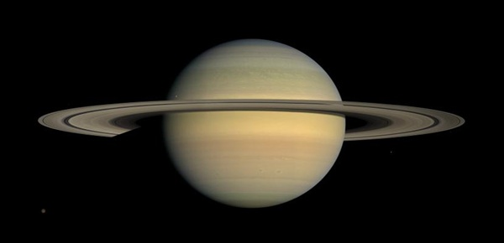 Saturn as seen by NASA's Cassini spacecraft in 2008. Long-term tracking of the spacecraft's position has revealed no unexplained perturbations in Cassini's orbit. NASA/JPL/Space Science Institute
Several recent news stories have reported that a mysterious anomaly in Cassini’s orbit could potentially be explained by the gravitational tug of a theorised massive new planet in our solar system, lurking far beyond the orbit of Neptune. “An undiscovered planet outside the orbit of Neptune, 10 times the mass of Earth, would affect the orbit of Saturn, not Cassini,” said William Folkner from JPL. Folkner develops planetary orbit information used for NASA’s high-precision spacecraft navigation. “This could produce a signature in the measurements of Cassini while in orbit about Saturn if the planet was close enough to the Sun. But we do not see any unexplained signature above the level of the measurement noise in Cassini data taken from 2004 to 2016.”
A recent paper predicts that, if data tracking Cassini’s position were available out to the year 2020, they might be used to reveal a 'most probable' location for the new planet in its long orbit around the Sun. However, Cassini’s mission is planned to end in late 2017, when the spacecraft -too low on fuel to continue on a longer mission - will plunge into Saturn’s atmosphere. “Although we’d love it if Cassini could help detect a new planet in the solar system, we do not see any perturbations in our orbit that we cannot explain with our current models,” said Earl Maize from JPL
By: Jet Propulsion Laboratory, Pasadena, California

Prepare for an explosion of gravitational wave detections 12 April: Based on the signals seen so far and the sensitivity of LIGO's detectors, scientists estimate that they will see between 10 and 100 black hole mergers during the instrument's next observing run, which begins in late summer. In the time it takes someone to finish their lunch break, several pairs of black holes will merge somewhere in the universe. That is the incredible picture emerging from early insights by the Laser Interferometer Gravitational-wave Observatory.
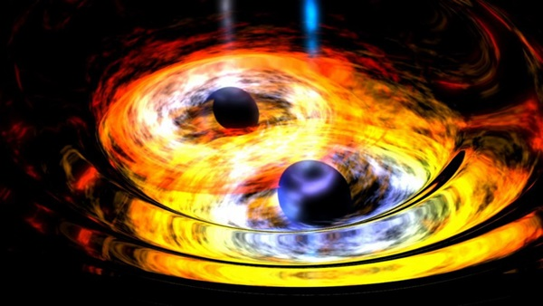 Merging black holes are the source of the gravitational waves observed so far. NASA
In February, LIGO announced the first detection of gravitational waves, confirming a key prediction of Albert Einstein’s theory of general relativity. That historic wave reached Earth at light speed on 14 September 2015, from a pair of black holes that collided 1.3 billion light-years away. However, LIGO heard another suspect gravitational wave signal that got less attention. Though it was not as strong, it looked promising. An analysis of that event, labelled LVT151012, has shown with 90 percent certainty that it also came from a pair of colliding black holes. That is not sufficient for scientists to deem it a detection', but the LIGO team is confident enough that they are using it to start piecing together a picture of black holes in the universe.
“The best guess we have is that binary black holes merge in our universe at the rate of a few per hour,” says LIGO scientist Jolien Creighton of the University of Wisconsin-Milwaukee. Assuming LIGO’s early data are not exceptional, scientists will soon piece together the first black hole census. Extrapolating from those two mergers in 16 days to the larger universe beyond what LIGO can see, the team calculates that a few binary black holes should merge every hour in the cosmos. Based on the signals seen so far and the sensitivity of LIGO’s detectors, scientists estimate that they will see between 10 and 100 black hole mergers during the instrument’s next observing run, which begins in late summer. “When the second science run turns on, we’ll be seeing more systems at rates of once every few days or weeks,” Creighton adds. “And the run will also last longer, so we will be collecting more and more events.”
Black holes are well suited to their names. They emit no light. So, before LIGO, astronomers could only infer a black hole’s existence by watching it interact with objects caught in their gravitational grip. Astronomers spotted most of the known stellar mass black holes indirectly: they observed X-rays that were emitted as they feed on a stellar companion. “In some ways, LIGO provides the first real direct way of probing black holes,” says LIGO scientist Chad Hanna of Pennsylvania State University. Physicists knew they existed, but the instrument allowed them to actually measure a black hole’s space-time and show it iis consistent with theories. IGO accomplished this because it is not bound by sight. Its twin detectors can see tiny stretches and squeezes of space-time from large objects merging. These gravitational waves carry information about a black hole’s mass, spin and location.
To date, only some 19 stellar mass black holes are known in the Milky Way. And considering our galaxy has hundreds of billions of stars, that number is certainly incorrect. However, the true black hole population size remains unknown. In fact, before LIGO, astronomers were not positive that nature could create binary black holes at all. “We’d never seen a binary black hole, so we didn’t know for sure that they existed,” says Creighton. “And, if they did exist, we didn’t know if they would ever merge.”
Instead, most experts thought LIGO’s first gravitational wave observations would come from merging binary neutron stars. Astronomers had already seen these collapsed supernova cores orbiting each other. Theoretical estimates predicted LIGO would catch around 40 of these neutron star mergers, and between 10 and 20 black hole mergers, each year.
One of the first things the black hole census can do is rewrite the textbook version of stellar evolution. Scientists have a pretty good idea of how single stars will live and die. Stars like our sun will grow into behemoths called red giants before they shed their outer layers and become a planetary nebula. Larger stars - those with more than about eight solar masses - will explode as supernovas. And, theoretically, any star at least 25 times bigger than the sun will end its life as a black hole.
However, most stars in the Milky Way are actually binaries. So, understanding such stellar pairs is fundamental to understanding stellar evolution as a whole. “Binary evolution is more complicated than single star evolution,” says Creighton. “There’s a lot more processes that can happen - mass exchange between the binary companions, winds, kicks during supernovae, all sorts of things.”
Interestingly, many binary evolution models did not predict binary black holes as big as the ones LIGO announced in February. That first gravitational wave signal came from the merger of black holes 36 times and 29 times more massive than the Sun. These stars likely formed in low-metal environments - a term astronomers use for anything more complicated than hydrogen or helium - during the early universe. However, it is also possible these binary black holes are born in dense clusters where stars interact more often.
As more detections stream in from LIGO, astronomers can begin to get an idea for the size of most stellar mass black holes. The likely second detection, LVT151012, had black holes of 23 and 13 solar masses - more in line with what astronomers expected to detect.
By: Eric Betz
Saturn spacecraft samples interstellar dust 18 April: NASA’s Cassini spacecraft has detected the faint but distinct signature of dust coming from beyond our solar system.
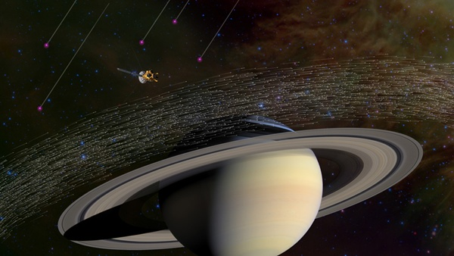 Of the millions of dust grains Cassini has sampled at Saturn, a few dozen appear to have come from beyond our solar system. Scientists believe these special grains have interstellar origins because they moved much faster and in different directions compared to dusty material native to Saturn. NASA/JPL-Caltech
Cassini has been in orbit around Saturn since 2004, studying the giant planet, its rings, and its moons. The spacecraft has also sampled millions of ice-rich dust grains with its cosmic dust analyser instrument. The vast majority of the sampled grains originate from active jets that spray from the surface of Saturn’s geologically active moon Enceladus.
However, among the myriad microscopic grains collected by Cassini, a special few - just 36 grains - stand out from the crowd. Scientists conclude these specks of material came from interstellar space - the space between the stars.
Alien dust in the solar system is not unanticipated. In the 1990s, the ESA/NASA Ulysses mission made the first in-situ observations of this material, which were later confirmed by NASA’s Galileo spacecraft. The dust was traced back to the local interstellar cloud - a nearly empty bubble of gas and dust that our solar system is travelling through with a distinct direction and speed. “From that discovery, we always hoped we would be able to detect these interstellar interlopers at Saturn with Cassini. We knew that if we looked in the right direction, we should find them,” said Nicolas Altobelli from the European Space Agency (ESA). “Indeed, on average, we have captured a few of these dust grains per year, travelling at high speed and on a specific path quite different from that of the usual icy grains we collect around Saturn.” The tiny dust grains were speeding through the Saturn system at over 72,000 km, fast enough to avoid being trapped inside the solar system by the gravity of the Sun and its planets.
“We’re thrilled Cassini could make this detection, given that our instrument was designed primarily to measure dust from within the Saturn system, as well as all the other demands on the spacecraft,” said Marcia Burton from NASA’s Jet Propulsion Laboratory in Pasadena, California. Importantly, unlike Ulysses and Galileo, Cassini was able to analyse the composition of the dust for the first time, showing it to be made of a specific mixture of minerals, not ice. The grains all had a surprisingly similar chemical make-up, containing major rock-forming elements like magnesium, silicon, iron, and calcium in average cosmic proportions. Conversely, more reactive elements like sulphur and carbon were found to be less abundant compared to their average cosmic abundance. “Cosmic dust is produced when stars die, but with the vast range of types of stars in the universe, we naturally expected to encounter a huge range of dust types over the long period of our study,” said Frank Postberg of the University of Heidelberg.
Stardust grains are found in some types of meteorites, which have preserved them since the birth of our solar system. They are generally old, pristine and diverse in their composition. However, surprisingly, the grains detected by Cassini are not like that. They have apparently been made rather uniform through some repetitive processing in the interstellar medium, the researchers said. The authors speculate on how this processing of dust might take place: Dust in a star-forming region could be destroyed and recondense multiple times as shock waves from dying stars passed through, resulting in grains like the ones Cassini observed streaming into our solar system.
By: Jet Propulsion Laboratory, Pasadena, California, ESA, Noordwijk, Netherlands

ESA finds a frigid surprise hiding at Venus' poles 19 April: Thanks to a thick layer of cloud cover trapping in heat, Venus is the hottest planet in our solar system, with temperatures boiling over at 454 degrees C. However, the European Space Agency has found something surprising at the planet’s poles: temperatures more frigid than anywhere on Earth.
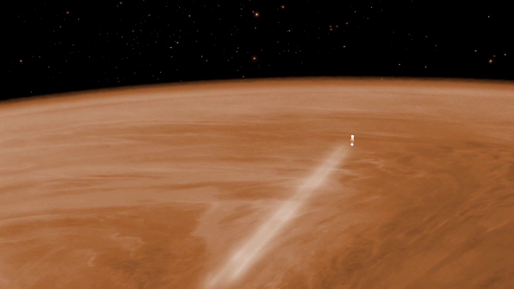 Venus Express plummeted into the planet's atmosphere in 2014. ESA - C. Carreau
Even though ESA lost contact with the Venus Express probe two years ago after it ran out of fuel, the agency is still working through the data it returned. As the first spacecraft to explore our nearest high-born since 1989’s Magellan mission, the probe revealed much about that world. Many of the observations were made through plunging the craft into the atmosphere above the poles, where the probe encountered an atmosphere thinner than previously modelled, and filled with choppy atmospheric gravity waves, ripples caused by transfers of momentum between layers in the atmosphere.
This marks the first time the poles of Venus have been directly studied, owing to Venus Express’ circumpolar orbit, which also allowed a global view. By crashing the probe through these winds on its final descent, the probe made the first ever in-situ observations of polar climates on Venus.
The Japanese Aerospace Exploration Agency has a probe in orbit around Venus called Akatsuki, but it will mostly study the climate closer to the planet’s equator, hoping to determine what caused the runaway greenhouse effect. Previous atmospheric models relied on equatorial data from the Pioneer Venus mission, which led to incorrect uniformity modelling of the atmosphere. NASA is mulling several missions as part of its Discovery program, one of which, VERITAS, will map the entire surface of the planet, and could tell us more about the geology of the poles. By: John Wenz

Mission Manager Update: Kepler recovered and returned to the K2 mission 25 April: The Kepler spacecraft has recovered from a system failure and, as of Friday, April 22, is back on the job as the K2 mission searching for exoplanets — planets beyond our solar system.
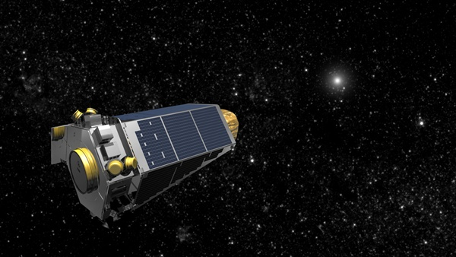 NASA
The team began the process of returning the spacecraft to science late on Tuesday 19 April. The process involved a succession of steps over the course of the next two days. The pointing tables and science targets (instructions that tell the spacecraft where to look and at what) were reloaded and confirmed; on-board logs and counters were reset; and a new command sequence was created, tested, and uploaded to account for the late start of the campaign. The spacecraft is now ready for science operations, officially starting K2's new gravitational microlensing campaign, known as Campaign 9 (C9). Gravitational microlensing occurs when a massive object bends light to amplify more distant objects.
During NASA's Deep Space Network (DSN) contact with the spacecraft yesterday, flight operations engineers at Ball Aerospace and the Laboratory for Atmospheric and Space Physics (LASP) at the University of Colorado turned the spacecraft towards the centre of the Milky Way Galaxy to start collecting data for C9. The K2 microlensing team and the ground-based observatories collaborating on C9's global experiment are searching through the collected data from the ground telescopes for possible events suitable for observations on larger telescopes, such as the 10-meter telescopes at the Keck Observatory atop Mauna Kea in Hawaii. During the three-day campaign break, beginning on 24 May, data accumulated to that point will be downlinked from the spacecraft to Earth. Shortly thereafter, the scientists will have their first chance to see K2’s view of the same events seen on the ground. The C9 observing period will conclude on 1 July, when the galactic centre is no longer in view from the vantage point of the spacecraft. K2 will then begin Campaign 10, which will proceed to investigate an entirely new set of interesting astrophysical targets.
The cause of the anomaly, first reported on 8 April, remains under investigation. The nature of the problem has indications of a transient event, which triggered a barrage of false alarms that eventually overwhelmed the system, placing Kepler in emergency mode. Power-cycling the on-board computers and subsystems appears to have cleared the problem. The scientists returned to science data collection while the investigation proceeds. By: NASA
Source of these and further astronomy news items: www.astronomy.com/news

DID YOU KNOW?
The Sun Part 2 History of scientific understanding

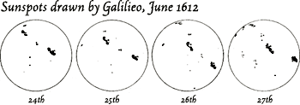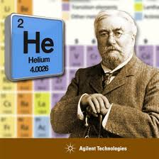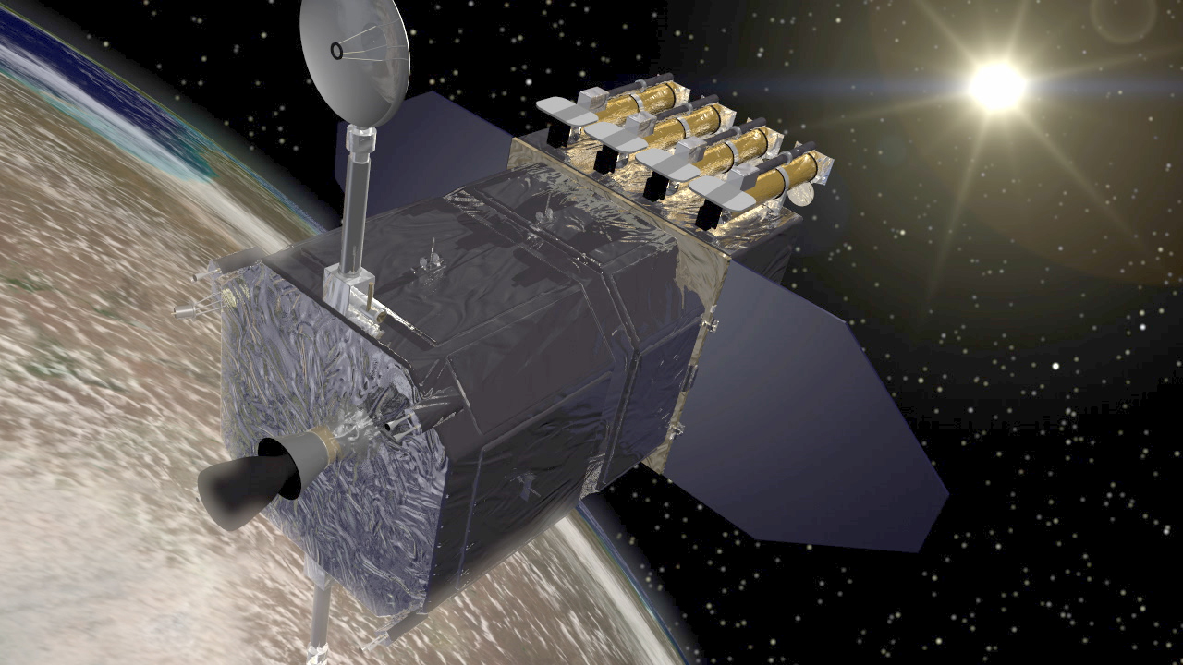

206 BCE – 220 CE First records of sunspots made in China during the Han dynasty.
12th century Averroes, an Arabic astronomer, also described sunspots.
Early 17th century Galileo, Thomas Hariot and others able to observe sunspots through telescopes. Galileo posited that they were on the surface of the Sun, not small objects passing between the Sun and Earth, as had been suggested.
1653 Christiaan Huygens first to accurately measure the distance to the Sun, but with some lucky estimates.
1666 Isaac Newton discovered that a prism breaks sunlight into component colours. Used the word 'spectrum' to describe the rainbow of colours.
1672 Giovanni Cassini and Jean Richter first to accurately determine the distance to the Sun, using the method they had developed to measure Mars's distance – parallax.
1716 Edmund Halley proposed use of a transit of Venus to measure Sun-Earth distances.
1769 Halley's transit method identified a Sun-Earth distance very close to modern values.
1800 William Herschel discovered infrared radiation.
1801 Johann Ritter discovered ultraviolet radiation.
1802 William Wollaston first noted dark features in the Sun's spectrum.
1806 Alexander von Humboldt possibly the first to record a geomagnetic storm.
1814 Joseph von Fraunhofer rediscovered the Sun's spectral lines with his newly invented spectrometer.
1843 Samuel Schwabe announced the existence of a ten year cycle of sunspot numbers.
1857 Rudolph Wolf confirmed that historic data. proved the existence of a solar cycle with an average of 11 years.
1859 Robert Bunsen and Gustav Kirchhoff invented the first spectroscope and found that the Sun contains many elements, each having a unique spectrum.
1859 Richard Carrington and Richard Hodgson independently observed the first solar flare.
1859 Strongest ever recorded geomagnetic storm - the Carrington Event.
1862 Anders Ångström confirmed that Faunhofer lines were hydrogen lines, proving the presence of hydrogen in the Sun.
1860s William and Margaret Huggins determined that stars are composed of the same elements as those found on Earth.
1866 Angelo Secchi developed the first stellar classification system.
1868 Helium discovered in the Sun independently by Pierre Jannsen and Norman Lockyerr.
1890 Edward Pickering published the first stellar catalogue using the early version of the Harvard stellar classification system.
1894 Edward Maunder published the first paper describing the prolonged low sunspot period now known as the Maunder Minimum.
1904 Ernest Rutherford suggested that the Sun's output could be maintained by an internal source of heat, potentially a result of radioactive decay.
1905 Einstein gave the essential clue to the source of S energy with his mass-energy equivalence relation E=mc².
1908 George Ellery Hale first to link the solar magnetic field with sunspots.
1914 Hertzsprung-Russell diagram published
1919 George Ellery Hale described the physical basis of the solar cycle.
1920 Arthur Eddington proposed that pressures and temperatures at the Sun's core could produce a nuclear fusion reaction that merged hydrogen into helium nuclei, resulting in energy production from the net change in mass.
1925 Cecilia Payne Goposchkin demonstrated that the spectral sequence in the Harvard classification was a sequence of temperatures. Also confirmed that the Sun consists mainly of hydrogen.
1925 George Ellery Hale proposed that the solar cycle lasts 22 years, covering two periods of increased and decreased sunspot numbers, accompanied by polar reversals of the solar magnetic field.
1938 Hans Bethe published details of the proton-proton chain reaction involved in stellar nuclear fusion.
1939 Hans Bethe published details of the carbon-nitrogen-oxygen chain reaction – the other means of fusing hydrogen into helium in stars.
1942 Stanley Hey first to detect radiowave emissions from the Sun.
1943 Morgan-Keenan stellar classification system published (an extension of the Harvard system).
1952 Harold and Horace Babcock develop the solar magnetograph and make the first ever measurements of the Sun's magnetic field.
1954 Fred Hoyle described how elements heavier than helium are produced in the Sun and other stars.
1959-1968 NASA's Pioneer 5, 6, 7, 8 and 9 the first satellites designed to observe the Sun from space.
1971 R Tousey observed the first official coronal mass ejection.
1995 Joint ESA and NASA Solar and Heliospheric Observatory (SOHO) satellite launched.
2006 NASA's Solar Terrestrial Relations Observatory (STEREO) launched.

Sources: Ridpath, I (Ed) (2012) Oxford dictionary of astronomy 2nd ed rev, www.en.wikipedia.org

For more information on the Hermanus Astronomy Centre and its activities, visit our website at www.hermanusastronomy.co.za

COMMITTEE MEMBERS
Pierre de Villiers (Chairperson, observatory, youth club) 028 313 0109
Laura Norris (Treasurer) 028 316 4453
Peter Harvey (Secretary, monthly sky maps) 028 316 3486
Jenny Morris (Vice-chairperson, newsletter) 071 350 5560
Karin de Bruin (Observing) 028 316 2080
Derek Duckitt (Website editor) 082 414 4024
Bennie Kotze (Outreach co-ordinator) 128 316 3666
Deon Krige (Youth robotics project, astro-photography) 028 314 1045
John Saunders (Guest speakers and events) tibouchina286@gmail.com
Non-committee members with roles:
Pierre Hugo (Cosmology interest group) 028 312 1639
Johan Retief (Hawston School Youth Club) 028 315 1132

