Mars exploration series

Mission: Mars Part 1 The quest begins

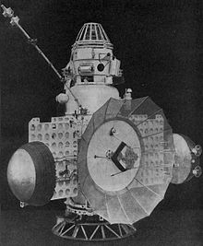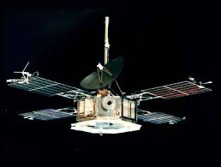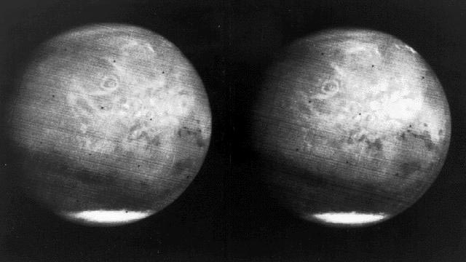
Zond 2 – lost com- Mariner 3 Mariner 7 – images of Mars
munication with Earth

Although Venus is closer to Earth than Mars, its hostile environment means that man’s interest in other rocky planets in the Solar System has focussed almost entirely on the Red Planet. However, exploring it has proved to be very challenging. Of the 55 missions to Mars, so far, the first of which took place in the 1960, only 26 (48%) have been successful. Failures have occurred at launch, during the 228 million kilometre journey, and on reaching the planet. However, despite these setbacks and the adverse statistics, the desire to learn more about Mars has not waned. In fact, it has increased, an impetus both fostering and fostered by a strengthening interest in the possibility of human colonisation of the planet. At the end of 2014, there were two functioning scientific rovers on the surface seeking evidence on Mars’s current make-up and its past, and five orbiters surveying various aspects of the planet and its atmosphere.

The race begins…
The Soviets were the first to send probes to Mars. However, during the decade of the 1960s, all nine attempts failed. Three failed at launch, three failed to reach near-Earth orbit, one failed during the procedure to place the probe into Mars trajectory, and two failed during inter-planetary orbit. These failures reflected the many technological weaknesses of the early stages of space exploration.

The first Soviet probes, named 1960A and 1960B by NASA, were launched in 1960. Both only reached the edge of the atmosphere at 120 km altitude and failed to reach Earth orbit before falling back towards Earth. Similarly, in 1962, Mars 1962A and 1962B proved to lack the thrust or physical strength to make the move into Earth orbit or escape the strength of Earth’s gravity. The Mars 1 probe, launched in late 1962, was the first to reach interplanetary orbit. It was a flyby mission designed to take photographs of the Martian surface and also to take measurements of a range of factors within its atmosphere. Initially, communications worked well, but they stopped when the craft was about half way to Mars. In 1965, one later probe (Zond 2) also lost communication with Earth while en route to Mars. The remaining three missions (Zond 1 in 1964, 1969A and 1969B) all failed during launch, the latter associated with complications arising from use of a newly developed rocket.

The Americans were not idle during this decade. In fact, the Mariner 2 probe was the first to succeed in a flyby mission when it flew past Venus in late 1962, and their early missions to Mars were much more successful than those of the Soviets. Their first attempt to reach Mars, in late 1964, was with Mariner 3. Its technical failure, when its solar panels did not open, was compensated for, however, by Mariner 4 which was launched 3 weeks later. After a 7½ month journey, from an altitude of about 10,000 km, it became the first spacecraft to provide close-up photographs of another planet, identifying the presence of impact craters. It also sent back information about atmospheric constituents (mostly CO₂), pressure and temperature, and the apparent absence of a magnetic field. This data was important both in existing design for Martian landers, and an early indicator of the small likelihood of life surviving on the red planet.

NASA followed its success with Mariner 4 with the first dual mission to Mars of Mariners 6 and 7 in 1969. During approach they photographed about 20% of the planet’s surface, confirming that the supposed canals on Mars were not present. Both craft also studied various aspects of the atmosphere of Mars.

Sources: Ridpath, I (Ed) (2012) Oxford dictionary of astronomy 2nd ed, revised, www.en.wikipedia.org, www.planetary.org, www.nasa.org, www.space.com, www.computerworld.com, www.astrobio.net

Mission: Mars Part 2 Into Mars orbit

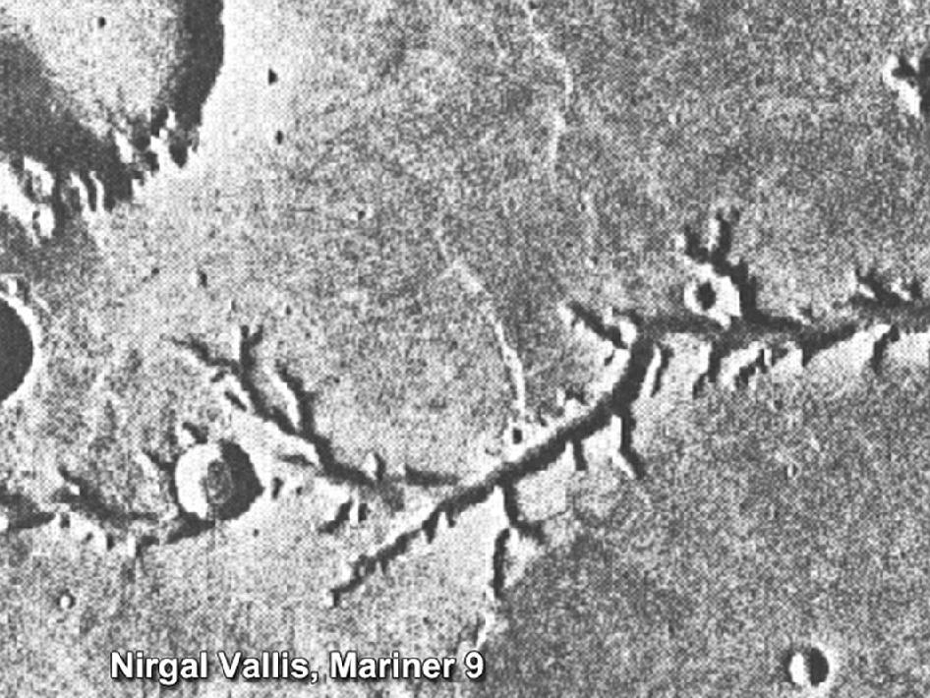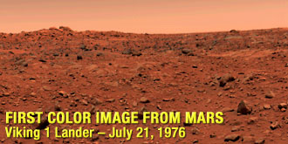
Mariner 9 – water channels

In late 1971, NASA’s Mariner 9 became the first spacecraft to enter into orbit around another planet. This achievement only just beat the ongoing attempts by the Soviets to be the first to place an artificial satellite into orbit round Mars. Also launched successfully in May 1971, the Soviet Mars 2 and Mars 3 craft, both containing an orbiter and lander, reached Mars at around the same time as Mariner 9. All three probes were greeted by a planet-wide dust storm which delayed their planned activities. Mariner 9 was redirected to take photographs of Phobos, one of Mars’s two moons. The photographs it later took of Mars were of much higher quality than those sent back by earlier Mariner probes. They included evidence that water might have flowed on Mars in the past. They also provided improved detail on a number of Martian features including the fact that volcanic Olympus Mons is the highest mountain on any planet in the Solar System.

However, although they lost the race to place a probe in Martian obit, the Soviets beat the Americans with other firsts. In 1971, when it crash landed after a technical malfunction, the Mars 2 lander became the first man-made object to touch the surface of Mars. Less accidentally, also in 1971, the Mars 3 lander became the first spacecraft to achieve a soft landing on another planet. Despite the fact that communications only survived for a few seconds, it was able to relay 20 seconds of video data to its orbiter. Both orbiters continued to return data on the Martian environment for another year.

In 1973, the Soviets sent 4 more probes to Mars. The Mars 4 and 5 orbiters further increased the data being collected about the planet, despite Mars 4 missing Martian orbit after a braking failure. Mars 6 and 7 were each combined orbiters and landers. Although the former did send back orbiting data, the lander crashed, and a technical problem meant that Mars 7 missed Mars by a few hundred kilometres.

The only other launches during the 1970s were made by NASA as part of the brief Viking programme. It consisted of just two missions, both orbiter-lander combinations sent to Mars in 1975. The most expensive and ambitious mission ever sent to Mars, both missions were very successful. The photographs of the planet’s surface sent back by the orbiters and the information sent back about the nature of the planet by the landers, including detailed colour panoramic views, formed the majority of the knowledge of the red planet for more than the next two decades. Orbiter images revealed that, in the past, water had carved deep valleys and travelled across extensive flood plains. The results of the biological tests undertaken, among several others, by the landers were inconclusive at the time. However, reanalysis in 2012 controversially suggested the presence of microbial life on Mars.

The Viking programme proved to include the last missions to Mars for two decades. The exception was the Phobos programme, a Soviet programme of the late 1980s. In 1988, the Phobos spacecraft were launched. Phobos 1 suffered a technical failure en route which led to depletion of the solar powered batteries and communication was lost. In contrast, Phobos 2 gained Mars orbit early in 1989, gathering information on Mars, Phobos, the Sun and the interplanetary medium. However, am on-board computer malfunction cut communications and the scheduled deployment of 2 landers onto the planet’s surface did not take place.

Sources: Ridpath, I (Ed) (2012) Oxford dictionary of astronomy 2nd ed, revised, www.en.wikipedia.org, www.planetary.org, www.nasa.org, www.space.com, www.computerworld.com, www.astrobio.net

Mission: Mars Part 3 Mars Renaissance

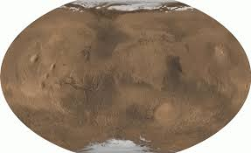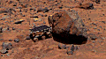
MGS – combined image of Mars Pathfinder – Aojourner at work

Renewed interest in Mars from the early 1990s led to the launch of a number of missions, mostly undertaken by NASA. Although there have been more successes than failures than there were before 1990, over a third of missions have failed, most during the 1990s. This demonstrates that, despite knowledge gained from several decades of space exploration and huge advances in technology, exploring Mars continues to be a huge challenge, particularly as the scope and complexity of missions increase. The focus of probes launched since the 1990s has been primarily on understanding the planet’s geology and history with a view to it potential for human habitation.

The new era in Mars exploration did not start well when, in 1992, NASA launched the orbiter Mars Observer. The mission ended prematurely eleven months later when contact with the spacecraft was lost just before insertion into orbit. There were also later failures. In 1996, the Russian craft Mars 96 suffered a launch failure. Lift-off was successful, but a technical error on entry to Earth orbit resulted in the craft tumbling into the Pacific Ocean off Chile. The Japanese Nozomi (Planet-B) Mars orbiter, launched in 1998, was to be the first Japanese spacecraft to reach another planet. Unfortunately, in 2003, when nearing Mars, it experienced technical complications, communication was lost and it never entered orbit. Also, in 1998, NASA experienced its most embarrassing failure when the Mars Climate Orbiter crashed onto the surface of the planet due to a mix-up between imperial and metric measurements during construction. Finally, in 1999, NASA’s Mars Polar Lander and its two included Deep Space 2 impact probes also crashed onto the planet’s surface, this time as a result of faulty software.

In contrast, the decade also saw the launch of two very successful missions, both NASA missions launched in 1996. Work on the Mars Global Surveyor (MGS) probe was informed by lessons learned from the failed Mars Observer. After a journey of longer than ten months, MGS entered orbit in September 1997. It took over 18 month’s of orbit trimming from an ellipse to a circular track around the planet before the spacecraft could begin its primary mapping mission. For the whole of the Martian year (almost two Earth years), it observed Mars from a low-altitude nearly polar obit. During that time, it studied the whole Martian surface, atmosphere and interior, returning more data about the planet than all previous Mars missions combined. It completed this mission in 2001, but continued with others until operations were stopped in 2006.

Its key findings included images of gullies and debris flow features which suggest that there may be current sources of liquid water, possibly an aquifer, at or near the surface of the planet. Although the low temperatures and thin atmosphere on Mars are unlikely to sustain liquid water, it has been hypothesised that, at times, the sub-surface water can emerge onto the surface, creating the gullies and channels before freezing or evaporating. MGS also identified that Mars’s magnetic field is localised in certain areas of crust and not globally generated in the planet’s core. Contact with the probe was lost in 2006, and efforts to restore communications ended a couple of month’s later.

Although launched after MGS, the Mars Pathfinder (MPF) took just over seven months to reach Mars and reached the red planet ahead of the orbiter. The lander and its roving probe landed on Mars on 4 July 1997. The small 10.5 kg 6-wheeled rover Sojourner was the first rover to operate on the surface of Mars. During the three months of its operation, Sojourner sampled and analysed the composition of Martian rocks. In addition to its scientific objectives, it also tested various designs and technologies involved in landing, steering and operation of a rover. Knowledge gained during this mission was central in the design and deployment of later Mars rovers. Daily communications with the lander and rover were stopped in November, 1997.

Sources: Ridpath, I (Ed) (2012) Oxford dictionary of astronomy 2nd ed, revised, www.en.wikipedia.org, www.planetary.org, www.nasa.org, www.space.com, www.computerworld.com, www.astrobio.net

Mission: Mars Part 4 The new millennium

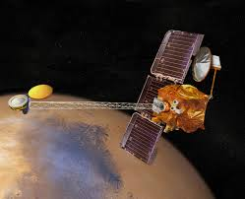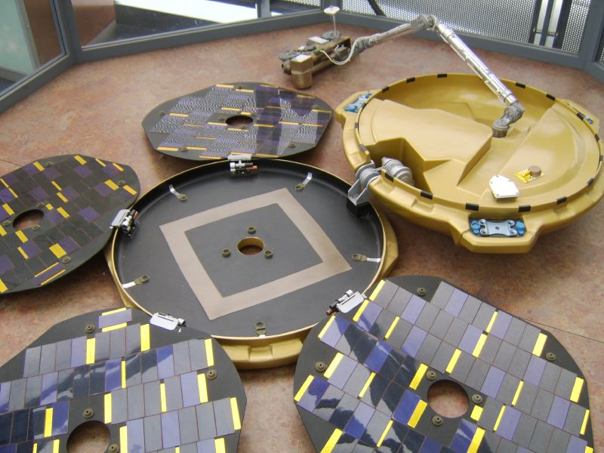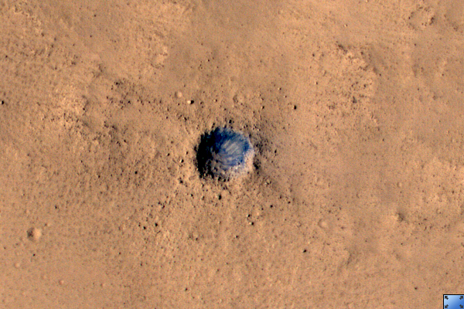
Mars Odyssey – conceptrual image Beagle 2 B2 wreckage

The early part of the twenty-first century has seen the successful launch of a number of missions, several still operational after a number of years. There were some failures, but the proportion has dropped.

The new century began well for Mars exploration with the launch, in 2001, of NASA’s orbiter 2001 Mars Odyssey (named in tribute to author Arthur C Clarke). Rather than needing a heavy fuel load to use its engines and thrusters to bring the craft into Mars orbit, a technique of ‘aerobraking’ was employed. As used previously in 1997 with Mars Global Surveyor, this procedure uses a planet’s atmospheric drag to gradually slow down the spacecraft into its correct orbit. Aerobraking has continued to be used during subsequent missions to reduce the fuel load and mass of spacecraft.

While following a polar orbit, which means it passes over most points of Mars’ surface twice a day, Odyssey’s three main instruments sought information on past or present water as well as volcanic activity on Mars. A Thermal Emission Imaging System mapped surface mineralogy, a Gamma Ray Spectrometer analysed surface chemistry and the Mars Radiation Environment Experiment assessed the radiation risk to possible future human explorers. In 2002, it was announced that the equipment had detected significant amounts of hydrogen, indicating that there are vast deposits of water ice in the upper 3m of Mars’ soil.

In 2010, Odyssey broke the record for the longest serving spacecraft at the red planet, passing that established by Mars Global Surveyor. It continues to observe Mars, identifying annual differences in phenomena like polar ice, clouds and dust storms in addition to continuing to map Martian minerals. The orbiter contains enough propellant to function for several more years.

It also has another crucial function, that of primary communication relay. Odyssey facilitated the success of the Phoenix Lander and the Mars Exploration Rover Spirit and still supports the ongoing operation of two surface explorers, the Mars Exploration Rover (Opportunity) and Curiosity (Mars Science Laboratory). In addition to transmitting images and other data from the rovers to Earth, it helped analyse potential landing sights for all these landers by monitoring atmospheric conditions during the months when the spacecraft were slowly being moved towards their final orbit.

Another successful mission early in the 2000s was also designed to study Mars’ atmosphere and geology. The European Space Agency’s (ESA) Mars Express mission was launched in 2003. This was the ESA’s first planetary mission. Like Odyssey, it continues to be operational. The multi-functional spacecraft carries several pieces of equipment including a high-resolution stereoscopic camera to image the entire planet in full colour and in 3D at a 10m resolution, a visible and infrared mineralogical spectrometer to map the surface composition, two spectrometers to analyse the composition and structure of the Martian atmosphere, a sensor for neutral and charged particles to study the interaction of the outer atmosphere with the solar wind, and a radar to probe the upper 2-3 km of the crust.

While NASA’s Odyssey had identified the presence of water ice and carbon dioxide at Mars’ north pole, Mars Express confirmed the same for the south pole. Also in 2004, one of the spectrometers detected methane in the Martian atmosphere. This is of great interest to scientist as it suggests a source of the organic compound on the planet, one possibility being microbial life. A later tentative discovery of atmospheric ammonia further strengthens the possibility of life on the red planet. Express equipment also identified the discovery of aurorae on Mars in 2006. Mars Express assisted NASA orbiters in data collection and relay during the 2012 landing of the Mars Science Laboratory (Curiosity rover).

Soon after reaching its final orbit, Mars Express released the Beagle 2 lander which was scheduled to make its first communication with Earth on Christmas Day, 2003. Although not designed to rove, it had a robotic which carried a range of devices to accurately analyse soil beneath Mar’s dusty surface. These included a digging tool and the smallest mass spectrometer built to date. However, nothing was heard from the lander and, in February 2004, it was formally declared lost. Unexpectedly, it was located eleven years later in early 2015 by a camera on NASA’s Mars Reconnaissance Orbiter. The image identified that Beagle 2 landed safely, but failed to fully deploy its solar panels and antenna. Its mission is now regarded as partially successful

Sources: Ridpath, I (Ed) (2012) Oxford dictionary of astronomy 2nd ed, revised, www.en.wikipedia.org, www.planetary.org, www.nasa.org, www.space.com, www.computerworld.com, www.astrobio.net

Mission: Mars Part 5 Roving on Mars – 1

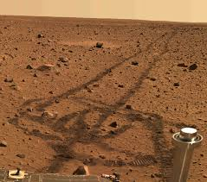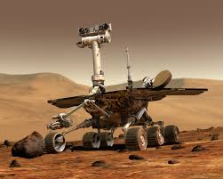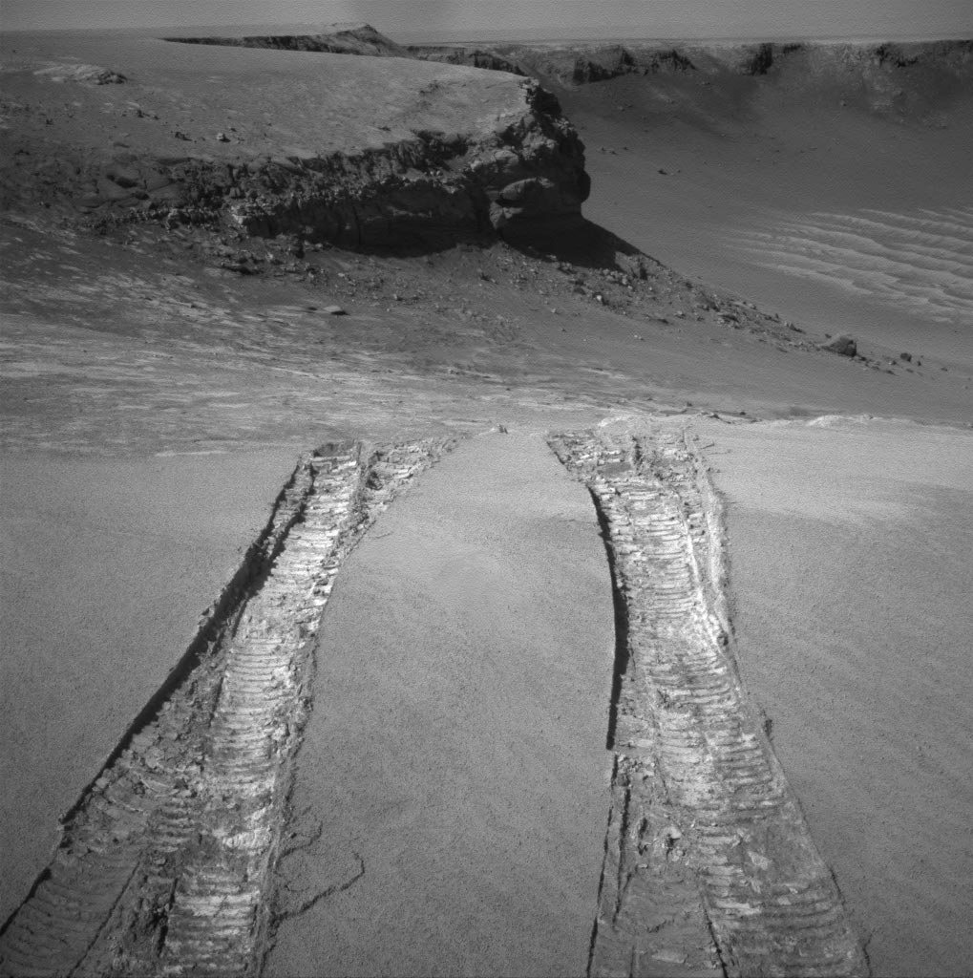
Spirit rover tracks Opportunity rover – aartist’s impression of Mars background Curiosity image of its tracks through soft sand

In addition to the successful launch of two Mars orbiters, 2003 also saw the launch of two pioneering surface rovers. As part of the NASA’s ongoing Mars Exploration Rover mission (MER), two identical rovers were launched three months apart. Spirit (MER-A) and Opportunity (MER-B) landed on opposite sides of the planet’s equatorial regions to explore the surface and geology of the surrounding areas. The mission’s objective was to search and identify the characteristics of a wide range of rocks and soils that hold clues to past water activity on Mars. MER is part of a larger Mars Explorer Programme which also included the earlier two Viking landers and Mars Pathfinder probe.

The six-wheeled solar-powered rovers are 1.5 x 2.3 x 1.6m in diameter and weigh 180 kg each. They carry various scientific instruments including a panoramic camera to determine the texture, colour, mineralogy and structure of the local terrain, a microscopic imager to obtain close-up high-resolution images of rocks and soil, a rock abrasion tool for grinding away the weathered surfaces to expose their interiors, and instruments, including magnets and spectrometers, to analyse selected rocks.

In 2004, NASA announced that the rovers had found strong geological and chemical evidence of past liquid water on the Martian surface. This was confirmed by ongoing travel and analysis as the rovers investigated different areas of the surface. In addition to providing substantial evidence for past water activity on Mars, Opportunity has also obtained astronomical observations and atmospheric data. Overall, too, their search has provided scientists which much new information on the general geology of Mars.

The rovers were initially funded for 3 months, but their success resulted in repeated, ever longer mission extensions, enabling them to reach and study a variety of landforms and surfaces, despite challenges from the terrain, weather and seasonal temperature extremes. In July 2007, huge dust storms blocked sunlight to the rovers’ solar panels, leading to a fear of permanent disablement of one or both. However, after the storms stopped, operations were able to resume. The MER mission is still operational, despite the loss of function of Spirit. In May 2009, Spirit became stuck in soft sand. Nine months of work failed to free it and, in January 2010, it was designated a stationary science platform. However, communication with Spirit was lost in March 2010. Attempts to re-establish contact were unsuccessful and formally ceased in May 2011. Spirit’s mission lasted 6 years 2 months 19 days, 25 times longer than the planned mission duration. It is believed that the rover probably lost power due to excessively cold internal temperatures.

Each rover was designed with a mission driving distance goal of only 600m. By January 2009 they had, together, travelled over 21 km and sent back over 250,000 images. By July 2014, Opportunity had driven further that any other vehicle on a world other than Earth: 40 km, surpassing the 39 km record distance travelled by the Soviet Lunokhoud 2 lunar rover.

In January 2014, NASA announced that the duties of Opportunity and more recent Curiosity (Mars Science \Laboratory mission) have been extended to use their wide range of instruments to search for evidence of ancient life. In recognition of the vast amount of scientific information collected by the rovers, two asteroids have been named in their honour.

Sources: Ridpath, I (Ed) (2012) Oxford dictionary of astronomy 2nd ed, revised, www.en.wikipedia.org, www.planetary.org, www.nasa.org, www.space.com, www.computerworld.com, www.astrobio.net

Mission: Mars Part 6 More flying visitors

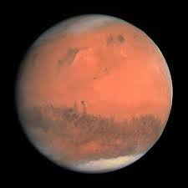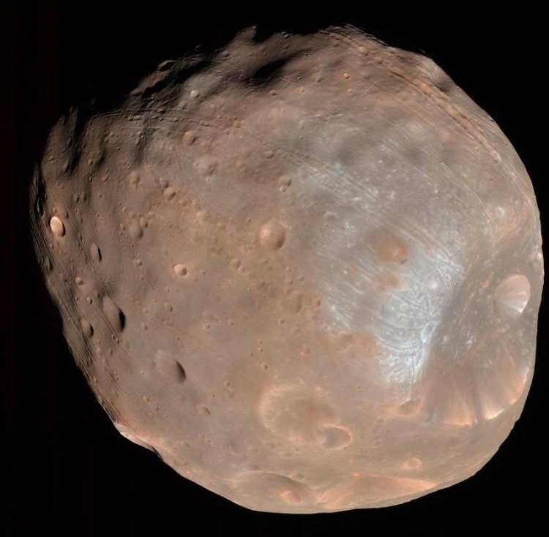
Mars seen by Rosetta Phobos by MRO MRO – crater detail

Spacecraft heading to objects further out in the Solar System have also passed closed by Mars. ESA’s Rosetta was launched in 2004. On its ten year journey to reach and land on a comet, it underwent four gravity assists, three from Earth and, in 2007, one from Mars. During the technically challenging low altitude sling-by, Rosetta’s camera took a number of detailed images of the red planet’s surface and atmosphere from an altitude of only 250 km.

Similarly, the Dawn probe, launched by NASA in 2007, also used Mars’ gravity to assist it to change direction and velocity on its journey to visit the asteroids Vesta and Ceres. The slingshot manoeuvre in 2009 enlarged the spacecraft’s elliptical orbit and boosted its speed by more than 9,300 km/hr, an outcome essential to its ability reach the asteroid belt. While passing Mars at a distance of 550 km from the surface, it did a little science in conjunction with the probes already in orbit around the planet. Although the main purpose of this was to test Dawn’s scientific instruments, it also added something to what is being learned about the Red Planet.

One other orbiting spacecraft was sent to study Mars during the 2000s. The multi-purpose Mars Reconnaissance Orbiter (MRO) was launched in 2005, with aerobraking used over several months to place it in its correct polar orbit. It joined five other spacecraft then investigating Mars, three orbiters and two rovers, a record number. Like the other NASA orbiter launched during that decade, it is still operational, despite operations initially being scheduled to last for only two years.

The MRO mission has objectives similar to those of its predecessor Mars Odyssey. They are to look for evidence of past or present water, to study Martian weather and climate, and to identify landing sites for future missions. The craft carries a number of instruments including a wide-angle camera, a stereo imaging camera capable of resolving images as small as 0.2 m across, a camera to monitor cloud and dust storms, a visible/near-infrared spectrometer to examine the surface composition, an infrared radiometer to study the atmosphere, an accelerometer, and a shallow subsurface sounding radar to search for underground water. Like Mars Odyssey and Mars Express it also serves as a telecommunication relay link for other missions. Data transfer to and from the spacecraft takes place faster than all previous interplanetary missions combined.

Important findings by MRO include banded terrain which indicates the presence and action of liquid carbon dioxide or water on Mars’ surface in its recent geological past. In 2009, radar measurements of the north polar ice cap determined that the volume of water ice is about 30% of that of Greenland’s ice sheet. Water ice has also been found under the surface soil in several craters. MRO data also helped confirm findings by earlier orbiters that there are widespread deposits of chloride mineral present. As chlorides are usually the last minerals to come out of solution, this strengthens the evidence the previous presence of water. These deposits could also have once held various lifeforms and may preserve traces of ancient life on Mars. The spacecraft also provides a daily weather report on Mars, data which helps identify seasonal and annual variations as well as the proportions of water vapour, and ozone in the atmosphere.

MRO did not just photograph natural features. In 2009, one of its earliest detailed image was of the Opportunity rover on the rim above a crater, and, in 2012, it photographed the Curiosity rover as it made its descent onto the Martian surface. In addition, it was MRO which, in early 2015, photographed the missing Beagle 2 lander which had been lost for twelve years.

Sources: Ridpath, I (Ed) (2012) Oxford dictionary of astronomy 2nd ed, revised, www.en.wikipedia.org, www.planetary.org, www.nasa.org, www.space.com, www.computerworld.com, www.astrobio.net

Mission: Mars Part 7 Roving on Mars – 2

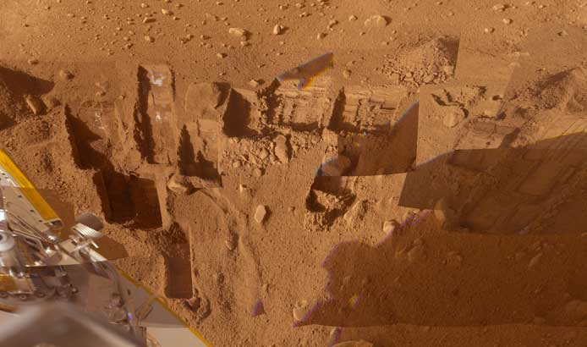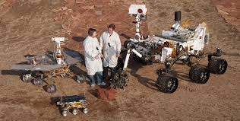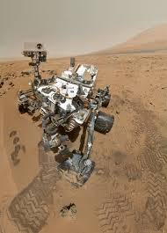
Phoenix lander – image of areas of digging Size comparison – Sojourner (front), Spirit/Opportunity (left) andcuriosity (right) Curiosity self-portrait

In 2008, the rovers Spirit and Opportunity were joined on Mars by another NASA vehicle for six months. Launched nine months earlier in 2007, the Phoenix static lander would investigate the icy north polar region of Mars. The two objectives were to study the geological history of the ice to unlock the history of past climate change, and to evaluate past and potential planetary habitability in the ice-soil boundary. Its robotic arm scooped up samples of soil and ice for analysis by instruments aboard the lander. Phoenix was the first Mars mission to return data directly from either pole.

The Surface Stereo Imager camera photographed the surrounding landscape, while a set of meteorological instruments recorded temperature, pressure and other atmospheric conditions. In July 2008, NASA announcement that Phoenix confirmed the presence of sub-surface water on Mars, as Odyssey’s data had suggested. In addition to showing that the rocks in polar areas appear to be small, Phoenix also observed snowfall from cirrus clouds. Temperatures meant that the clouds would have to be composed of water ice, as opposed to dry carbon dioxide ice. An important conclusion is that water ice snow accumulates in the polar regions, an important finding regarding Martian weather.

The lander managed to successfully complete its mission before the rigours of the Martian polar winter seem to have ‘killed’ it. Communication could not be re-established during the following Martian summer and, unlike the other NASA missions of this and the following decade, Phoenix did not survive more than a couple of months beyond its scheduled lifespan.

In contrast to the US success with the Phoenix mission, the Russian-Chinese Phobos-Grunt mission launched in late 2011 only reached low Earth orbit before a complete systems failure resulted in remaining stranded until if later fell back to Earth in a destructive re-entry in early 2012. The 2-part mission had planned to land a Russian probe on moon Phobos and return samples to Earth and also launch the Chinese orbiter Ynghou-1.

In 2011, NASA launched the Mars Science Laboratory mission and successfully landed the rover Curiosity on the Martian surface. The most accurate and complex landing (using parachutes and powered descent rather than airbags) ever was achieved onto a very small target. The six-wheeled rover is the largest ever sent to Mars, with a mass of 900 kg and the ability to travel up to 90m per hour. It carries a variety of instruments designed to look for past or present conditions relevant to past or future habitability on the red planet, particularly investigating whether Mars has or had an environment able to support microbial life. A dozen main instruments consist of cameras, spectrometers, environmental detectors and small sample analysis laboratories.

Curiosity has achieved its main mission: it has shown that Mars could have once sustained life. By drilling into Martian rocks it discovered carbon, hydrogen, oxygen, phosphorus and sulphur, the key ingredients for life. More recently, it also discovered organic molecules, particularly methane. The methane levels were much lower than atmospheric levels, and quickly diminished, suggesting a localised source. The presence of methane does not prove the existence of biological life as it is also a product of non-biological processes, but it adds to the existing suggestive evidence.

Other minerals found also confirm the past presence of liquid water with constituents positive for living organisms to survive. In addition to identifying a wide variety of soil and rocks, it also found further geological evidence of water flows on the planet’s surface. The findings of levels of radiation dangerous for humans will require careful design of future manned spacecraft and spacesuits.

In late 2012, Curiosity’s two year mission was extended indefinitely. Further findings may help confirm the theory that, at the same time as like began on Earth, Mars had the same conditions: liquid water, a warm environment and organic matter.

Sources: Ridpath, I (Ed) (2012) Oxford dictionary of astronomy 2nd ed, revised, www.en.wikipedia.org, www.planetary.org, www.nasa.org, www.space.com, www.computerworld.com, www.astrobio.net

Mission: Mars Part 8 Other nations join the quest

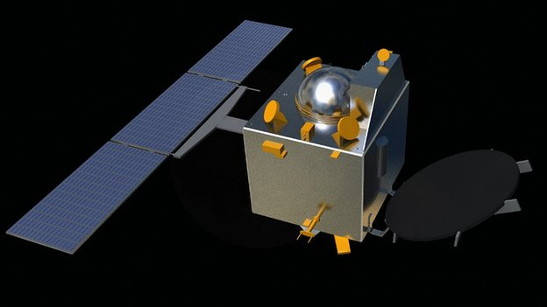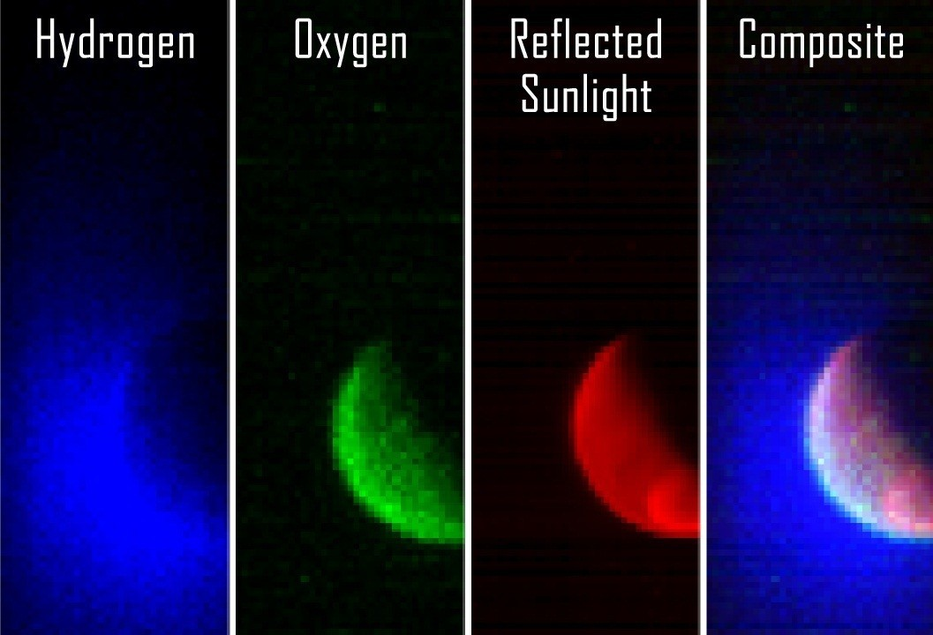
India joins the space nations Mars Orbiter MAVEN analyses of Martian atmosphere

The 2010s has been the decade when countries other than Russia, the United States and those in Western Europe have joined the quest to explore Mars. Although the 2011 Phobos-Grunt mission was a failure, it marked the entry of China.

India’s first foray into space exploration has proved to be much more successful. The Mars Orbiter mission (aka Mangalyaan) was launched late in 2013. Almost eleven months later the spacecraft successfully entered Mars orbit in September 2014. For the Indian Space Research Organisation (ISRO), their first mission to Mars is largely a technological demonstration of their claim to be the fourth space agency to successfully reach the red planet after the USSR, NASA and the ESA. However, the small 15 kg probe also has scientific objectives to study the Martian atmosphere. The success of the Mars Orbiter mission, made India the first country to reach Mars on its first attempt, and the first Asian country to successfully send an orbiter to Mars.

The science objective is being fulfilled by five instruments which investigate the morphology and mineralogy of the Martian surface, and several atmospheric parameters and constituents. Three instruments focus on the atmosphere: a methane sensor, a photometer which measures gas concentrations in the upper atmosphere, allowing for estimation of the amount of water loss to space undertake the atmospheric studies, and an atmospheric composition analyser which tests the atmosphere’s particle composition. The thermal infrared imaging spectrometer and a colour camera study the surface. The spectrometer measures the temperature and chemical emissions, enabling identification of the surface composition and mineralogy. The colour camera has the umbrella role of providing visual images to give the context for the spectrometer’s work.

The successful launch of MAVEN (Mars Atmospheric and Volatile EvolutioN) by NASA in 2013 means that there are currently two rovers and five orbiters either on or orbiting Mars, As its full name implies, the MAVEN orbiter’s mission is to undertake a detailed study of the atmosphere of Mars to help understand both current and past dramatic climate changes. Like other NASA orbiters, it also serves as a communication relay satellite for the robotic rovers on the surface. MAVEN was launched a couple of weeks after India’s orbiter, reaching its final orbit within days of the latter. Its elliptical orbit means that its altitude above Mars varies between 6,200 km and as close as 150 km.

Findings from other missions have provided strong evidence that Mars once had a dense enough atmosphere and was warm enough for liquid water to flow on its surface. However, somehow, that thick atmosphere has been lost to space. It is hypothesised that, over millions of years, Mars lost 99% of its atmosphere as the planet’s core cooled and its magnetic field decayed, allowing the solar wind to sweep away most of the water vapour and other gases in the atmosphere. MAVEN’s goal is to determine the history of the loss of atmospheric gases to space, thus providing answers about Mars’ climate evolution. Measurements of the current rate of loss will enable scientists to make inference on past processes. To this end, it is studying Mars’ upper atmosphere and its interactions with the solar wind.

During its one year mission MAVEN is not working alone. Data from the Curiosity rover’s Sample Analysis at Mars (SAM) instruments helps guide interpretation of the orbiter’s upper atmospheric measurements which are being made by eight main instruments.

Sources: Ridpath, I (Ed) (2012) Oxford dictionary of astronomy 2nd ed, revised, www.en.wikipedia.org, www.planetary.org, www.nasa.org, www.space.com, www.computerworld.com, www.astrobio.net

Mission: Mars Part 9 Future missions

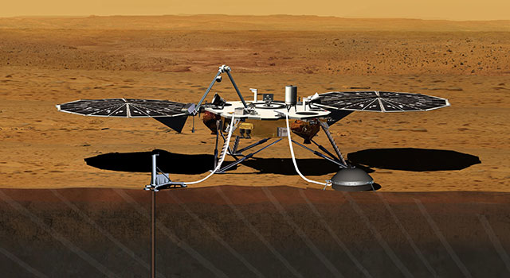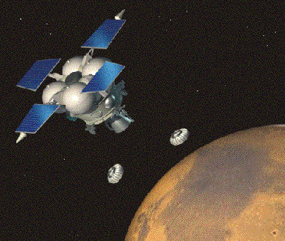
Insight lander – artist’s conception MetNet mission

Despite the roughly 60% failure rate, robotic exploration of Mars during the past 55 years has proved increasingly successful and has yielded information of increasing breadth and depth in line with the ever larger number of probe launches and associated huge technological advances. At first, exploration of Mars was a largely cerebral undertaking to learn more about the red planet. However, with time, the focus of the multi-national search for knowledge of Mars and its atmosphere has become mainly one of understanding its characteristics with a view to its potential for human habitability.

Seven orbiters and rovers are currently adding to the every-growing knowledge and understanding of Mars. They are not an end in themselves, but part of a continuing quest to explore the red planet. In addition to searching for evidence of past life, and the potential of Mars for future habitation, one technological goal of planetary discovery also remains to be achieved The only attempt, so far, to successfully return sample collected on Mars back to Earth was Russia’s Phobos-Grunt mission and that failed during launch.

A number of missions to Mars are in the pipeline. They include:
- The Finnish-Russian MetNet atmospheric science mission is planned for 2015-2016. It will use at least 16 small meteorological stations on Mars to establish a widespread observation network investigating the planet’s atmospheric structure, physics and meteorology.
- InSight (Interior exploration using Seismic Investigations Geodesy and Heat Transport) is scheduled for launch in 2016. The NASA lander will carry a drill and seismometer in order to determine the deep interior structure of Mars.
- As part of the ExoMars programme, ESA and the Russian Space Agency have two missions planned. The Trace Gas Orbiter and Schiaparelli lander are scheduled for launch in 2016, and the goal of the ExoMars rover, scheduled for launch in 2018, is to search for past or present microscopic life on Mars.
- The Indian space agency is planning a follow up to the Mars Orbiter mission. Sometime between 2018 and 2020, the launch of Mangalyaan 2 is scheduled to take place. Rather than the current orbiter-only, a greater payload including a lander and rover is planned.
- China unveiled a prototype rover based on its lunar rover Yutu in 2014. A mission to Mars with an orbiter, lander and the rover to be launched before 2020 has been announced.
- Mars 2020 is a planned astrobiology mission by NASA involving a rover based on Curiosity.
- United Arab Emirates Space Agency has announced that its first mission will be to send a robotic mission to Mars by 2021.
- The Russian Mars-Grunt mission, planned for the mid-2020s, will be the second attempt to bring a sample of Martian soil to Earth.
- An ESA-NASA team is also proposing Mars sample return mission by the early 2020s. The 3-part concept would use an orbiter to launch the lander, a rover to collect samples, and an ascent vehicle to return the sample to the orbiter, which would then return to Earth.

The first manned mission to Mars is foreseen to take place within the next two decades.

Sources: Ridpath, I (Ed) (2012) Oxford dictionary of astronomy 2nd ed, revised, www.en.wikipedia.org, www.planetary.org, www.nasa.org, www.space.com, www.computerworld.com, www.astrobio.net

