THE FISHERHAVEN ASTRONOMER
A TRANSIT OF MERCURY
On Monday, 9 May 2016, the smallest planet in our solar system, Mercury, will transit the face of the Sun. This occurrence will be visible from South Africa provided that one watches the event with the help of a solar telescope or with a telescope fitted with a proper solar filter. The planet is visible as a tiny black dot against the face of the Sun. This specific transit commences with the planet crossing the edge of the Sun at approximately 13h15 as seen from Fisherhaven.
Transits of the Sun by the two inner planets, Mercury and Venus, are rare planetary events. Transits by Mercury take place in May or November, intervals between a November transit to the next November transit may be 7, 13 or 33 years, with the transit occurring close to 10 November. Transits in May are less frequent, the interval between subsequent May transits being 13 or 33 years, with the transit occurring close to 8 May. The next transit of Mercury will take place on 11 November 2019.
The diagram on the right is copied from the Sky Guide Africa South (SGAS) and shows the planet relative to the face for the Sun. A is the point at which the planet commences the transit (the point of ingress). B shows the planet at the point where it is closest to the centre of the Sun.  The times of the event on 9 May are as follows:  • Ingress (A) takes place at 13h15, with the Sun at an altitude of 37½º above the horizon.  • Minimum separation from the solar centre (B) takes place at 16h57, with the Sun at an altitude of approximately 10º above the WNW horizon. | 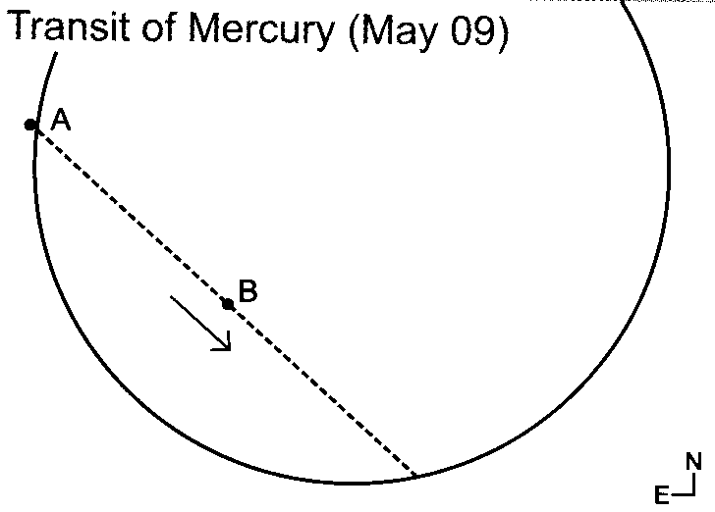
• The planet will leave the face of the Sun (the point of egress) at approximately 20h40, well after sunset which is at 17h54.
Only the two inner planets (Mercury and Venus) can be seen to transit the Sun from the Earth. If we were to be on Mars, a transit of the Earth would of course theoretically be visible.
Transits by Venus occur very rarely and when they do occur they do so in pairs with two transits, with pairs of transits eight years apart separated by long gaps of 121.5 years and 105.5 years (The pattern repeats every 243 years). The last pair of transits took place in June 2004 and June 2012, these were the last Venus transits in the 21st century. The next pair of Venus transits will be in December 2117 and December 2125.
Venus, being considerably larger than Mercury (its angular diameter being nearly 9 x that of Mercury) and also considerably closer to Earth, provides for a much more spectacular transit than in the case of Mercury.
WARNING: NEVER LOOK AT THE SUN WITH YOUR NAKED EYES

Compiled by Johan Retief with information from various sources, amongst others the Sky Guide Africa South issued annually by the Astronomical Society of Southern Africa and Wikipedia.

