“The Southern Cross”

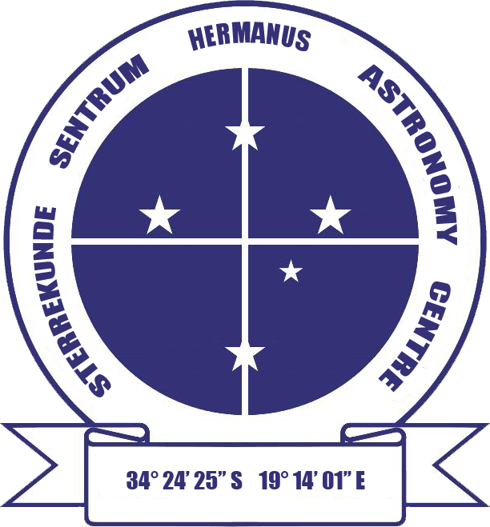

HERMANUS ASTRONOMY CENTRE NEWSLETTER

APRIL 2016

This month’s Centre meeting

This takes place on Monday 18 April in the Scout Hall starting at t 19.00. Dr Mike Kosch, Chief Scientist at SANSA will be talking on 'Travel to the South Pole: space science and astronomy'. Further details below.

New newsletter series begins A new series on the Sun begins this month in the 'Did you know?' section. Find Part 1 towards the end of the newsletter.

WHAT’S UP?
Jupiter’s moons Jupiter and its four largest moons (Io, Europa, Ganymede and Callisto, the Galilean moons) regularly demonstrate two interactions between celestial bodies which can be observed with binoculars. During a transit, the path of a smaller object crosses that of a larger one. As the Galilean moons orbit, at times, one or more of them can be seen as small bright objects passing in front of Jupiter. An occulation occurs when the path of a larger object crosses in front of that of a smaller one. An occulation is, thus, taking place whenever one of the four moons is behind the planet and not visible from Earth. Whether or not a transit or occulation is taking place, it is interesting to ‘moon spot’, noting how many of the four moons are visible. In addition, because Jupiter itself rotates so quickly (a day lasts 10 hours) it is also possible to see details on the planet eg the Big Red Spot move with only a few hours between observations. This month, Jupiter can be found all night in the constellation of Leo, the lion.

LAST MONTH’S ACTIVITIES
Monthly centre meeting The presenter at the meeting on 21 March was Centre member Lia Labuschagne. She focussed on the Australasia part of her series of talks on 'Astronomy around the world'. Her interesting presentation began with an overview of the number and activities of amateur astronomy clubs and societies in New Zealand. Surprisingly numerous and popular, considering the small population of that country, one has even built an accurate full-scale reconstruction of Stonehenge which illustrates how early civilisations, including those from Polyneisa, understood details of the day and night skies and the seasons. The remainder of the talk focussed on Australia. After giving an overview of the wide range of professional astronomy which takes place there, Lia also highlighted some of the activities undertaken by amateur astronomers and societies.

Interest groups
Cosmology Fifteen members attended the meeting on 7 March. They viewed the seventh pair of episodes of the 24 part DVD series on Time, given by Prof Sean Carroll from CalTech. The topics were: Lecture 13: ‘Boltzman brains’ and Lecture 14: ‘Complexity and life'.

Astro-photography Three members attended the meeting on 14 March..

Other activities
Sidewalk astronomy No events took place in March.

Educational outreach
Hawston Secondary School Astronomy Group In addition to continuing to cover a range of topics during March, the learners also started undertaking practical telescope and observational activities.
Lukhanyo Youth Club No meetings took place in March.

Magazine article An article by Jenny Morris titled 'Pluto: the solar system's puzzle' was published in the February/March issue of Whale Talk magazine.

THIS MONTH’S ACTIVITIES
Monthly centre meeting This will take place on Monday 18 April at the Scout Hall at 19.00. Dr Mike Kosch, the Chief Scientist at SANSA will be talking on ''Travel to the South Pole: space science and astronomy'. Mike gave a fascinating presentation on space science last year, and hearing about his experiences of visiting and working in Antarctica will, doubtless, be just as interesting and enjoyable.

There is an entrance fee of R10 per person for members, R20 per person for non-members, and R10 for children, students and U3A members.

Interest group meetings
The Cosmology group meets on the first Monday of each month at 19.00. This month’s meeting will take place on 4 April at the Scout Hall. Attendees will view the eighth pair of episodes of the new DVD series on Time by Prof Sean Carroll from CalTech. The topics for this month are: Lecture 15: ‘Perception of time’ and Lecture 16: ‘Memory and consciousness'.

There is an entrance fee of R10 per person for members, R20 per person for non-members, and R10 for children, students and U3A members. For further information on these meetings, or any of the group’s activities, please contact Pierre Hugo at pierre@hermanus.co.za

Astro-photography This group meets on the third Monday of each month. The next meeting will take place on 11 April. Work on image processing will continue.

To find out more about the group’s activities and the venue for particular meetings, please contact Deon Krige at astronomy.hermanus@gmail.com

Sidewalk astronomy No public events have been scheduled for this month. Details will be e-mailed out if this situation changes.

Hermanus Youth Robotic Telescope Interest Group A 'dry-run' has been undertaken in order to learn how the new MONET system works. When this is complete, relevant activities for learners will be identified and meetings arranged at Curro school.

For further information on both the MONET and Las Cumbres projects, please contact Deon Krige at deonk@telkomsa.net

FUTURE ACTIVITIES

None is currently being planned.

2016 MONTHLY MEETINGS
Meetings take place on the third Monday of each month at the Scout Hall beginning at 19.00. Details for 2016 are:
18 Apr 'Travel to the South Pole: pace science and astronomy'. Presenter: Dr Mike Kosch, Chief Scientist, SANSA
16 May 'Our solar system and the order of the planets'. Presenter: Johan Retief, Centre member
20 June 'Cataclysmic variables'. Presenter: Hannes Breytenbach, UCT
18 July, Topic TBA. Presenter: Case Rijsdijk, Garden Route Centre
15 Aug, TBA
19 Sept Topic TBA. Presenter: Dr Bruce Bassett, UCT and AIMS
17 Oct ‘Dark skies: the unseen Universe’’. Presenter: Jenny Morris, Committee member
21 Nov 'Science we have learned from space telescopes'. Presenter, Pierre de Villiers, Chairman, HAC committee
19 Dec Xmas party

ASTRONOMY EDUCATION CENTRE AND AMPHITHEATRE (AECA)
The date of publication of the updated plans for public consultation is still unknown. In the meantime, the Friends of the Observatory pledge fund continues to be an important source of funds to cover associated costs.

The Friends of the Observatory campaign was launched several years ago when preliminary work began on plans to construct an astronomical observatory in Hermanus. Over the years, members have been very generous, for which we are deeply grateful. It may seem logical to assume that, now money has been awarded by the National Lotteries Board, pledge monies are no longer needed. Unfortunately, that is not the case. NLC funds can only be used once the plans have been formally approved by the Municipality, something which is still awaited.

We would, therefore, be very grateful if members could either continue to contribute to the campaign or start becoming a contributor. Both single donations and small, regular monthly donations, of any amount, are welcome. Contributions can take the form of cash (paid at meetings), or online transfer, The Standard Bank details are as follows:
Account name – Hermanus Astronomy Centre
Account number – 185 562 531
Branch code – 051001
If you make an online donation, please include the word ‘pledge’, and your name, unless you wish to remain anonymous.

Science Centre The committee continues to work on the project.

ASTRONOMY NEWS

Most distant galaxy: Hubble breaks cosmic distance record 3 March: By pushing the NASA/ESA Hubble Space Telescope to its limits, astronomers have shattered the cosmic distance record by measuring the distance to the most remote galaxy ever seen in the Universe. This galaxy existed just 400 million years after the Big Bang and provides new insights into the first generation of galaxies. This is the first time that the distance of an object so far away has been measured from its spectrum, which makes the measurement extremely reliable.
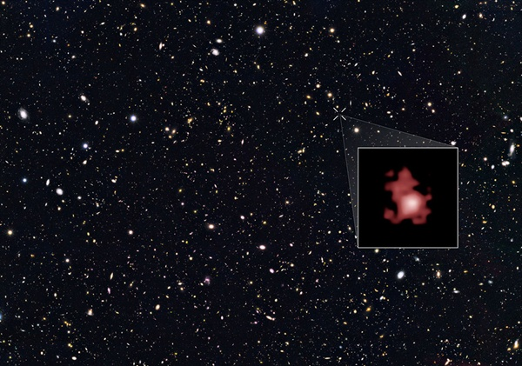The position of the most distant galaxy discovered so far within a deep sky Hubble Space Telescope survey. The survey field contains tens of thousands of galaxies stretching far back into time. The remote galaxy GN-z11, shown in the inset, existed only 400 million years after the Big Bang when the universe was only 3 percent of its current age. GN-z11 is actually ablaze with bright young blue stars, but these look red in this image because its light was stretched to longer, redder wavelengths by the expansion of the Universe. ASA/ESA
Although extremely faint, the galaxy, named GN-z11, is unusually bright considering its distance from Earth. The distance measurement of GN-z11 provides additional strong evidence that other unusually bright galaxies found in earlier Hubble images are really at extraordinary distances, showing that we are closing in on the first galaxies that formed in the Universe. “Our spectroscopic observations reveal the galaxy to be even further away than we had originally thought, right at the distance limit of what Hubble can observe,” said Gabriel Brammer of the Space Telescope Science Institute. This puts GN-z11 at a distance that was once thought only to be reachable with the upcoming NASA/ESA/CSA James Webb Space Telescope (JWST). “We managed to look back in time to measure the distance to a galaxy when the universe was only three percent of its current age,” said Pascal Oesch of Yale University in New Haven, Connecticut.
To determine large distances, like the one to GN-z11, astronomers measure the redshift of the observed object. This phenomenon is a result of the expansion of the universe. Every distant object in the universe appears to be receding from us, and as a result, its light is stretched to longer, redder wavelengths. Before astronomers determined the distance to GN-z11, the most distant measured galaxy, EGSY8p7, had a redshift of 8.68. Now, the team has confirmed GN-z11’s distance to be at a redshift of 11.1, which corresponds to 400 million years after the Big Bang.
“The previous record-holder was seen in the middle of the epoch when starlight from primordial galaxies was beginning to heat and lift a fog of cold hydrogen gas,” said Rychard Bouwens from the University of Leiden in the Netherlands. “This transitional period is known as the reionization era. GN-z11 is observed 150 million years earlier, near the very beginning of this transition in the evolution of the universe.”
The combination of observations taken by Hubble and Spitzer revealed that the infant galaxy is 25 times smaller than the Milky Way and has just one percent of our galaxy’s mass in stars. However, the number of stars in the newborn GN-z11 is growing fast: The galaxy is forming stars at a rate about 20 times greater than the Milky Way does today. This high star formation rate makes the remote galaxy bright enough for Hubble to see and to perform detailed observations.
However, the discovery also raises many new questions as the existence of such a bright and large galaxy is not predicted by theory. Marijn Franx, a member of the team from the University of Leiden said, “The discovery of GN-z11 was a great surprise to us as our earlier work had suggested that such bright galaxies should not exist so early in the universe.” His colleague Ivo Labbe added: “The discovery of GN-z11 showed us that our knowledge about the early universe is still restricted. How GN-z11 was created remains somewhat of a mystery for now. Probably we are seeing the first generations of stars forming around black holes?” By: Hubble ESA, Garching, Germany

Dawn’s first year at Ceres: A mountain emerges 7 March: One year ago, on 6 March 2015, NASA's Dawn spacecraft slid gently into orbit around Ceres, the largest body in the asteroid belt between Mars and Jupiter. Since then, the spacecraft has delivered a wealth of images and other data that open an exciting new window to the previously unexplored dwarf planet.
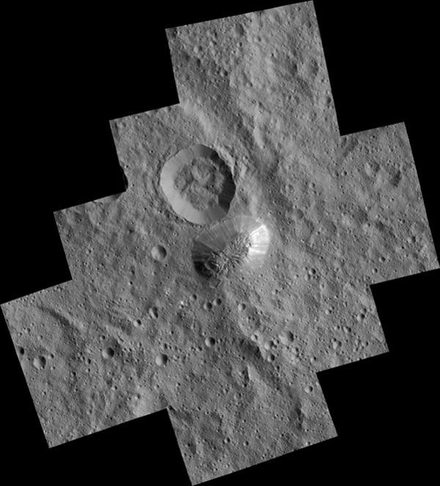 Ahuna Mons is seen in this mosaic of images from NASA's Dawn spacecraft.
Among Ceres' most enigmatic features is a tall mountain the Dawn team named Ahuna Mons. This mountain appeared as a small bright-sided bump on the surface as early as February 2015 from a distance of 46,000 km before Dawn was captured into orbit. As Dawn circled Ceres at increasingly lower altitudes, the shape of this mysterious feature began to come into focus. From afar, Ahuna Mons looked to be pyramid-shaped, but upon closer inspection, it is best described as a dome with smooth, steep walls.
Dawn's latest images of Ahuna Mons, taken 120 times closer than in February 2015, reveal that this mountain has a lot of bright material on some of its slopes and less on others. On its steepest side, it is about 5 km high. The mountain has an average overall height of 4 km. It rises higher than Washington's Mount Rainier and California's Mount Whitney. "No one expected a mountain on Ceres, especially one like Ahuna Mons," said Chris Russell from the University of California, Los Angeles. "We still do not have a satisfactory model to explain how it formed."
About 670 km northwest of Ahuna Mons lies the now-famous Occator Crater. Before Dawn arrived at Ceres, images of the dwarf planet from NASA's Hubble Space Telescope showed a prominent bright patch on the surface. As Dawn approached Ceres, it became clear that there were at least two spots with high reflectivity. As the resolution of images improved, Dawn revealed to its earthly followers that there are at least 10 bright spots in this crater alone, with the brightest area on the entire body located in the centre of the crater. It is not yet clear whether this bright material is the same as the material found on Ahuna Mons. By: Jet Propulsion Laboratory, Pasadena, California

Close comet flyby threw Mars' magnetic field into chaos 10 March: Just weeks before the historic encounter of Comet Siding Spring (C/2013 A1) with Mars in October 2014, NASA’s Mars Atmosphere and Volatile Evolution (MAVEN) spacecraft entered orbit around the Red Planet. To protect sensitive equipment aboard MAVEN from possible harm, some instruments were turned off during the flyby; the same was done for other Mars orbiters. However, a few instruments, including MAVEN’s magnetometer, remained on, conducting observations from a front-row seat during the comet’s remarkably close flyby.
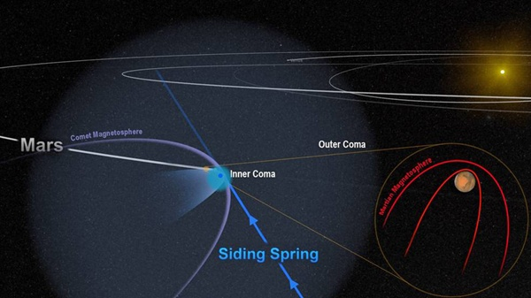 Artist's impression of the comet's powerful magnetic field temporarily merged with, and overwhelmed, the planet's weak field. NASA/Goddard
The one-of-a-kind opportunity gave scientists an intimate view of the havoc that the comet’s passing wreaked on the magnetic environment, or magnetosphere, around Mars. The effect was temporary but profound. “Comet Siding Spring plunged the magnetic field around Mars into chaos,” said Jared Espley, a MAVEN science team member at NASA’s Goddard Space Flight Centre in Greenbelt, Maryland. “We think the encounter blew away part of Mars’ upper atmosphere, much like a strong solar storm would.”
Unlike Earth, Mars is not shielded by a strong magnetosphere generated within the planet. The atmosphere of Mars offers some protection, however, by redirecting the solar wind around the planet, like a rock diverting the flow of water in a creek. This happens because at high altitudes Mars’ atmosphere is made up of plasma — a layer of electrically charged particles and gas molecules. Charged particles in the solar wind interact with this plasma, and the mingling and moving around of all these charges produces currents. Just like currents in simple electrical circuits, these moving charges induce a magnetic field, which in Mars’ case is quite weak.
Comet Siding Spring is also surrounded by a magnetic field. This results from the solar wind interacting with the plasma generated in the coma - the envelope of gas flowing from a comet’s nucleus as it is heated by the Sun. Comet Siding Spring’s nucleus - a nugget of ice and rock measuring no more than about 500m - is small, but the coma is expansive, stretching out 1,000,000 km in every direction. The densest part of the coma - the inner region near the nucleus - is the part of a comet that’s visible to telescopes and cameras as a big fuzzy ball. When Comet Siding Spring passed Mars, the two bodies came within about 140,000 km of each other. The comet’s coma washed over the planet for several hours, with the dense inner coma reaching, or nearly reaching, the surface. Mars was flooded with an invisible tide of charged particles from the coma, and the powerful magnetic field around the comet temporarily merged with and overwhelmed the planet’s own weak one.
At first, the changes were subtle. As Mars’ magnetosphere, which is normally draped neatly over the planet, started to react to the comet’s approach, some regions began to realign to point in different directions. With the comet’s advance, these effects built in intensity, almost making the planet’s magnetic field flap like a curtain in the wind. By the time of closest approach, when the plasma from the comet was densest, Mars’ magnetic field was in complete chaos. Even hours after the comet’s departure, some disruption continued to be measured.
Espley and colleagues think the effects of the plasma tide were similar to those of a strong but short-lived solar storm. And like a solar storm, the comet’s close passage likely fuelled a temporary surge in the amount of gas escaping from Mars’ upper atmosphere. Over time, those storms took their toll on the atmosphere. By: NASA
ExoMars sets off to solve the Red Planet’s mysteries 15 March: The first of two joint European Space Agency (ESA)-Roscosmos missions to Mars has begun a seven-month journey to the Red Planet, where it will address unsolved mysteries of the planet’s atmosphere that could indicate present-day geological - or even biological – activity. Signals from the spacecraft, received at ESA’s control centre in Darmstadt, Germany via the Malindi ground tracking station in Africa at 21:29 GMT, confirmed that the launch was fully successful and the spacecraft is in good health. The orbiter’s solar wings have also now unfolded and the craft is on its way to Mars.
“We’re not only looking forward to the world-class science data that this mission will return, but it is also significant in paving the way for the second ExoMars mission, which will move our expertise from in-orbit observations to surface and subsurface exploration of Mars,” said Alvaro Giménez from ESA.
The Trace Gas Orbiter (TGO) and Schiaparelli are travelling to Mars together before separating on 16 October 900,000 km from the planet. On 19 October 19, Schiaparelli will enter the Martian atmosphere, descending to the surface in just under six minutes.
It will demonstrate key entry, descent, and landing technologies for future missions and will conduct a number of environmental studies during its short mission on the surface. For example, it will obtain the first measurements of electric fields on the surface of Mars that, combined with measurements of the concentration of atmospheric dust, will provide new insights into the role of electric forces on dust lifting - the trigger for dust storms.
Meanwhile, on the same day, TGO will enter an elliptical four-day orbit around Mars, taking it from about 300 km at its nearest to around 96,000 km at its furthest point. After a year of complex 'aerobraking,' manoeuvres during which the spacecraft will use the planet’s atmosphere to lower its orbit slowly to a circular 400 km, its scientific mission to analyse rare gases in the atmosphere will begin. Of particular interest is methane, which on Earth points to active geological or biological processes. One of the mission’s key goals is to follow up on the methane detection made by ESA’s Mars Express in 2004 to understand the processes at play in its generation and destruction, with an improved accuracy of three orders of magnitude over previous measurements.
TGO will also image features on the Martian surface that may be related to trace-gas sources such as volcanoes. In addition, it will be able to detect buried water-ice deposits, which, along with locations identified as sources of the trace gases, could influence the choice of landing sites of future missions. The orbiter will also act as a data relay for the second ExoMars mission, comprising a rover and stationary surface science platform, which is scheduled for launch in May 2018, arriving in early 2019.
By: ESA, Noordwijk, Netherlands

New gravity map gives best view yet inside Mars 21 March: A new map of Mars’ gravity made with three NASA spacecraft is the most detailed to date, providing a revealing glimpse into the hidden interior of the Red Planet.
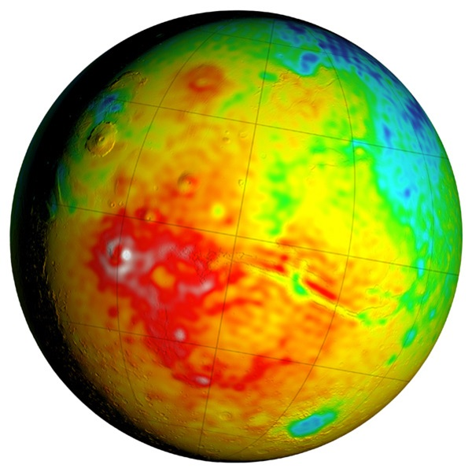 This Mars map shows detailed variations in thickness of the planet's crust, the relatively thin surface layer overlying the mantle of the planet. NASA
“Gravity maps allow us to see inside a planet, just as a doctor uses an X-ray to see inside a patient,” said Antonio Genova from NASA’s Goddard Space Flight Center in Greenbelt, Maryland. “The new gravity map will be helpful for future Mars exploration because better knowledge of the planet’s gravity anomalies helps mission controllers insert spacecraft more precisely into orbit about Mars.”
The improved resolution of the new gravity map suggests a new explanation for how some features formed across the boundary that divides the relatively smooth northern lowlands from heavily cratered southern highlands. Also, the team confirmed that Mars has a liquid outer core of molten rock by analysing tides in the Martian crust and mantle caused by the gravitational pull of the Sun and the two moons of Mars. Finally, by observing how Mars’ gravity changed over 11 years - the period of an entire cycle of solar activity - the team inferred the massive amount of carbon dioxide that freezes out of the atmosphere onto a Martian polar ice cap when it experiences winter. They also observed how that mass moves between the south pole and the north pole with the change of season in each hemisphere.
The map was derived using Doppler and range tracking data collected from three NASA spacecraft in orbit around Mars.. Like all planets, Mars is lumpy, which causes the gravitational pull felt by spacecraft in orbit around it to change. For example, the pull will be a bit stronger over a mountain, and slightly weaker over a canyon. Slight differences in Mars’ gravity changed the trajectory of the NASA spacecraft orbiting the planet, which altered the signal being sent from the spacecraft to the Deep Space Network. These small fluctuations in the orbital data were used to build a map of the Martian gravity field.
The gravity field was recovered using about 16 years of data that were continuously collected in orbit around Mars. However, orbital changes from uneven gravity are tiny, and other forces that can perturb the motion of the spacecraft had to be carefully accounted for, such as the force of sunlight on the spacecraft’s solar panels and drag from the Red Planet’s thin upper atmosphere. It took two years of analysis and computer modelling to remove the motion not caused by gravity. “With this new map, we’ve been able to see gravity anomalies as small as about 100 km across, and we’ve determined the crustal thickness of Mars with a resolution of almost 120 km,” said Genova. “
By: Jet Propulsion Laboratory, Pasadena, California, NASA's Goddard Space Flight Center, Greenbelt, Maryland, NASA Headquarters, Washington, D.C
Tales of a tilting Moon hidden in its polar ice 24 March: The same face of the Moon has not always pointed towards Earth. The spin axis of the Moon has moved by at least 6°, and that motion is recorded in ancient lunar ice deposits, said Matthew Siegler of the Planetary Science Institute (PSI) in Tucson, Arizona. This motion is believed to have resulted from a warm, low-density region of the lunar mantle below the dark patch of lunar mare called Oceanus Procellarum. The same heat source that caused the volcanic mare to form also warmed the mantle. This is the first physical evidence that the Moon underwent such a dramatic change in orientation and implies that the ice on the Moon is billions of years old.
The new findings help explain the earliest dynamic and thermal history of the Moon and shed light on the origin of lunar water. “We found that the polar shift required to explain the distribution of ice matches perfectly with the existence of a fossilised mantle plume below the lunar mare,” said Siegler. “So, the same thing that caused the dark lavas that make up the face of the Man on the Moon also caused the axis of the Moon to move - and it is recorded in the polar ice. This ice distribution tells us the near side of the Moon shifted towards the north pole - so the Man on the Moon is sort of turning his nose up at Earth. This gives us a way to model exactly where the ice should be, which tells us about its origin and where astronauts might find a drink on future missions to the Moon.”
A physical change of the lunar spin axis, known as true polar wander, can only result from a large change in the mass distribution of the Moon. According to models by James Keane from the University of Arizona, this change was provided by a large warm region of the near-side lunar mantle, which still exists, controls the current orientation of the Moon, and the face we see from Earth.
This also provides an explanation for a longstanding mystery of the odd distribution of lunar hydrogen that has been painstakingly mapped by Richard Miller of the University of Alabama in Huntsville. Compared to similar temperature environments on the planet Mercury, the Moon has far less ice. As this polar migration occurred, ice formerly hidden from the Sun in shadowed craters near the lunar poles would have moved into sunlight and boiled away. The Moon might have once had much more ice near its poles, and the ice we see today is the tiny portion that has survived this polar migration. Large amounts of ice could have been brought to the Moon by comets and icy asteroids early in the Moon’s history or potentially outgassed from the lunar maria themselves. Figuring out the origin of this ancient lunar water might also help scientists understand how water was delivered to the early Earth. By: Planetary Science Institute, Tucson, Arizona

Moons of Saturn may be younger than the dinosaurs 25 March: New research suggests that some of Saturn’s icy moons, as well as its famous rings, might be modern adornments. Their dramatic birth may have taken place a mere 100 million years ago, more recent than the reign of many dinosaurs.
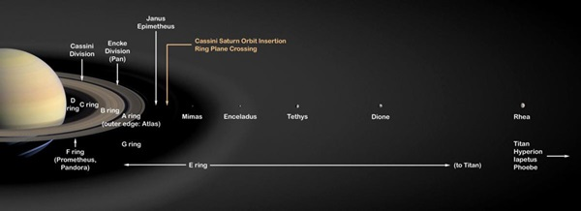 Saturn's moon Rhea and all other moons and rings closer to Saturn may be only 100 million years old. Outer satellites (not pictured here), including Saturn's largest moon Titan, are probably as old as the planet itself. NASA/JPL
“Moons are always changing their orbits. That’s inevitable,” said Matija Cuk from the SETI Institute in Mountain View, California. “But that fact allows us to use computer simulations to tease out the history of Saturn’s inner moons. Doing so, we find that they were most likely born during the most recent two percent of the planet’s history.”
While Saturn’s rings have been known since the 1600s, there’s still debate about their age. The straightforward assumption is that they are primordial - as old as the planet itself, which is more than 4 billion years. However, in 2012, French astronomers found that tidal effects - the gravitational interaction of the inner moons with fluids deep in Saturn’s interior - are causing them to spiral to larger orbital radii comparatively quickly. The implication, given their present positions, is that these moons, and presumably the rings, are recent phenomena.
Scientists used computer modelling to infer the past dynamic behaviour of Saturn’s icy inner moons. While our own moon has its orbit around Earth to itself, Saturn’s many satellites have to share space with each other. All of their orbits slowly grow due to tidal effects, but at different rates. This results in pairs of moons occasionally entering so-called orbital resonances. These occur when one moon’s orbital period is a simple fraction (for example, one-half or two-thirds) of another moon’s period. In these special configurations, even small moons with weak gravity can strongly affect each other’s orbits, making them more elongated and tilting them out of their original orbital plane.
By comparing present orbital tilts and those predicted by computer simulations, the researchers could learn how much the orbits of Saturn’s moons grew. It turns out that for some of the most important satellites - Tethys, Dione and Rhea - the orbits are less dramatically altered than previously thought. The relatively small orbital tilts indicate that they have not crossed many orbital resonances, meaning that they must have formed not far from where they are now.
How long ago was their birth? Cuk and his team used results from NASA’s Cassini mission to help answer this question. The Cassini spacecraft has observed ice geysers on Saturn’s moon Enceladus. Assuming that the energy powering these geysers comes directly from tidal interactions, and that Enceladus’ level of geothermal activity is more or less constant, then the tides within Saturn are quite strong. According to the team’s analysis, these would move the satellite by the small amount indicated by the simulations in only about 100 million years. This would date the formation of the major moons of Saturn, with the exception of more distant Titan and Iapetus, to the relatively recent Cretaceous Period, the era of the dinosaurs. “So the question arises, what caused the recent birth of the inner moons?” asked Cuk. “Our best guess is that Saturn had a similar collection of moons before, but their orbits were disturbed by a special kind of orbital resonance involving Saturn’s motion around the Sun. Eventually, the orbits of neighbouring moons crossed, and these objects collided. From this rubble, the present set of moons and rings formed.”
By: SETI Institute, Mountain View, California

INTEGRAL sets limits on gamma rays from merging black holes 30 March: On 14 September 2015, the terrestrial Laser Interferometer Gravitational-wave Observatory (LIGO) detected gravitational waves - fluctuations in the fabric of spacetime - produced by a pair of black holes as they spiralled towards each other before merging. The signal lasted less than half a second. The discovery was the first direct observation of gravitational waves predicted by Albert Einstein a century ago.
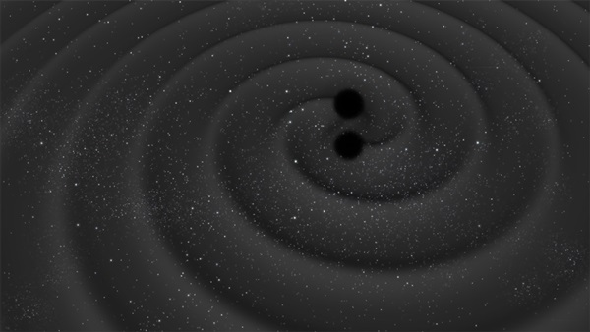 Artist's impression of two black holes as they spiral towards each other before merging, releasing gravitational waves. ESA–C.Carreau
Two days after the detection, the LIGO team alerted a number of ground- and space-based astronomical facilities to look for a possible counterpart to the source of gravitational waves. The nature of the source was unclear at the time, and it was hoped that follow-up observations across the electromagnetic spectrum might provide valuable information about the culprit.
Gravitational waves are released when massive bodies are accelerated, and strong emission should occur when dense stellar remnants such as neutron stars or black holes spiral towards each other before coalescing. Models predict that the merging of two stellar-mass black holes would not produce light at any wavelength, but if one or two neutron stars were involved in the process, then a characteristic signature should be observable across the electromagnetic spectrum. Another possible source of gravitational waves would be an asymmetric supernova explosion, also known to emit light over a range of wavelengths.
It was not possible to pinpoint the LIGO source - its position could only be narrowed down to a long strip across the sky. Observatories searched their archives in case data had been serendipitously collected anywhere along this strip around the time of the gravitational wave detection. They were also asked to point their telescopes to the same region in search for any possible 'afterglow' emission.
INTEGRAL (International Gamm-Ray Astrophysics Laboratory) is sensitive to transient sources of high-energy emission over the whole sky, and thus a team of scientists searched through its data, seeking signs of a sudden burst of hard X-rays or gamma rays that might have been recorded at the same time as the gravitational waves were detected “We searched through all the available INTEGRAL data, but did not find any indication of high-energy emission associated with the LIGO detection,” said Volodymyr Savchenko of the François Arago Centre in Paris, France. The team also looked at data from INTEGRAL’s IBIS instrument, although at the time it was not pointing at the strip where the source of gravitational waves was thought to be located. “The source detected by LIGO released a huge amount of energy in gravitational waves, and the limits set by the INTEGRAL data on a possible simultaneous emission of gamma rays are one million times lower than that,” said Carlo Ferrigno from the INTEGRAL Science Data Centre at the University of Geneva, Switzerland.
Subsequent analysis of the LIGO data has shown that the gravitational waves were produced by a pair of coalescing black holes, each with a mass roughly 30 times that of our Sun, located about 1.3 billion light-years away. Scientists do not expect to see any significant emission of light at any wavelength from such events, and thus INTEGRAL’s null detection is consistent with this scenario. Similarly, nothing was seen by the great majority of the other astronomical facilities making observations from radio and infrared to optical and X-ray wavelengths. The exception was the Gamma-Ray Burst Monitor on NASA’s Fermi Gamma-Ray Space Telescope, which observed what appears to be a sudden burst of gamma rays about 0.4 seconds after the gravitational waves were detected. The burst lasted about one second and came from a region of the sky that overlaps with the strip identified by LIGO.
This detection resulted in possible scenarios in which two merging black holes of stellar mass could indeed have released gamma rays along with the gravitational waves. However, if this gamma-ray flare had had a cosmic origin, either linked to the LIGO gravitational wave source or to any other astrophysical phenomenon in the Universe, it should have been detected by INTEGRAL as well. The absence of any such detection by both instruments on INTEGRAL suggests that the measurement from Fermi could be unrelated to the gravitational wave detection. By: ESA, Noordwijk, Netherlands
Source of these and further astronomy news items: www.astronomy.com/news

DID YOU KNOW?
The Sun Part 1 Some facts

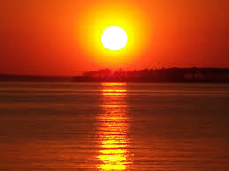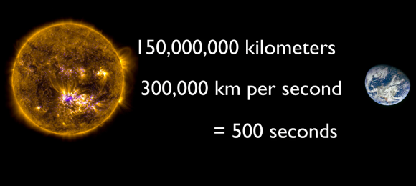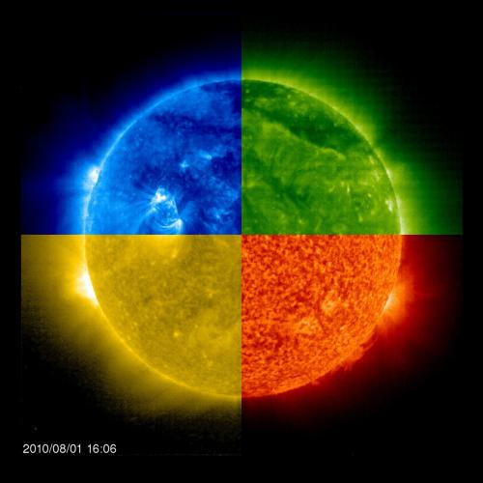
Our star Time for sunlight to reach Earth Sun through filters

Our nearest star is central to the existence and continuation of life on Earth and it permeates many aspects of human culture eg religion, language, calendars, lifestyle. Astronomically, it also totally dominates the solar system.

Vital statistics
Age Around 4.6 billion years. It is roughly middle-aged, with a remaining life of around 5 billion years.
Spectral class The Sun is a G2V star ie a yellow-white star in the main sequence (it generates its energy by converting hydrogen to helium), with a surface temperature around 5,000 K.
Colour When viewed from space or when high in the sky it appears almost white. Its yellow, red or orange colours are a result of atmospheric scattering.
Distance from Earth This varies ,because Earth’s orbit is slightly elliptical. The mean distance is about 150,000,000 km – 1 astronomical unit (AU).
Time for light from the Sun to reach Earth About 8 minutes 19 seconds.
Absolute magnitude +4.83. Absolute magnitude is the brightness a star would have in perfectly clear space around 30 light years away from Earth. + values mean less bright. So, the Sun is a relatively pale star.
Apparent (observed) magnitude -26.74 . For an observer on Earth, the Sun is easily the brightest celestial object visible from Earth (signified by the large negative value). For comparison, that of Sirius, the brightest distant star, is -1.44.
Shape Made of hot plasma, it is almost a perfect sphere, polar and equatorial diameters differing by only 10 km. Planetary tidal effects are almost non-existent.
Diameter 1,392,530 km (about 109 times Earth). For practical purposes, the Sun’s radius is considered to be the distance from the centre to edge of photosphere, the apparent visible surface of the Sun.
Mass The Sun contains about 99.86% of the total mass of the solar system - 1.989 x 10³⁰ kg. Its mass is approximately 330,000x times that of Earth.
Mean density The gaseous Sun has a density of 1.41 g/cm³ (that of rocky Earth is 5.52 g/cm³⁾). It has no definite boundary, the density in its atmosphere decreasing exponentially with increasing distance.
Temperature At the surface: this is around 5,595°C (5,778 K). Initially, this falls with altitude, but then there is a marked increase with increasing distance from the surface. Temperatures at the core are around 15.6 million K.
Rotation This occurs faster at the equator than the poles, the differential rotation caused by convective motion due to heat transport and the Coriolis force caused by the rotation itself.
Rotational period About 25.6 days at the equator and 33.5 days at the poles. Viewed from Earth, solar equatorial rotation appears to be about 28 days.
History A Population 1 (heavy element rich) type, it formed from the gravitational collapse of matter within part of a giant molecular cloud. This cloud would have contained the remnants of older Population II and III stars. Its formation was possibly triggered by shockwaves from a nearby supernova – evidence given by the high abundance of heavy elements in the solar system eg gold, uranium relative to their abundance in Population ll, heavy-element poor stars. As one fragment of the cloud collapsed, it began to rotate because of conservation of angular momentum, and heat up with the increasing pressure. Gravity and pressure at the centre caused the mass to become increasingly hot, eventually initiating nuclear fusion.
Composition This was inherited from the interstellar medium from which it formed. About ¾ of its mass is hydrogen (+/- 73%). The rest is mostly helium (23.8%), plus tiny quantities of heavier elements including oxygen (1%), neon (0.2%), iron (0.2%) and carbon (0.3%). The hydrogen and helium were formed during the Bing Bang and the heavier elements form stellar nucleosynthesis by earlier generation stars. In the inner areas, nuclear fusion has converted hydrogen to helium, so the innermost parts are now about 60% helium.
Energy production Every second, more than 4 million tonnes of matter are converted into energy within the core, producing solar radiation and neutrinos. So far, the Sun has converted around 100 times Earth’s mass into energy, about 0.03% of its own total mass. It is gradually becoming hotter because the helium atoms in the core occupy less volume than the original hydrogen atoms which were fused. The Sun's brightness increases by about 1% every 100 million years.
Magnetism Motion inside the Sun generates a magnetic field via a dynamo process. The field varies across the surface, and over a wide range of timescales, the 11-year solar cycle being the most prominent. The field is the source of active solar events including solar flares and coronal mass ejections. The solar magnetic field extends well beyond the Sun, the solar wind carrying plasma into space, forming the interplanetary magnetic field.

Sources: Ridpath, I (Ed) (2012) Oxford dictionary of astronomy 2nd ed rev, Ridpath, I (Ed) Astronomy (2006) Dorling Kindersley – Eyewitness companions, www.en.wikipedia.org

For more information on the Hermanus Astronomy Centre and its activities, visit our website at www.hermanusastronomy.co.za

COMMITTEE MEMBERS
Pierre de Villiers (Chairperson, observatory, youth club) 028 313 0109
Laura Norris (Treasurer) 028 316 4453
Peter Harvey (Secretary, monthly sky maps) 028 316 3486
Jenny Morris (Vice-chairperson, newsletter) 071 350 5560
Karin de Bruin (Observing) 028 316 2080
Derek Duckitt (Website editor) 082 414 4024
Bennie Kotze 128 316 3666
Deon Krige (Youth robotics project, astro-photography) 028 314 1045
John Saunders (Guest speakers and events) tibouchina286@gmail.com
Non-committee members with roles:
Lynette Geldenhuys (Education) 028 316 2428
Pierre Hugo (Cosmology interest group) 028 312 1639
Johan Retief (Hawston School Youth Club) 028 315 1132

