“The Southern Cross”

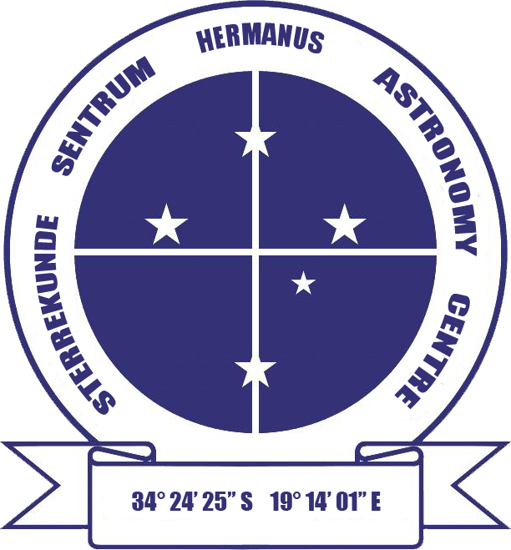

HERMANUS ASTRONOMY CENTRE NEWSLETTER

MARCH 2016

Important notice 2015 membership renewal window closed

If you have not already renewed your membership, from this month, your details will be removed from the Centre’s membership list. The implications of this are that you will no longer receive the monthly sky maps or Southern Cross newsletter, no longer be eligible to join Centre trips, and, if you wish to attend monthly or interest group meetings, on each occasion, you will have to pay the R20 visitor’s fee. All is not lost, however. You are welcome to rejoin the Centre at any time by contacting Laura Norris, the Treasurer, at meetings, on 028 3164453 or at dunorris@whalemail.co.za

This month’s Centre meeting

This takes place on Monday 14 March in the Scout Hall starting at t 19.00. In a change from the previously published schedule, the presenter will be Centre member Lia Labuschagne. Her topic is 'Astronomy round the world'. Further details below.

WHAT’S UP?
Comet 252P/ LINEAR will be visible in the south-east after around 22.00 from 17 March until 25 April. It will be easy to locate, as its fairly straight path begins in the curve of the easily identified tail of Scorpius before moving through neigh-bouring, but less conspicuous, Ophiuchus. First discovered in 2004, like other short-period comets, 252P/LINEAR probably originated in the Kuiper belt, beyond Neptune. Comets seen from Earth have orbits which have been disturbed and altered to elliptical orbits by the gravitational effects of the gas giants, particularly Jupiter. Deep in space, comets are chunks of frozen gases, ice and dust. However, the nuclei of those, like 252P/LINNEAR, which approach the Sun are vapourised by solar radiation, forming a coma. The solar wind may then sweep the liberated gas and dust into the characteristic split tail, which always points away from the Sun. The straight gas part of the tail appears blue-green and the often curved dust part yellowish in colour.

LAST MONTH’S ACTIVITIES
Monthly centre meeting The Centre’s AGM was held on 5 February. Chairman Pierre de Villiers first noted the main events which marked the Centre's eight year. These were: progress with planning procedures for the Astronomy Education Centre and Amphitheatre, the start of the Hawston space cadets youth club, participation in National Science Week which included talks and star-gazing, construction of the Gearing' Point sundials and ongoing work on others, unexpected publicity for the Centre in an article published in SA Country Life magazine, observation of the partial solar eclipse, talks from two leading astronomers in addition to the presentations at the monthly meetings, very successful trips to the Palmiet pumped water storage scheme and the Cederberg, and confirmation of the Centre’s new meeting venue.

Pierre then outlined the range of regular activities which took place during 2015, as well as the resources available to members. Finally, he thanked all those who have contributed to the ongoing success of the Centre, and confirmed the make-up of the committee in 2016.

Interest groups
Cosmology Seventeen people (13 members, 4 visitors) attended the meeting on 1 February. They viewed the sixth pair of episodes of the 24 part DVD series on Time, given by Prof Sean Carroll from CalTech. The topics were: Lecture 11: ‘The past hypothesis’ and Lecture 12: ‘Memory causation and action'.

Astro-photography No meeting took place in February.

Other activities
Sidewalk astronomy No events took place in February.

Educational outreach
Hawston Secondary School Astronomy Group Meetings recommenced at the start of the month. The learners, now in Grade 11, continue to be enthusiastic about what they are learning about astronomy.
Lukhanyo Youth Club No meetings took place in February.

Southern Star Party. Five Centre members attended this event held from 5-7 February. Karin de Bruin reports: “It was astronomical!” For a first-timer attending the Southern Star Party, the whole weekend turned out to be an eye-opener on many levels. I certainly can understand why they have chosen Bonnievale for the location – the dark skies and bright stars. It was with open mouths and hungry eyes that all 60+ attendees gazed at the beauty. Every night was perfect for observation – no wind, no clouds. As soon as the sun had set the fast rule was: NO LIGHTS! That included candles, house lights, car boot lights, and everybody turned on their red head lamps. Then the skies looked like Star Wars when green laser pointers showed, explained and navigated their way around. And all the telescopes! Wow! The 16 inch really stole my heart and everybody were more than happy to share viewing time.

The Deep Sky Challenge certainly was exactly that. Out of a long list of numbers, beginners had to find, describe and draw at least 10 of them, intermediate 25 and advanced 100. I am proud to say that we kept Hermanus Astronomy Centre’s name high as I reached the beginners level and Pierre de Villiers reached the advanced level. Special badges for us! During the daytime, the most interesting and knowledgeable speakers from all over spoke on various subjects, including Pierre who led a spirited discussion on how to foster an interest and enjoyment of astronomy. Others were Magda Streicher, well known for her beautiful drawings of celestial objects, Ray Brederode who spoke about Rosetta and Philae and Charl Carter speaking about Green Pea Galaxies.

Gail and Derek Duckitt as well as Susan Joubert attended the weekend and I think we all agree that the next Star Party planned for 26 – 31 October 2016 is not to be missed. I know I will certainly be there!

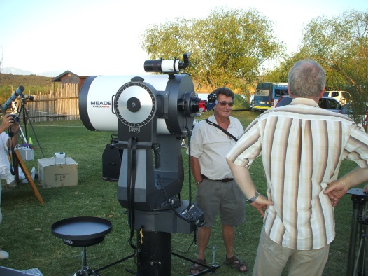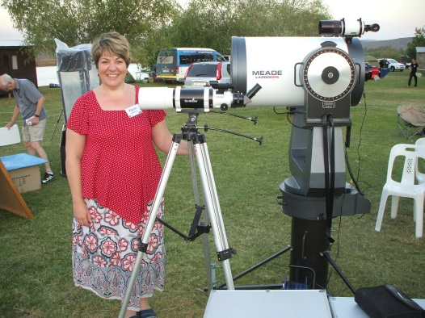

THIS MONTH’S ACTIVITIES
Monthly centre meeting This will take place on Monday 15 February at the Scout Hall at 19.00. Centre member, Lia Labuschagne will be talking on 'Astronomy around the world'. Lia has given several presentations to and for the Centre, both before and since she moved to the Overstrand. These included one on Einstein, which she also gave again at a U3A open meeting in 2015, and another on the Star of Bethlehem, which she gave at the 2014 Christmas party.

There is an entrance fee of R10 per person for members, R20 per person for non-members, and R10 for children, students and U3A members.

Interest group meetings
The Cosmology group meets on the first Monday of each month at 19.00. This month’s meeting will take place on 7 March at the Scout Hall. Attendees will view the seventh pair of episodes of the new DVD series on Time by Prof Sean Carroll from CalTech. The topics for this month are: Lecture 13: ‘Boltzman brains’ and Lecture 14: ‘Complexity and life'.

There is an entrance fee of R10 per person for members, R20 per person for non-members, and R10 for children, students and U3A members. For further information on these meetings, or any of the group’s activities, please contact Pierre Hugo at pierre@hermanus.co.za

Astro-photography This group meets on the third Monday of each month. The next meeting will take place on 21 March. Work will continue on image processing.

To find out more about the group’s activities and the venue for particular meetings, please contact Deon Krige at astronomy.hermanus@gmail.com

Sidewalk astronomy No events have been scheduled for this month. Details will be e-mailed out if this situation changes.

Hermanus Youth Robotic Telescope Interest Group Preparatory work will be able to begin when the telescopes again become available to the public.

For further information on both the MONET and Las Cumbres projects, please contact Deon Krige at deonk@telkomsa.net

FUTURE ACTIVITIES

None is currently being planned.

2016 MONTHLY MEETINGS
Meetings take place on the third Monday of each month at the Scout Hall beginning at 19.00. Details for 2016 are:
21 Mar ‘Astronomy around the world'. Presenter: Lia Labuschgne, Centre member
18 Apr 'Space science and astronomy'. Presenter: Dr Mike Kosch, Chief Scientist, SANSA
16 May 'Our solar system and the order of the planets'. Presenter: Johan Retief, Centre member
20 June 'Cataclysmic variables'. Presenter: Hannes Breytenbach, UCT
18 July, Topic TBA. Presenter: Case Rijsdijk, Garden Route Centre
15 Aug, TBA
19 Sept Topic TBA. Presenter: Dr Bruce Bassett, UCT and AIMS
17 Oct ‘Dark skies: the unseen Universe’’. Presenter: Jenny Morris, Committee member
21 Nov 'Science we have learned from space telescopes'. Presenter, Pierre de Villiers, Chairman, HAC committee
19 Dec Xmas party

ASTRONOMY EDUCATION CENTRE AND AMPHITHEATRE (AECA)
Internal processing of the planning application to Overstrand Municipality is still underway and the date of publication for public consultation is, presently, unknown.
In the meantime, the Friends of the Observatory pledge fund continues to be an important source of funds to cover associated costs.

The Friends of the Observatory campaign was launched several years ago when preliminary work began on plans to construct an astronomical observatory in Hermanus. Over the years, members have been very generous, for which we are deeply grateful. It may seem logical to assume that, now money has been awarded by the National Lotteries Board, pledge monies are no longer needed. Unfortunately, that is not the case. NLC funds can only be used once the plans have been formally approved by the Municipality, something which is still awaited.

We would, therefore, be very grateful if members could either continue to contribute to the campaign or start becoming a contributor. Both single donations and small, regular monthly donations, of any amount, are welcome. Contributions can take the form of cash (paid at meetings), or online transfer, The Standard Bank details are as follows:
Account name – Hermanus Astronomy Centre
Account number – 185 562 531
Branch code – 051001
If you make an online donation, please include the word ‘pledge’, and your name, unless you wish to remain anonymous.

Science Centre The committee continues to work on the project. Consultation with interested and affected organizations and parties is being planned.

ASTRONOMY NEWS

Scientists discover hidden galaxies behind the Milky Way 9 February: Hundreds of hidden nearby galaxies have been studied for the first time, shedding light on a mysterious gravitational anomaly dubbed the Great Attractor. Despite being just 250 million light-years from Earth -very close in astronomical terms - the new galaxies had been hidden from view until now by our Milky Way Galaxy.
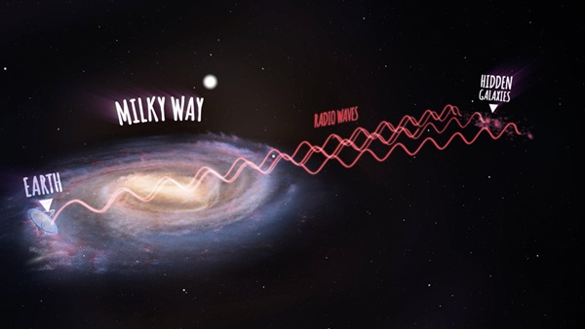 An annotated artist's impression showing radio waves traveling from the new galaxies, then passing through the Milky Way and arriving at the Parkes radio telescope on Earth (not to scale). ICRAR
Using CSIRO’s Parkes radio telescope equipped with an innovative receiver, an international team of scientists was able to see through the stars and dust of the Milky Way into a previously unexplored region of space. The discovery may help to explain the Great Attractor region, which appears to be drawing the Milky Way and hundreds of thousands of other galaxies towards it with a gravitational force equivalent to a million billion Suns.
Lister Staveley-Smith, from The University of Western Australia node of the International Center for Radio Astronomy Research, said the team found 883 galaxies, a third of which had never been seen before. He said scientists have been trying to get to the bottom of the mysterious Great Attractor since major deviations from universal expansion were first discovered in the 1970s and 1980s. “We don’t actually understand what’s causing this gravitational acceleration on the Milky Way or where it’s coming from,” he said. “We know that in this region there are a few very large collections of galaxies we call clusters or superclusters, and our whole Milky Way is moving towards them at more than two million kilometres per hour.” The research identified several new structures that could help to explain the movement of the Milky Way, including three galaxy concentrations - NW1, NW2 and NW3 - and two new clusters - CW1 and CW2.
Renée Kraan-Korteweg from University of Cape Town said astronomers have been trying to map the galaxy distribution hidden behind the Milky Way for decades. “We’ve used a range of techniques, but only radio observations have really succeeded in allowing us to see through the thickest foreground layer of dust and stars,” she said. “An average galaxy contains 100 billion stars, so finding hundreds of new galaxies hidden behind the Milky Way points to a lot of mass we didn’t know about until now.”
By: International Centre for Radio Astronomy Research, Perth, Western Australia

Even Einstein doubted his gravitational waves 11 February: Even before LIGO published its detection this week, most modern scientists had already accepted gravitational waves as an observable manifestation of Einstein’s general relativity. However, that has not always been the case. As recently as the 1970s, scientists were not sure gravitational waves were strong enough to detect. Other theorists rejected their existence outright.
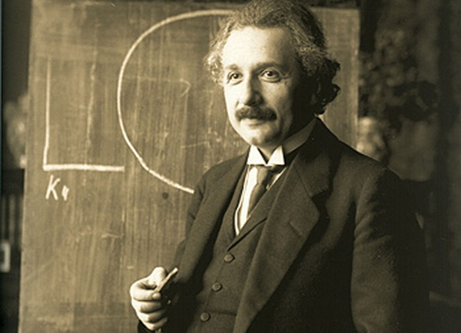 Wikimedia Commons
Interestingly, Einstein himself was a prominent doubter. In 1936, twenty years after he introduced the concept, the great physicist took another look at his maths and came to a surprising conclusion. “Together with a young collaborator, I arrived at the interesting result that gravitational waves do not exist, though they had been assumed a certainty to the first approximation,” he wrote in a letter to his friend Max Born. Einstein submitted his change of heart in a paper to the Physical Review Letters t itled “Do gravitational waves exist?” The reviewer soon poked holes in the maths, showing how Einstein’s coordinate system lacked imagination when dealing with pesky singularities. PRL sent the paper back requesting revisions. That incensed Einstein, who had never experienced peer-review before, according to an investigative piece in Physics Today back in 2005. Einstein told PRL that he had not authorised them “to show it to specialists before it is printed.” He would never publish a scholarly work in the journal again.
He took his paper instead to the Journal of the Franklin Institute in Philadelphia, a lesser-known science publication. However, when it did ultimately appear in print, Einstein’s conclusion was completely different. Physics Today managed to piece together the real story from archival documents, showing that the anonymous PRL reviewer, prominent physicist Howard Percy Robertson, had eventually befriended Einstein’s young co-author Leopold Infeld and walked him through the maths errors in their paper. However, Robertson never mentioned his role as reviewer.
Einstein, the king of reference frames, had failed to realise he could simply change coordinate systems and isolate the unwanted singularities. When Einstein’s apprentice brought the revised maths to his attention, he reportedly claimed he had found an error himself the previous night. The paper soon appeared under the revised title "On gravitational waves."
Despite his reluctance to accept his faulty findings, Einstein didn’t view his work as beyond reproach. Infeld would eventually recount telling the famous physicist that he was extra careful when they worked together because Einstein’s name would appear on it. You don’t need to be so careful about this,” Einstein said. “There are incorrect papers under my name too.” As LIGO’s own PRL paper showed this week, Einstein’s 1916 gravitational waves paper was not one of them. By:Eric Betz, associate editor of Astronomy
Pan-STARRS chases source of LIGO gravity wave event 12 Febvruary: The email came in the night on 15 September . A significant event had happened at the Laser Interferometer Gravitational-wave Observatory (LIGO) during their engineering run. A ripple in spacetime had occurred somewhere in the universe. But where?
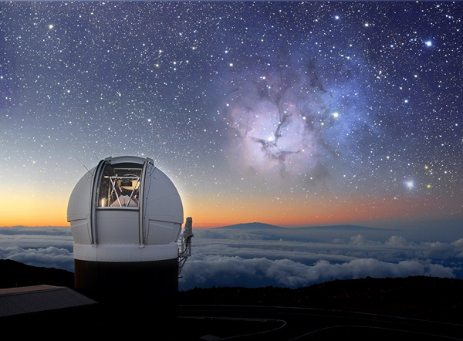Pan-STARRS1 Telescope, University of Hawaii
LIGO had not yet started their formal observing run, and with only two gravity wave detectors, one in Hanford, Washington, and one in Livingston, Louisiana, they could not pinpoint where in the sky, amongst billions and billions of galaxies, the source of this disturbance had occurred. The LIGO team’s first analysis was preliminary, but it showed that two black holes in tight orbits around each other had finally spiraled together and merged into a single black hole. The resulting turmoil launched a cascade of vibrations into the very fabric of spacetime that ultimately set the astonishingly sensitive pendulums at LIGO swinging together.
Pan-STARRS, the University of Hawaii’s Panoramic Survey Telescope and Rapid Response System, was prepared for just this eventuality. It has spent years mapping the sky to find all kinds of changing celestial objects, all the while building the most detailed map of the sky in five colours. This image of the sky, the PS1 Sky Survey, , is the ideal resource for trying to find the source of the gravity wave event. If 'sparks' fly when black holes merge then a new point of light will be seen in the sky. Pan-STARRS, with its powerful surveying capability, can rapidly map the region of the sky identified by LIGO, compare it to the previous map, and find anything that has changed.
To do this, the powerful computers of Pan-STARRS must construct a new image of the sky and then carefully subtract the pre-existing deep sky image. Whatever remains are the objects that have changed in the universe since the map was made, called 'transients'. In the large area provided by LIGO, there will be many more common variable objects like supernovae, stellar flares, highly variable stars, even variations in the active nuclei of galaxies, also fuelled by black holes. The team had to eliminate the 'normal' ones, and search for something truly new. Pan-STARRS was prepared for this from its years of ground-breaking work on every kind of astronomical transient.
"I’ve been interested in gravity waves since I was a kid." said Ken Chambers from the Institute for Astronomy at the University of Hawaii. He jumped at the possibly to sign up with LIGO to get their email alerts. "Most people thought the odds of them finding anything were too small to spend any time on it, but I was thrilled at the chance." But when that email came in the night, he knew it would be hard. The region LIGO had identified as most likely to contain the source was rising with the Sun at dawn, observable only for a few minutes before the sky became too bright. With its infrared filters, Pan-STARRS could observe the brightening sky for longer, and over the course of a few weeks, PS1 was able to map the most important sky regions. PS1 identified 56 astronomical explosions over 41 days after the LIGO event. But what were they?\
tephen Smartt from the Astrophysics Research Center at Queen’s University Belfast, leader of the spectroscopic effort to follow up the Pan-STARRS discoveries, explained: "We didn’t find anything in our data that was likely related to the gravitational wave source. We discovered over 50 new sources that are normal supernovae - exploding stars that we find all the time. We didn’t see any hint of unusual behaviour." There are two likely reasons. One is that the source was too far in the southern hemisphere, not visible from Hawaii. The other is that the source may have been too faint to detect it in the time available. "That is science," said Chambers. "Sometimes all you can report is what you don’t see because that is important information too. LIGO has opened a brand new field of astronomy, and confirmation from facilities like Pan-STARRS will be very important to understanding them."
The limits Pan-STARRS has set for a potential counterpart will be important for constraining theories of what should have been seen and demonstrate the infrastructure is in place to respond the next time LIGO finds a gravity wave. LIGO will have another observing campaign in the fall when PS2, the second Pan-STARRS telescope, will be ready, doubling the survey power of the system. Meanwhile, PS1 continues to map the sky every night, seeking the unknown. By: Manoa's Institute for Astronomy, Hawaii

Rosetta’s lander faces eternal hibernation 12 February: Silent since its last call to mother ship Rosetta seven months ago, the Philae lander is facing conditions on Comet 67P/Churyumov-Gerasimenko from which it is unlikely to recover.
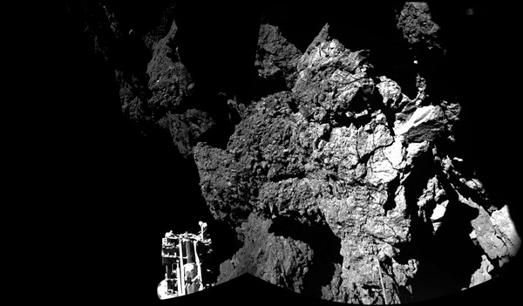 Rosetta’s lander Philae is safely on the surface of Comet 67P/Churyumov-Gerasimenko, as this mosaiced CIVA image confirms. One of the lander’s three feet can be seen in the foreground. SA/Rosetta/Philae/CIVA
Rosetta, which continues its scientific investigations at the comet until September before its own comet-landing finale, has in recent months been balancing science observations with flying dedicated trajectories optimized to listen out for Philae. However, the lander has remained silent since 9 July 2015. “The chances for Philae to contact our team at our lander control centre are unfortunately getting close to zero,” said Stephan Ulamec from the German Aerospace Center, DLR. “We are not sending commands any more, and it would be very surprising if we were to receive a signal again.”
Philae’s team of expert engineers and scientists at the German, French, and Italian space centres and across Europe have carried out extensive investigations to try to understand the status of the lander, piecing together clues since it completed its first set of scientific activities after its historic landing on 12 November 2014. A story with incredible twists and turns unfolded on that day. In addition to a faulty thruster, Philae also failed to fire its harpoons and lock itself onto the surface of the comet after its seven-hour descent, bouncing from its initial touchdown point at Agilkia to a new landing site, Abydos, over 1 km away. The lander's precise location has yet to be confirmed in high-resolution images.
A reconstruction of the flight of the lander suggested that it made contact with the comet four times during its two-hour additional flight across the small comet lobe. After bouncing from Agilkia, it grazed the rim of the Hatmehit depression, bounced again, and then finally settled on the surface at Abydos. Even after this unplanned excursion, the lander was still able to make an impressive array of science measurements, with some even as it was flying above the surface after the first bounce. Once the lander had made its final touchdown, science and operations teams worked around the clock to adapt the experiments to make the most of the unanticipated situation. About 80% of its initial planned scientific activities were completed. In the 64 hours following its separation from Rosetta, Philae took detailed images of the comet from above and on the surface, sniffed out organic compounds, and profiled the local environment and surface properties of the comet, providing revolutionary insights into this fascinating world.
However, with insufficient sunlight falling on Philae’s new home to charge its secondary batteries, the race was on to collect and transmit the data to Rosetta and across 510 million km of space back to Earth before the lander’s primary battery was exhausted as expected. Thus, on the evening of 14-15 November 0214, Philae fell into hibernation.
As the comet and the spacecraft moved closer to the Sun ahead of perihelion on 13 August 2015 -the closest point to the Sun along its orbit - there were hopes that Philae would wake up again. Estimates of the thermal conditions at the landing site suggested that the lander might receive enough sunlight to start warming up to the minimum –45°C required for it to operate on the surface even by the end of March 2015. It is worth noting that if Philae had remained at its original landing site of Agilkia, it would have likely overheated by March, ending any further operations.
On 13 June 2015, the lander finally hailed the orbiting Rosetta and subsequently transmitted housekeeping telemetry, including information from its thermal, power, and computer subsystems. Subsequent analysis of the data indicated that the lander had in fact already woken up on 26 April 2015, but had been unable to send any signals until 13 June. The fact that the lander had survived the multiple impacts on 12 November and then unfavourable environmental conditions, greatly exceeding the specifications of its various electronic components, was quite remarkable.
After 13 June, Philae made a further seven intermittent contacts with Rosetta in the following weeks, with the last coming on 9 July. However, the communications links that were established were too short and unstable to enable any scientific measurements to be commanded. Despite the improved thermal conditions, with temperatures inside Philae reaching 0°C, no further contacts were made as the comet approached perihelion in August. Nevertheless, while hopes of making contact again with Philae dwindle, Rosetta will continue to listen for signals from the lander as it flies alongside the comet ahead of its own comet landing in September. By: ESA, Noordwijk, Netherlands

How LISA Pathfinder will learn to "hear" the universe 16 February: LISA Pathfinder - the first step toward a space-based gravitational wave detector - launched into orbit last December from Kourou, French Guiana, but its origin goes back a century.

In 1916, following his revolutionary general relativity theory, Albert Einstein predicted that extreme objects could create gravitational waves. However, no one had ever found them. The European Space Agency hopes to change that and allow astronomers to study the universe for the first time outside the electromagnetic spectrum —-letting them 'hear' the universe, as the mission managers put it. The proof-of-concept mission is a flying physics lab that packs an optical bench with 22 mirrors and beam splitters. One laser beam aims at two free-falling test masses, while the other reflects through the bench. LISA Pathfinder will isolate these gold-platinum cube test masses from all external forces except gravity, allowing them to enter the most precise freefall ever observed. By Eric Betz\
Science mission begins for orbiting gravitational-wave detector prototype 16 February: Launched on 3 December, LISA Pathfinder reached its operational location on 22 January, nearly a million and a half kilometres from Earth in the direction of the Sun.
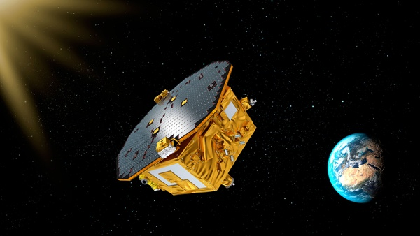The European Space Agency's LISA Pathfinder spacecraft has released both of its gold-platinum cubes, and will shortly begin its demanding science mission, placing these test masses in the most precise freefall ever obtained to demonstrate technologies for observing gravitational waves from space. ESA
As tests on the spacecraft and its precious payload continue, a major milestone was reached today. For the first time, the two masses -- a pair of identical 46 mm gold-platinum cubes -- in the heart of the spacecraft are floating freely, several millimetres from the walls of their housings. The cubes sit 38 cm apart linked only by laser beams. Throughout LISA Pathfinder’s ground handling, launch, the burns that raised its orbit, and the six-week cruise to its work site, each cube was held firmly in place by eight ‘fingers’ pressing on its corners. On 3 February, the locking fingers were retracted and a valve was opened to allow any residual gas molecules around the cubes to vent to space. Each cube remained in the centre of its housing held by a pair of rods softly pushing on two opposite sides. The rods were finally released from one test mass yesterday and from the other today, leaving the cubes floating freely, with no mechanical contact with the spacecraft.
This is why we sent the test cubes into space: to recreate conditions impossible to achieve in the gravitational field of our planet,” says Paul McNamara, ESA’s project scientist. “Only under these conditions is it possible to test freefall in the purest achievable form. We can’t wait to start running experiments with this amazing gravity laboratory.”
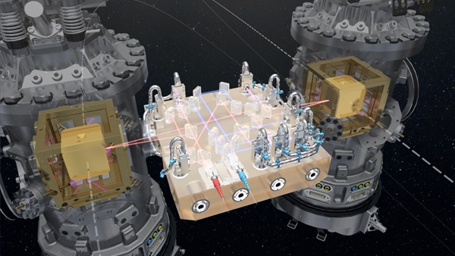 LISA Pathfinder has two gold–platinum cube test masses at its core, which float freely from their housings and are linked only by laser beams to measure their position continuously. ESA/ATG Medialab
It will be another week before the cubes are left completely at the mercy of gravity, with no other forces acting on them. Before then, minute electrostatic forces are being applied to move them around and make them follow the spacecraft as its flight through space is slightly perturbed by outside forces such as pressure from sunlight.
On 23 February, the team will switch LISA Pathfinder to science mode for the first time, and the opposite will become true: the cubes will be in freefall and the spacecraft will start sensing any motions towards them owing to external forces. Microthrusters will make minuscule shifts in order to keep the craft centered on one mass. Then the scientists will be in a position to run several months of experiments to determine how accurately the two freely-flying test masses can be kept positioned relative to each other, making measurements with the laser that links them. Roughly speaking, the required accuracy is on the order of a millionth of a millionth of a meter. The release of the test masses was clearly the most critical operation throughout the mission, as it was not possible to test it fully on the ground due to the small forces and movements involved. We are ecstatic with this world-class achievement,” says César García Marirrodriga, ESA’s project manager.
After final checks, LISA Pathfinder will begin its science mission on March 1, validating a key technology for observing gravitational waves from space. Gravitational waves are minute fluctuations in the fabric of spacetime, predicted by Albert Einstein’s general theory of relativity and directly observed for the first time recently by the Laser Interferometer Gravitational-Wave Observatory -- an announcement that created a worldwide sensation last week. As this discovery confirmed, ground-based experiments can detect high-frequency gravitational waves from cosmic events such as the coalescence of a pair of stellar remnants, like neutron stars or black holes.
However, to observe lower-frequency gravitational waves emitted by different astronomical sources, such as the merging of supermassive black holes at the centre of large galaxies, it is necessary to move the search into space. There, a future gravitational wave observatory, already identified as the goal for the L3 mission in ESA’s Cosmic Vision program, will measure distortions in the fabric of spacetime on the inconceivably tiny scale of a few millionths of a millionth of a meter over a distance of a million kilometres. In the coming months, LISA Pathfinder will verify the fundamental condition needed for a future gravitational wave observatory in space: putting test masses into freefall at unprecedented levels of accuracy, by isolating the two cubes from all external and internal forces except one: gravity. By: ESA, Noordwijk, Netherlands

Scientists pinpoint distance to fast radio burst 25 February: For the first time a team of scientists has tracked down the location of a fast radio burst (FRB), confirming that these short but spectacular flashes of radio waves originate in the distant universe.
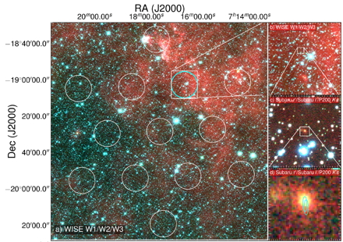This image shows the field of view of the Parkes radio telescope on the left. On the right are successive zoom-ins in on the area where the signal came from. The image at the bottom right shows the Subaru Telescope's image of the FRB galaxy, with the elliptical regions showing the location of the fading 6-day afterglow seen with ATCA.
The breakthrough, published in the journal Nature, was made using the Commonwealth Scientific and Industrial Research Organization (CSIRO) radio telescopes in eastern Australia and the National Astronomical Observatory of Japan’s Subaru telescope in Hawaii. “Our discovery opens the way to working out what makes these bursts,” said Simon Johnston, Head of Astrophysics at CSIRO and a member of the research team.
Fast radio bursts (FRBs) emit as much energy in one millisecond as the sun emits in 10,000 years, but the physical phenomenon that causes them is unknown. This, and their apparently huge distances, have tantalized scientists since their discovery in 2007. Only 16 bursts have ever been found but astronomers estimate that they might occur 10,000 times a day across the entire sky.
The recent paper in Nature records a burst from a host galaxy around 6 billion light-years away. Importantly, it also confirms that FRBs can be used to find matter in the universe that had ‘gone missing’. Astronomers think the contents of the universe are 70% dark energy, 25% dark matter, and 5% ordinary matter. However, when they add up the matter they can see in stars, galaxies and hydrogen gas, they still only find half as much ordinary matter as should be there - the rest has not been seen directly and so has been described as ‘missing’.
Using the burst (FRB 150418) as a tool, the team was able to ‘weigh’ the universe, or at least the normal matter it contains. "The good news is our observations and the model match - we have found the missing matter," explained Evan Keane from the SKA Organisation, lead author on the Nature paper. "It's the first time a fast radio burst has been used to conduct a cosmological measurement."
Most FRBs have been found by sifting through recorded data months or even years after it was taken, by which time it was too late for follow-up observations. To remedy this, Keane and his international team developed a system to detect FRBs within seconds, immediately alerting other telescopes with a view to pinpointing their location. The Parkes telescope detected the new FRB on April 18, 2015, and two hours later, CSIRO’s Compact Array telescope, 400 km north of Parkes, homed in on the patch of sky the flash had come from. It saw a radio source that lasted for six days before fading - the FRB’s radio afterglow. This let the researchers zoom in on the FRB about 1,000 times more precisely than any of the 16 previously detected bursts.
Meanwhile, in Hawaii, the 8.2-meter optical Subaru telescope was also at work. Looking at the FRB field, it found a galaxy that could be matched with the radio source seen by the Compact Array. More sleuthing showed that this object was an elliptical galaxy — a huge football-shaped mass of stars. Its redshift (0.492) means that it is about 6 billion light-years away. The galaxy is old, well past its prime period for star formation.
“This is not what we expected,” Johnston said. “It might mean that the FRB resulted from, say, two neutron stars colliding rather than anything to do with recent star birth.” However, there could be more than one road to an FRB, he added. “In the near future, using CSIRO’s Australian SKA Pathfinder (ASKAP) should be ideal and ASKAP will be able to start looking for FRBs this year,” he said. “We expect to find several a week, and really clean up.” By: CSIRO, Sydney, Australia
Source of these and further astronomy news items: www.astronomy.com/news

DID YOU KNOW?
Mission: Mars Part 9 Future missions

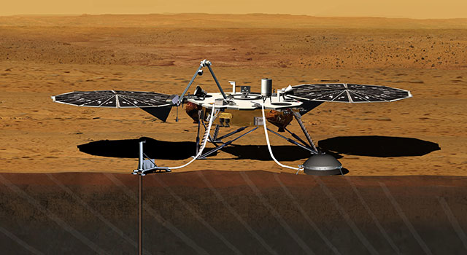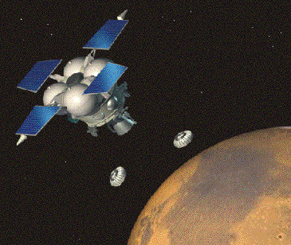
Insight lander – artist’s conception MetNet mission

Despite the roughly 60% failure rate, robotic exploration of Mars during the past 55 years has proved increasingly successful and has yielded information of increasing breadth and depth in line with the ever larger number of probe launches and associated huge technological advances. At first, exploration of Mars was a largely cerebral undertaking to learn more about the red planet. However, with time, the focus of the multi-national search for knowledge of Mars and its atmosphere has become mainly one of understanding its characteristics with a view to its potential for human habitability.

Seven orbiters and rovers are currently adding to the every-growing knowledge and understanding of Mars. They are not an end in themselves, but part of a continuing quest to explore the red planet. In addition to searching for evidence of past life, and the potential of Mars for future habitation, one technological goal of planetary discovery also remains to be achieved The only attempt, so far, to successfully return sample collected on Mars back to Earth was Russia’s Phobos-Grunt mission and that failed during launch.

A number of missions to Mars are in the pipeline. They include:
- The Finnish-Russian MetNet atmospheric science mission is planned for 2015-2016. It will use at least 16 small meteorological stations on Mars to establish a widespread observation network investigating the planet’s atmospheric structure, physics and meteorology.
- InSight (Interior exploration using Seismic Investigations Geodesy and Heat Transport) is scheduled for launch in 2016. The NASA lander will carry a drill and seismometer in order to determine the deep interior structure of Mars.
- As part of the ExoMars programme, ESA and the Russian Space Agency have two missions planned. The Trace Gas Orbiter and Schiaparelli lander are scheduled for launch in 2016, and the goal of the ExoMars rover, scheduled for launch in 2018, is to search for past or present microscopic life on Mars.
- The Indian space agency is planning a follow up to the Mars Orbiter mission. Sometime between 2018 and 2020, the launch of Mangalyaan 2 is scheduled to take place. Rather than the current orbiter-only, a greater payload including a lander and rover is planned.
- China unveiled a prototype rover based on its lunar rover Yutu in 2014. A mission to Mars with an orbiter, lander and the rover is to be launched before 2020.
- Mars 2020 is a planned NASA astrobiology mission involving a Curiosity-like rover.
- United Arab Emirates Space Agency has announced that its first mission will be to send a robotic mission to Mars by 2021.
- The Russian Mars-Grunt mission, planned for the mid-2020s, will be the second attempt to bring a sample of Martian soil to Earth.
- An ESA-NASA team is also proposing Mars sample return mission by the early 2020s. The 3-part concept would use an orbiter to launch the lander, a rover to collect samples, and an ascent vehicle to return the sample to the orbiter, which would then return to Earth.

The first manned mission to Mars is foreseen to take place within the next two decades.

Sources: Ridpath, I (Ed) (2012) Oxford dictionary of astronomy 2nd ed, revised, www.en.wikipedia.org, www.planetary.org, www.nasa.org, www.space.com, www.computerworld.com, www.astrobio.net

For more information on the Hermanus Astronomy Centre and its activities, visit our website at www.hermanusastronomy.co.za

COMMITTEE MEMBERS
Pierre de Villiers (Chairperson, observatory, youth club) 028 313 0109
Laura Norris (Treasurer) 028 316 4453
Peter Harvey (Secretary, monthly sky maps) 028 316 3486
Jenny Morris (Vice-chairperson, newsletter) 071 350 5560
Karin de Bruin (Observing) 028 316 2080
Derek Duckitt (Website editor) 082 414 4024
Bennie Kotze 128 316 3666
Deon Krige (Youth robotics project, astro-photography) 028 314 1045
John Saunders (Guest speakers and events) tibouchina286@gmail.com
Non-committee members with roles:
Lynette Geldenhuys (Education) 028 316 2428
Pierre Hugo (Cosmology interest group) 028 312 1639
Johan Retief (Hawston School Youth Club) 028 315 1132

