“The Southern Cross”

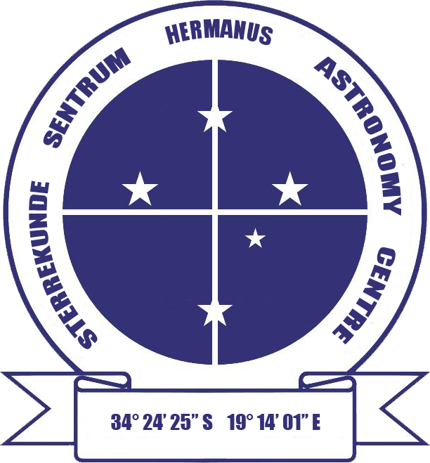

HERMANUS ASTRONOMY CENTRE NEWSLETTER

FEBRUARY 2016

2016 membership renewal reminder

The fees for 2016 are as follows:

Member: R140

Member’s spouse/partner/child, student: R70

Six-month membership from July – December 2016:

Member: R70 Member’s spouse etc, student: R40

Payment can be made in cash (at meetings directly to the Treasurer), or via online transfer. The Standard Bank details, for the latter, are as follows:
Account name – Hermanus Astronomy Centre
Account number – 185 562 531
Branch code – 051001
If you make an online donation, please include the word ‘membership’, and your name, or it is not possible to attribute the payment to you.

This month’s Centre meeting

The Annual General Meeting takes place on Monday 15 February in the Scout Hall starting at t 19.00.

2016 monthly meeting dates

Unless changed to accommodate holiday seasons, the monthly meetings will, in future, take place on the third Monday of the month. The remaining dates for 2016 are as follows: 15 February, 21 March, 18 April, 16 May, 20 June, 18 July, 15 August, 19 September, 17 October, 21 November and 19 December. See further details below.

WHAT’S UP?
Aldebaran (and Hyades) To the left of Orion, the inverted V shape of the Hyades cluster can be seen during the summer. Part of Taurus (the 17th largest constellation), its brightest star forms the bottom right hand point of the cluster. The 14th brightest star in the night sky, Aldebaran (Alpha Tauri) is a red giant with a surface temperature around 4,000 K, whose colour is easily visible to the naked eye. It forms the red eye of Taurus, the bull. Older and cooler than the Sun, Aldebaran has used up its hydrogen and is generating energy by fusing helium to form carbon. Although it appears to be part of the cluster, this is, in fact, a visual illusion. While Aldebaran is 67 light years (ly) away, the 200 or so stars of the cluster are around 150 ly away. One of over 2,000 known open clusters, Hyades is the closest major star cluster to Earth. They range in age from a few million to several billion years, making Hyades, at around 660 million years old, comparatively young.

LAST MONTH’S ACTIVITIES
Monthly centre meeting Dr Ian Glass, retired senior astronomer at the SAAO in Cape Town was the presenter on 25 January. He gave a fascinating talk on 'Proxima, our nearest star' in which he combined interesting biographical information about those who contributed to the discovery of Proxima Centauri in the Cape with the scientific advances which enabled the discovery to be made. He explained how understanding of proper motion, the individual motion of stars, and parallax, the angular difference between an objects direction as seen from two observation points, enabled astronomers to identify that Alpha Centauri (one of the Pointers) is located relatively close to Earth. Ongoing study of Alpha Centauri at the Cape led to discovery of small, cool Proxima Centauri, whose discovery was officially published in 1915. Ian then summarised more recent work using terrestrial and space-based instruments which has consistently increased the accuracy of measurement of distances to stars and speed of stellar motion. Finally, he outlined current efforts being made to identify whether either Alpha Centauri or Proxima Centauri have any planets orbiting them.

Interest groups
Cosmology Thirteen people (all members) attended the meeting on 11 January. They viewed the fifth pair of episodes of the 24 part DVD series on Time, given by Prof Sean Carroll from CalTech. The topics were: Lecture 9: ‘Entropy and counting’ and Lecture 10: ‘Playing with entropy’. As usual, the content prompted lively discussion.

Astro-photography At the meeting on 18 January, members continued work on image processing.

Other activities
Sidewalk astronomy No events took place in January.

Educational outreach
Hawston Secondary School Astronomy Group Meetings will recommence when the new term begins.
Lukhanyo Youth Club No meetings took place in January.

THIS MONTH’S ACTIVITIES
Monthly centre meeting This will take place on Monday 15 February at the Scout Hall at 19.00.. It will take the form of the Annual General Meeting.

There is an entrance fee of R10 per person for members, R20 per person for non-members, and R10 for children, students and U3A members.

Interest group meetings
The Cosmology group meets on the first Monday of each month at 19.00. This month’s meeting will take place on 1 February at the Scout Hall. Attendees will view the sixth pair of episodes of the new DVD series on Time given by Prof Sean Carroll from CalTech. The topics for this month are: Lecture 11: ‘The past hypothesis’ and Lecture 12: ‘Memory causation and action'.

There is an entrance fee of R10 per person for members, R20 per person for non-members, and R10 for children, students and U3A members. For further information on these meetings, or any of the group’s activities, please contact Pierre Hugo at pierre@hermanus.co.za

Astro-photography This group meets on the third Monday of each month. The next meeting will take place on 8 February. Members will continue to work on image processing.

To find out more about the group’s activities and the venue for particular meetings, please contact Deon Krige at astronomy.hermanus@gmail.com

Sidewalk astronomy No events have been scheduled for this month. Details will be e-mailed out if this situation changes.

Hermanus Youth Robotic Telescope Interest Group Work to gain access to the telescopes is underway, now that the schools have re-opened.

For further information on both the MONET and Las Cumbres projects, please contact Deon Krige at deonk@telkomsa.net

FUTURE ACTIVITIES

None is currently being planned.

2016 MONTHLY MEETINGS
Meetings take place on the third Monday of each month at the Scout Hall beginning at 19.00. Details for 2016 are:
15 Feb AGM
21 Mar ‘Missions into the solar system’. Presenter: Case Rijsdijk, Chair, Garden Route Centre
18 Apr TBA
16 May 'Our solar system and the order of the planets'. Presenter: Johan Retief, Centre member
20 June 'Cataclysmic variables'. Presenter: Hannes Breytenbach, UCT
18 July, 15 Aug, 19 Sept TBA
17 Oct ‘Dark skies: the unseen Universe’’. Presenter: Jenny Morris, Committee member
21 Nov 'Science we have learned from space telescopes'. Presenter, Pierre de Villiers, Chairman, HAC committee
19 Dec Xmas party

HERMANUS ASTRONOMY EDUCATION CENTRE (HAEC)
Work on the application to Overstrand Municipality for consent use of the preferred site, confirming details of the amended of architectural plans, and updated costings is ongoing. In the meantime, the Friends of the Observatory pledge fund continues to be an important source of funds to cover associated costs.

The Friends of the Observatory campaign was launched several years ago when preliminary work began on plans to construct an astronomical observatory in Hermanus. Over the years, members have been very generous, for which we are deeply grateful. It may seem logical to assume that, now money has been awarded by the National Lotteries Board, pledge monies are no longer needed. Unfortunately, that is not the case. NLC funds can only be used once the plans have been formally approved by the Municipality, something which is still awaited.

We would, therefore, be very grateful if members could either continue to contribute to the campaign or start becoming a contributor. Both single donations and small, regular monthly donations, of any amount, are welcome. Contributions can take the form of cash (paid at meetings), or online transfer, The Standard Bank details are as follows:
Account name – Hermanus Astronomy Centre
Account number – 185 562 531
Branch code – 051001
If you make an online donation, please include the word ‘pledge’, and your name, unless you wish to remain anonymous.

Science Centre The committee continues to work on the project. Consultation with interested and affected organizations and parties is being planned.

ASTRONOMY NEWS

Strong magnetic fields prevalent in stars 4 January: An international group of astronomers led by the University of Sydney has discovered strong magnetic fields are common in stars, not rare as previously thought, which will dramatically impact our understanding of how stars evolve.
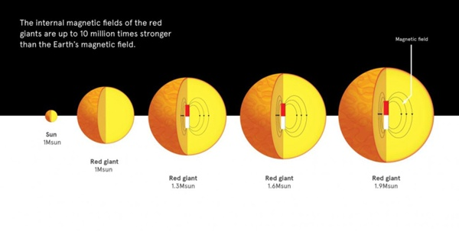 Stars like the Sun puff up and become red giants towards the end of their lives. The red giants - old Suns - of the same mass as the Sun do not show strong magnetic fields in their interior, but for stars slightly more massive, up to 60 percent host strong magnetic fields. University of Sydney
Using data from NASA’s Kepler mission and based on previous work by researchers at Caltech, the team found that stars only slightly more massive than the Sun have internal magnetic fields up to 10 million times that of Earth, with important implications for evolution and the ultimate fate of stars. Because these magnetic fields hide deep within a star’s interior, it was previously believed that only a small percentage of stars hosted strong internal magnetic fields. Consequently, the phenomenon has been left out of current models of stellar evolution.
“The prevalence of magnetic fields in stars slightly more massive than the Sun was unexpected and demonstrates that magnetic fields are robust features of stars that influence their evolution and their ultimate demise,” said Jim Fuller from Caltech in Pasadena, California.
The research is based on previous work led by Caltech and the University of California, Santa Barbara, which found that measurements of stellar oscillations, or sound waves, inside stars could be used to infer the presence of strong magnetic fields. Most stars 'ring' like a bell due to sound waves bouncing back and forth in their interiors. By looking at a large number of evolved versions of our Sun - so-called red giants - the team found that certain oscillation frequencies were missing in over half of the stars more massive than the Sun because they were suppressed by strong magnetic fields in the stellar cores. However, strong magnetic fields were found to be completely absent in red giants with the same mass as the Sun. This is significant because magnetic fields can alter the physical processes that take place in the core, including internal rotation rates, which affects how stars grow old. By: California Institute of Technology, Pasadena

Rosetta team confirms water ice on Comet 67P’s surface 14 January: Observations made shortly after Rosetta’s arrival at its target comet in 2014 have provided definitive confirmation of the presence of water ice. Although water vapour is the main gas seen flowing from Comet 67P/Churyumov–Gerasimenko, the great majority of ice is believed to come from under the comet’s crust, and very few examples of exposed water ice have been found on the surface.
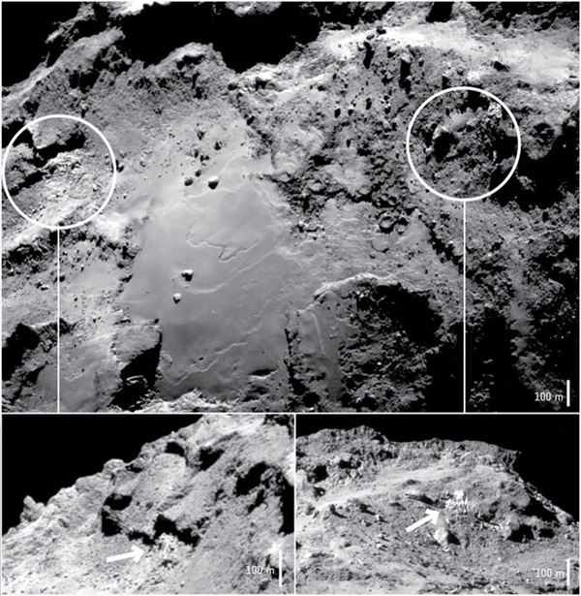 Two exposures of water ice identified by Rosetta’s VIRTIS instrument in the Imhotep region of Comet 67P/Churyumov–Gerasimenko in September–November 2014. The main image was taken on September 17, 2014, from a distance of about 28.8 km from the comet centre. The two insets show oblique views of the two icy exposures. The left-hand image was taken on 20 September 2014, from a distance of 27.9 km. The right-hand image was taken on 15 September 2014, from a distance of 29.9 km. The image contrasts have been enhanced to better reveal the icy regions. The approximate scale for each image is indicated. ESA/Rosetta/NavCam – CC BY-SA IGO 3.0

However, a detailed analysis by Rosetta’s VIRTIS infrared instrument reveals the composition of the comet’s topmost layer: It is primarily coated in a dark, dry, and organic-rich material but with a small amount of water ice mixed in. The ice is associated with cliff walls and debris falls, and was at an average temperature of about –120º C at the time. In those regions, pure water ice was found to occupy around 5% of each pixel sampling area, with the rest made up of the dark, dry material. The abundance of ice was calculated by comparing Rosetta’s VIRTIS infrared measurements to models that consider how ice grains of different sizes might be mixed together in one pixel.
The data reveal two different populations of grains: one is several tens of micrometers in diameter, while the other is larger, around 2 mm. These sizes contrast with the small grains, just a few micrometers in diameter, found in the Hapi region on the “neck” of the comet, as observed by VIRTIS in a different study. “The various populations of icy grains on the surface of the comet imply different formation mechanisms and different time scales for their formation,” said Gianrico Filacchione, lead author of the new study.
At Hapi, the small grains are associated with a thin layer of 'frost' that forms as part of the daily ice cycle, a result of fast condensation in this region over each comet rotation of just over 12 hours. “By contrast, we think that layers of the larger millimetre-sized grains we see in Imhotep have a more complex history. They likely formed slowly over time and are only occasionally exposed through erosion,” said Gianrico.
The observations of millimetre-sized grains can be explained by the growth of secondary ice crystals. One way this can occur is via 'sintering', whereby ice grains are compacted together. Another method is 'sublimation', in which heat from the Sun penetrates the surface, triggering the evaporation of buried ice. While some of the resulting water vapour may escape from the nucleus, a significant fraction of it re-condenses in layers beneath the surface.
“Ice grain growth can lead to ice-rich subsurface layers several metres thick that can then affect the large-scale structure, porosity, and thermal properties of the nucleus,” said Fabrizio Capaccioni, VIRTIS principal investigator. “The thin ice-rich layers that we see exposed close to the surface may be a consequence of cometary activity and evolution, implying that global layering did not necessarily occur early in the comet’s formation history.”
“Understanding which features on the comet are left over from its formation and which have been created during its evolution is somewhat challenging, but this is why we are studying a comet up close: to try to discover what processes are important at different stages of a comet’s lifetime,” said Matt Taylor from the European Space Agency.
By: ESA, Noordwijk, Netherlands

Green pea galaxy provides insights to early universe evolution 18 January: Newly formed dwarf galaxies were likely the reason that the universe heated up about 13 billion years ago, according to new work by an international team of scientists. The finding opens an avenue for better understanding the early period of the universe’s 14-billion-year history.

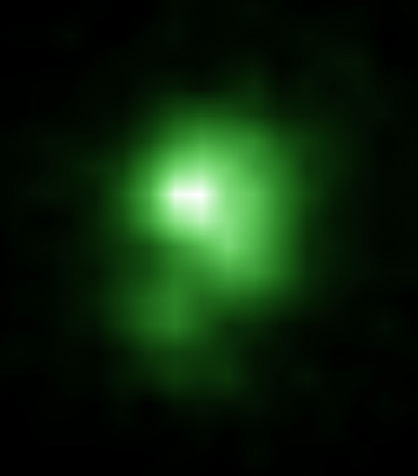 A Hubble Space Telescope image of the compact green pea galaxy J0925+1403. The diameter of the galaxy is approximately 6,000 light years, and it is about twenty times smaller than the Milky Way. NASA\
In the period of several hundred thousand years after the Big Bang, the universe was so hot and dense that matter was ionized instead of being in a neutral form. But 380,000 years later, the expansion of the universe had cooled it enough for matter to become neutral and for the first structures of the universe to form - gas clouds of hydrogen and helium. Gravity then made these gas clouds grow in mass and collapse to form the first stars and galaxies. Then, about one billion years after the Big Bang, another important transformation occurred: the universe reheated and hydrogen - the most abundant element - became ionised for a second time, as it had shortly after the Big Bang - an event which astronomers call 'cosmic re-ionization'. How this happened is still debated.
Astronomers have long thought that galaxies were responsible for this transformation. An international team of scientists, organized by Trinh Thuan from the University of Virginia, has largely validated that hypothesis. Trinh’s research colleagues are at institutions in Ukraine, the Czech Republic, Switzerland, France and Germany. Using data from an ultraviolet spectrometer aboard the Hubble Space Telescope, the team discovered a nearby compact dwarf galaxy emitting a large number of ionizing photons into the intergalactic medium — the space between galaxies. Scientists believe those photons are responsible for the universe’s re-ionization.
“This galaxy appears to be an excellent local analogy of the numerous dwarf galaxies thought to be responsible for the reionisation of the early universe,” Trinh said. “The finding is significant because it gives us a good place to look for probing the reionisation phenomenon, which took place early in the formation of the universe that became the universe we have today.”
Normal matter in the early universe consisted mostly of gas. Stars and star clusters are born from clouds of gas, forming the first galaxies. Ultraviolet radiation emitted by these stars contains numerous ionising photons. For this reason, scientists have long suspected that galaxies were responsible for cosmic reionisation. However, for reionisation to occur, galaxies must eject these photons into the intergalactic medium; otherwise, they are easily absorbed by the gas and dust before they can escape. Despite 20 years of intensive searching, no galaxy emitting sufficient ionising radiation has been found, and the mechanism by which the universe became re-ionised remains a mystery.
To solve this problem, the international research team proposed to observe 'green pea' galaxies. Discovered in 2007, these galaxies represent a special and rare class in the nearby universe. They appear green to light sensors and are round and compact, like a pea. They are believed to host stellar explosions or winds strong enough to eject ionizing photons.
The team examined data from the Sloan Digital Sky Survey. They identified approximately 5,000 galaxies that match their criteria: very compact galaxies emitting very intense UV radiation. Researchers selected five galaxies for observation with the Hubble Space Telescope. They found that the 'green pea' galaxy J0925+1403, located at a distance of three billion light-years from Earth, was 'ejecting' ionising photons with an intensity never seen before - about an 8% ejection. This fundamental discovery shows that galaxies of this type could explain cosmic reionisation, confirming the most commonly made hypothesis for this phenomenon. By: University of Virginia, Charlottesville

The aliens are silent because they are extinct 21 January: Life on other planets would likely be brief and become extinct very quickly due to runaway heating or cooling on their fledgling planets., said astrobiologists from the Australian National University (ANU).

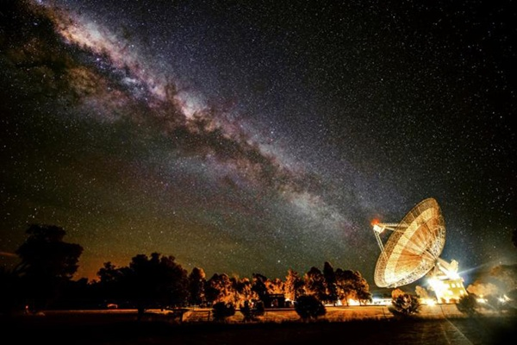 CSIRO Parkes radio telescope is in the search for alien civilisations. Wayne England
“The universe is probably filled with habitable planets, so many scientists think it should be teeming with aliens,” said Aditya Chopra from ANU. “Early life is fragile, so we believe it rarely evolves quickly enough to survive. Most early planetary environments are unstable. To produce a habitable planet, life forms need to regulate greenhouse gases such as water and carbon dioxide to keep surface temperatures stable.”
About four billion years ago, Earth, Venus, and Mars may have all been habitable. However, a billion years or so after formation, Venus turned into a hothouse and Mars froze into an icebox. Early microbial life on Venus and Mars, if there was any, failed to stabilise the rapidly changing environment, said Charley Lineweaver from ANU. “Life on Earth probably played a leading role in stabilising the planet’s climate,” he said.
“The mystery of why we haven’t yet found signs of aliens may have less to do with the likelihood of the origin of life or intelligence and have more to do with the rarity of the rapid emergence of biological regulation of feedback cycles on planetary surfaces,” he said. Wet, rocky planets with the ingredients and energy sources required for life seem to be ubiquitous. However, as Enrico Fermi pointed out in 1950, no signs of surviving extra-terrestrial life have been found. A plausible solution to Fermi’s paradox, say the researchers, is near universal early extinction, which they have named the Gaian Bottleneck. By: Australian National University in Canberra|
Theorists propose a new method to probe the beginning of the universe 25 January: How did the universe begin? And what came before the Big Bang? Cosmologists have asked these questions ever since discovering that our universe is expanding. The answers aren't easy to determine. The beginning of the cosmos is cloaked and hidden from the view of our most powerful telescopes. Yet observations we make today can give clues to the universe's origin. New research suggests a novel way of probing the beginning of space and time to determine which of the competing theories is correct.
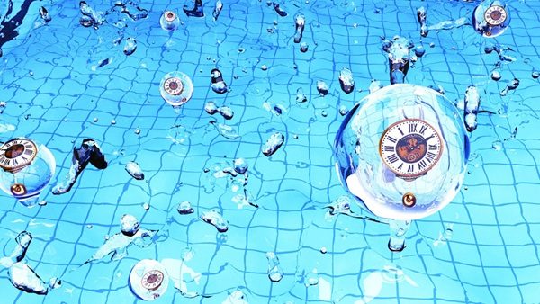 New research suggests that oscillating heavy particles generated "clocks" in the primordial universe that could be used to determine what produced the initial conditions that gave rise to the universe. Yi Wang and Xingang Chen
The most widely accepted theoretical scenario for the beginning of the universe is inflation, which predicts that the universe expanded at an exponential rate in the first fleeting fraction of a second. However a number of alternative scenarios have been suggested, some predicting a Big Crunch preceding the Big Bang. The trick is to find measurements that can distinguish between these scenarios.
One promising source of information about the universe's beginning is the cosmic microwave background (CMB) - the remnant glow of the Big Bang that pervades all of space. This glow appears smooth and uniform at first, but upon closer inspection varies by small amounts. Those variations come from quantum fluctuations present at the birth of the universe that have been stretched as the universe expanded.
The conventional approach to distinguish different scenarios searches for possible traces of gravitational waves, generated during the primordial universe, in the CMB. "Here we are proposing a new approach that could allow us to directly reveal the evolutionary history of the primordial universe from astrophysical signals. This history is unique to each scenario," says co-author Xingang Chen of the Harvard-Smithsonian Centre for Astrophysics (CfA) and the University of Texas at Dallas.
While previous experimental and theoretical studies give clues to spatial variations in the primordial universe, they lack the key element of time. Without a ticking clock to measure the passage of time, the evolutionary history of the primordial universe can't be determined unambiguously. "Imagine you took the frames of a movie and stacked them all randomly on top of each other. If those frames aren't labelled with a time, you can't put them in order. Did the primordial universe crunch or bang? If you don't know whether the movie is running forward or in reverse, you can't tell the difference," explains Chen.
This new research suggests that such 'clocks' exist, and can be used to measure the passage of time at the universe's birth. These clocks take the form of heavy particles, which are an expected product of the 'theory of everything' that will unite quantum mechanics and general relativity. They are named the 'primordial standard clocks'.
Subatomic heavy particles will behave like a pendulum, oscillating back and forth in a universal and standard way. They can even do so quantum-mechanically without being pushed initially. Those oscillations or quantum wiggles would act as clock ticks, and add time labels to the stack of movie frames in our analogy. "Ticks of these primordial standard clocks would create corresponding wiggles in measurements of the cosmic microwave background, whose pattern is unique for each scenario," says co-author Yi Wang of The Hong Kong University of Science and Technology. However, current data isn't accurate enough to spot such small variations.
Ongoing experiments should greatly improve the situation. Projects like CfA's BICEP3 and Keck Array, and many other related experiments worldwide, will gather exquisitely precise CMB data at the same time as they are searching for gravitational waves. If the wiggles from the primordial standard clocks are strong enough, experiments should find them in the next decade. Supporting evidence could come from other lines of investigation, like maps of the large-scale structure of the universe including galaxies and cosmic hydrogen.
By: Harvard-Smithsonian Centre for Astrophysics, Cambridge, Massachusetts
Source of these and further astronomy news items: www.astronomy.com/news

DID YOU KNOW?
Mission: Mars Part 8 Other nations join the quest

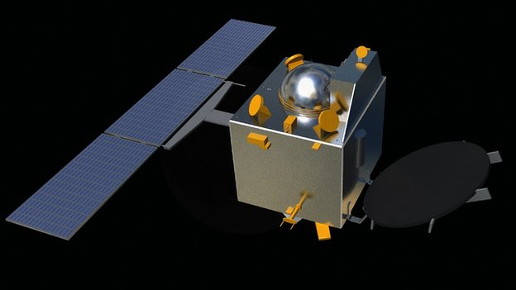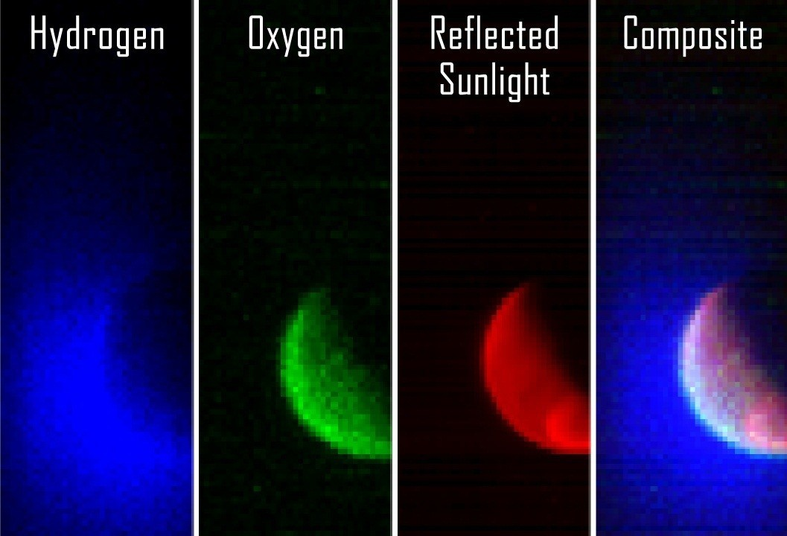
India joins the space nations Mars Orbiter MAVEN analyses of Martian atmosphere

The 2010s has been the decade when countries other than Russia, the United States and those in Western Europe have joined the quest to explore Mars. Although the 2011 Phobos-Grunt mission was a failure, it marked the entry of China.

India’s first foray into space exploration has proved to be much more successful. The Mars Orbiter mission (aka Mangalyaan) was launched late in 2013. Almost eleven months later the spacecraft successfully entered Mars orbit in September 2014. For the Indian Space Research Organisation (ISRO), their first mission to Mars is largely a technological demonstration of their claim to be the fourth space agency to successfully reach the red planet after the USSR, NASA and the ESA. However, the small 15 kg probe also has scientific objectives to study the Martian atmosphere. The success of the Mars Orbiter mission, made India the first country to reach Mars on its first attempt, and the first Asian country to successfully send an orbiter to Mars.

The science objective is being fulfilled by five instruments which investigate the morphology and mineralogy of the Martian surface, and several atmospheric parameters and constituents. Three instruments focus on the atmosphere: a methane sensor, a photometer which measures gas concentrations in the upper atmosphere, allowing for estimation of the amount of water loss to space undertake the atmospheric studies, and an atmospheric composition analyser which tests the atmosphere’s particle composition. The thermal infrared imaging spectrometer and a colour camera study the surface. The spectrometer measures the temperature and chemical emissions, enabling identification of the surface composition and mineralogy. The colour camera has the umbrella role of providing visual images to give the context for the spectrometer’s work.

The successful launch of MAVEN (Mars Atmospheric and Volatile EvolutioN) by NASA in 2013 means that there are currently two rovers and five orbiters either on or orbiting Mars, As its full name implies, the MAVEN orbiter’s mission is to undertake a detailed study of the atmosphere of Mars to help understand both current and past dramatic climate changes. Like other NASA orbiters, it also serves as a communication relay satellite for the robotic rovers on the surface. MAVEN was launched a couple of weeks after India’s orbiter, reaching its final orbit within days of the latter. Its elliptical orbit means that its altitude above Mars varies between 6,200 km and as close as 150 km.

Findings from other missions have provided strong evidence that Mars once had a dense enough atmosphere and was warm enough for liquid water to flow on its surface. However, somehow, that thick atmosphere has been lost to space. It is hypothesised that, over millions of years, Mars lost 99% of its atmosphere as the planet’s core cooled and its magnetic field decayed, allowing the solar wind to sweep away most of the water vapour and other gases in the atmosphere. MAVEN’s goal is to determine the history of the loss of atmospheric gases to space, thus providing answers about Mars’ climate evolution. Measurements of the current rate of loss will enable scientists to make inference on past processes. To this end, it is studying Mars’ upper atmosphere and its interactions with the solar wind.

During its one year mission MAVEN is not working alone. Data from the Curiosity rover’s Sample Analysis at Mars (SAM) instruments helps guide interpretation of the orbiter’s upper atmospheric measurements which are being made by eight main instruments.

Sources: Ridpath, I (Ed) (2012) Oxford dictionary of astronomy 2nd ed, revised, www.en.wikipedia.org, www.planetary.org, www.nasa.org, www.space.com, www.computerworld.com, www.astrobio.net

For more information on the Hermanus Astronomy Centre and its activities, visit our website at www.hermanusastronomy.co.za

COMMITTEE MEMBERS
Pierre de Villiers (Chairperson, observatory, youth club) 028 313 0109
Laura Norris (Treasurer) 028 316 4453
Peter Harvey (Secretary, monthly sky maps) 028 316 3486
Jenny Morris (Vice-chairperson, newsletter) 071 350 5560
Derek Duckitt (Website editor) 082 414 4024
Deon Krige (Youth robotics project, astro-photography) 028 314 1045
John Saunders (Guest speakers and events) tibouchina286@gmail.com
Non-committee members with roles:
Lynette Geldenhuys (Education) 028 316 2428
Pierre Hugo (Cosmology interest group) 028 312 1639
Johan Retief (Hawston School Youth Club) 028 315 1132

