Liquid water still flows on Mars
Researchers detected signatures of hydrated minerals on slopes where mysterious streaks are seen on the Red Planet.

By Jet Propulsion Laboratory, Pasadena, California | Published: Monday, September 28, 2015

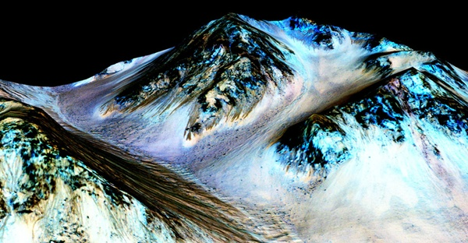
Dark, narrow streaks on martian slopes such as these at Hale Crater are inferred to be formed by seasonal flow of water on contemporary Mars. The streaks are roughly the length of a football field.
NASA/JPL-Caltech/Univ. of Arizona

New findings from NASA's Mars Reconnaissance Orbiter (MRO) provide the strongest evidence yet that liquid water flows intermittently on present-day Mars.
Using an imaging spectrometer on MRO, researchers detected signatures of hydrated minerals on slopes where mysterious streaks are seen on the Red Planet. These darkish streaks appear to ebb and flow over time. They darken and appear to flow down steep slopes during warm seasons, and then fade in cooler seasons. They appear in several locations on Mars when temperatures are above –10° F (–23° C) and disappear at colder times.
"Our quest on Mars has been to 'follow the water' in our search for life in the universe, and now we have convincing science that validates what we've long suspected," said John Grunsfeld from NASA's Science Mission Directorate in Washington. "This is a significant development as it appears to confirm that water — albeit briny — is flowing today on the surface of Mars."
These downhill flows, known as recurring slope lineae (RSL), often have been described as possibly related to liquid water. The new findings of hydrated salts on the slopes point to what that relationship may be to these dark features. The hydrated salts would lower the freezing point of a liquid brine, just as salt on roads here on Earth causes ice and snow to melt more rapidly. Scientists say it's likely a shallow subsurface flow with enough water wicking to the surface to explain the darkening.
"We found the hydrated salts only when the seasonal features were widest, which suggests that either the dark streaks themselves or a process that forms them is the source of the hydration. In either case, the detection of hydrated salts on these slopes means that water plays a vital role in the formation of these streaks," said Lujendra Ojha of the Georgia Institute of Technology in Atlanta.
Ojha first noticed these puzzling features as a University of Arizona undergraduate student in 2010, using images from the MRO's High Resolution Imaging Science Experiment (HiRISE). HiRISE observations now have documented RSL at dozens of sites on Mars. The new study pairs HiRISE observations with mineral mapping by MRO's Compact Reconnaissance Imaging Spectrometer for Mars (CRISM).
The spectrometer observations show signatures of hydrated salts at multiple RSL locations, but only when the dark features were relatively wide. When the researchers looked at the same locations and RSL weren't as extensive, they detected no hydrated salt.
Ojha and his team members interpret the spectral signatures as caused by hydrated minerals called perchlorates. The hydrated salts most consistent with the chemical signatures are likely a mixture of magnesium perchlorate, magnesium chlorate and sodium perchlorate. Some perchlorates have been shown to keep liquids from freezing even when conditions are as cold as –94° F (–70° C). On Earth, naturally produced perchlorates are concentrated in deserts, and some types of perchlorates can be used as rocket propellant.
Perchlorates have previously been seen on Mars. NASA's Phoenix lander and Curiosity rover both found them in the planet's soil, and some scientists believe that the Viking missions in the 1970s measured signatures of these salts. However, this study of RSL detected perchlorates, now in hydrated form, in different areas than those explored by the landers. This also is the first time perchlorates have been identified from orbit.
MRO has been examining Mars since 2006 with its six science instruments.
"The ability of MRO to observe for multiple Mars years with a payload able to see the fine detail of these features has enabled findings such as these: first identifying the puzzling seasonal streaks and now making a big step towards explaining what they are," said Rich Zurek of NASA's Jet Propulsion Laboratory in Pasadena, California.
For Ojha, the new findings are more proof that the mysterious lines he first saw darkening martian slopes five years ago are, indeed, present-day water.
"When most people talk about water on Mars, they're usually talking about ancient water or frozen water," he said. "Now we know there's more to the story. This is the first spectral detection that unambiguously supports our liquid water-formation hypotheses for RSL."
The discovery is the latest of many breakthroughs by NASA's Mars missions.
"It took multiple spacecraft over several years to solve this mystery, and now we know there is liquid water on the surface of this cold desert planet," said Michael Meyer from NASA's Mars Exploration Program at the agency's headquarters in Washington. "It seems that the more we study Mars, the more we learn how life could be supported and where there are resources to support life in the future."

