Between Galaxies: Lonely Supernovae
By: Anne McGovern | June 10, 2015

Researchers confirm that three solitary stars have gone supernovae in intergalactic space.
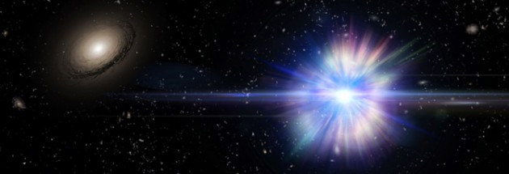Artist's concept of a Type Ia supernova exploding in the region between galaxies in a large cluster of galaxies, one of which is visible at the left.
Credit: Dr. Alex H Parker / NASA / SDSS
The space between a cluster’s galaxies is not entirely empty — sometimes there are stars. These intracluster stars have been ejected from their host galaxies and left to drift alone in intergalactic space. Though they’re solitary, they’re still important for understanding how much mass the universe contains, and where that mass is.
But there’s a catch. Although it’s possible to make out a star in relatively nearby Andromeda Galaxy, it’s not so easy to see individual stars beyond our local universe. This is why astronomers have turned to supernovae, which are much brighter and easier to spot, to map normal matter between more distant galaxies.
Several years ago, researchers using the Canada France Hawaii Telescope (CFHT) conducted a survey of Type Ia supernovae in and near distant galaxy clusters. They discovered four of these exploding white dwarfs floating in the mostly empty space between galaxies, but back then, they couldn’t resolve the images clearly enough to confirm the explosions’ solitude. Now, using images from the Hubble Space Telescope, Melissa Graham (University of California, Berkeley) and colleagues have the evidence in hand.
The authors confirm the solitary nature of three of the CFHT supernovae — the fourth appears to belong to a faint dwarf galaxy. Graham and her colleagues calculate that 11% of all the supernovae they found occurred in intergalactic space. And since the supernovae trace normal matter, including stars, gas, and dust that we can’t see, that means roughly 11% of normal matter floats in intergalactic space too.
Researchers hope to use intracluster stars to better understand galaxy cluster formation. Although one of these stars’ neighbors may lie more than 300 light-years away (about 70 times further than our own nearest neighbor, Proxima Centauri), the intracluster star remains gravitationally bound to the galaxy cluster as a whole. Think of it like a hermit living in a cave next to a large city; the hermit may not interact with the city’s residents, but she is still part of its larger society. Like hermits, intracluster stars can offer insight into the history of their galactic exilers.
For more information, check out the UC Berkeley press release.

References:
Melissa Graham et al. “Confirmation of Hostless Type Ia Supernovae Using Hubble Space Telescope Imaging.” The Astrophysical Journal, May 13, 2015.
David Sand et al. “Intracluster supernovae in the Multi-epoch Nearby Cluster Survey.” The Astrophysical Journal, October 11, 2011.

About Anne McGovern
Anne is the 2015 summer Editorial Intern at Sky & Telescope and a graduate student in Science and Medical Writing at Johns Hopkins University. She is sustained by science and literature, and loves to travel the world.
- See more at: http://www.skyandtelescope.com/astronomy-news/between-galaxies-lonely-supernovae-0610201577/?et_mid=759660&rid=247487212#sthash.AqyUjkBe.dpuf

