“The Southern Cross”

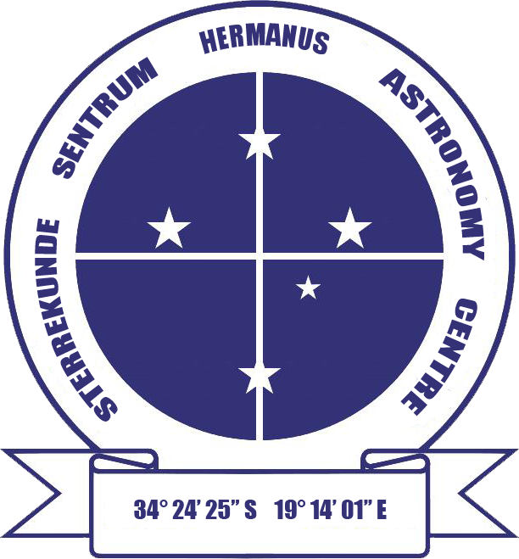

HERMANUS ASTRONOMY CENTRE NEWSLETTER

JULY 2014

Welcome to this month’s issue of the newsletter which, we hope, you find the content both informative and enjoyable.

Did you know? This month, we start a new 12 part series titled ‘Some important female astronomers’. Although not so in modern astronomy, historically, only a tiny number of women formed part of the profession. Small though their numbers were, however, many made significant contributions to both astronomy and cosmology. This series outlines the lives and achievements of twelve of these women, beginning in the late 18th century with Caroline Herschel.

WHAT’S UP?
Meteor showers July is the month to look for meteor showers. Although active from earlier in the month until well into August, three showers peak at the end of July: Piscis Australids on the 28th from 21.30 – 05.00, Southern δ Aquariids on the 29th from 22.00 – 05.00, and α Capricornids on the 30th from 20.00 – 04.00. The new moon makes conditions favourable for at least one successful evening. The relevant constellations of Piscis Austrinus (the Southern Fish), Aquarius and (the Water Carrier) and Capricorn (the Sea Goat) can be found in the area to the right of the distinctive delta wing shaped constellation of Aquila (the Eagle) towards the east. Meteor showers like these are annual events. Originating from one point in the sky, they are streams of cosmic debris from comets, which enter Earth’s atmosphere at very high speeds. The resulting friction causes the small dust particles or meteoroids to burn up, leaving a trail of excited ionised particles in their paths, the result of which forms the visible light or ‘shooting stars’ which can be observed.

LAST MONTH’S ACTIVITIES
Monthly centre meeting On 5 June, Lia Labuschagne from the ASSA in Cape Town gave her postponed talk on ‘Einstein – the man (and a bit about his work)’. It was clear that Lia had researched her subject both widely and deeply, something which enriched her very interesting presentation on a complex and remarkable, yet humble man. She summarised Einstein’s several groundbreaking theories, including special and general relativity, against the events taking place in his life. The latter involved both numerous moves within Europe and finally to the United States, and often challenging or unhappy relationships with family members, women and his children. She also touched on the way in which his fame pulled him into public and political arena. At times, he was an unwilling participant, but sometimes it enabled him to take a public stand on issues of importance to himself eg his concerns for the future of humanity in the new atomic age and his support for Judaism and the Jewish state She concluded with evidence, from images of some of the many books, magazines, advertising, posters and past and present pop culture material which feature)d) his life, name and/or face, of the continuing centrality of Einstein in the collective consciousness of global society, more than half a century after his death.

Interest groups
Cosmology Fourteen people (12 members, 2 visitors) attended the meeting on 2 June. They watched the fifth pair of programmes in the DVD series ‘Black holes, tides and curved spacetime: understanding gravity’ presented by Dr Benjamin Schumacher from the University of Texas at Austin. The topics were: Part 9: ‘Nudge – perturbations of orbits’ and Part 10: ‘Resonance – surprises in the intricate dance’

Astro-photography The meeting scheduled for 16 June was cancelled.

Hermanus Binocular Observation Programme (HBOP) Members have received the final briefing and been encouraged to undertake practical star-gazing, either in their own time or during scheduled Sidewalk astronomy evenings.

If you are interested in obtaining the materials distributed to group members, please e-mail petermh@hermanus.co.za

Other activities
Sidewalk astronomy Unfortunately, cloudy weather meant that the sessions scheduled for 30 and 31 May and again on 27 June did not take place. The night sky was clear for the planned event on 28 June, but, it was seemingly too cold for people to venture out.

Educational outreach
Youth club The June meeting was organized and presented by SANSA staff.
Hermanus Youth Robotic Telescope Interest Group Unfortunately, the Las Cumbres and Monet telescopes are still not available for public use.

For further information on both the MONET and Las Cumbres projects, please contact Deon Krige at deonk@telkomsa.net

U3A presentations During June, Pierre de Villiers presented three talks on Galileo, marking the 450th anniversary of his birth. The content which Pierre presented demonstrated his in-depth research into Galileo’s life and work, the regular inclusion of quotations directly from Galileo’s own writings strengthening the image portrayed of the man who is widely recognised as the father of modern science as well as the first to open up the skies to close study via his work and observations with the newly developed telescope.

THIS MONTH’S ACTIVITIES
Monthly centre meeting This month’s meeting will take place on 3 July. The presenter is Centre member Johan Retief, who will be talking about ‘The astronomy of Stonehenge’. Johan is a regular HAC presenter. His previous talks, on a variety of interesting subjects, have always been carefully compiled, and presented in an informative and enjoyable style. No doubt, the same will be true of a topic which is of ongoing interest to many people.

An entrance fee of R20 will be charged per person for non-members and R10 for children, students and U3A members.

Interest group meetings
The Cosmology group meets meeting on the first Monday of the month at 7 pm at SANSA. This month’s meeting will take place on 7 July. The sixth pair of programmes in the 24 part DVD series ‘Black holes, tides and curved spacetime: understanding gravity’, presented by Dr Benjamin Schumacher from the University of Texas at Austin will be shown and discussed. The topics are: Part 11: ‘The million body problem’ and Part 12: ‘The billion year battle’.

An entrance fee of R20 will be charged per person for non-members and R10 for children, students and U3A members. For further information on these meetings, or any of the group’s activities, please contact Pierre Hugo at pierre@hermanus.co.za

Astro-photography This group meets on the third Monday of each month. The next meeting will be on 21 July.

To find out more about the group’s activities and the venue for particular meetings, please contact Deon Krige at astronomy.hermanus@gmail.com

FUTURE ACTIVITIES
Possible trips are being considered, but nothing has been arranged yet.
2014 MONTHLY MEETING DATES
Unless affected by public holidays, these meetings will take place on the first Thursday of each month at SANSA, beginning at 7 pm. Details are listed below.

3 July ‘The astronomy of Stonehenge’. Presenter: Johan Retief, HAC
member.
7 August ‘The High Energy Stereoscopic System (HESS) in the Namibian
desert’. Presenter: Derek Duckitt, HAC committee member.
4 September ‘Astro-photography’. Presenter: Deon Krige, HAC committee
member.
2 October Topic: TBA Presenter: Pierre de Villiers, Chairperson, HAC
6 November ‘Milestones in radio astronomy: from the merry-go-round to the
SKA’. Presenter: Jenny Morris, Vice-chairperson, HAC committee.
5 December Xmas party.

OBSERVATORY PROJECT

Work on completing the procedures required to obtain the lease for the site on Rotary Way from Overstrand Municipality and on updating the architectural plans and related costings for submission to the National Lotteries Board continues.

Meanwhile, he ‘Friends of the Observatory’ campaign continues. We are very grateful to members who have already contributed to this, and hope that the generosity of the Centre’s membership continues. Both single donations and small, regular monthly donations, of any amount, are welcome.

Contributions can take the form of cash (paid at meetings), or online transfer, The Standard Bank details are as follows:
Account name – Hermanus Astronomy Centre
Account number – 185 562 531
Branch code – 051001
If you make an online donation, please include the word ‘pledge’, and your name, unless you wish to remain anonymous.

ASTRONOMY NEWS
Discovery of a triple supermassive black hole by South African and international scientists 25 June: SKA SA Project Director Bernie Fanaroff today congratulated Cape Town astronomer Roger Deane and the team of SKA SA-funded researchers who have discovered a triple supermassive black hole system. Four South African institutions (the Universities of Cape Town and the Western Cape, as well as Rhodes University and SKA South Africa) are represented by the research team, which is a very positive confirmation of the dynamic and significant radio astronomy which has developed rapidly in South Africa. The discovery demonstrates that South Africa has the scientific and technical expertise to be a world leader in radio astronomy and to contribute directly to gravitational wave experiments that will provide fundamental insights not only to astronomy, but also more broadly to physics.

Multiple supermassive black hole systems are thought to have a significant impact on the way galaxies evolve, particularly through their impact on stars and gas as they spiral in towards one another. When these black holes get very close to one another they are expected to emit gravitational waves. Einstein predicted these ripples in space-time a century ago and MeerKAT and the SKA have been designed to detect them.

Although they were predicted theoretically, these exotic back hole systems have remained elusive for decades. This discovery suggests that they are more common than previous observations have shown and predicts that the radio telescopes we are building here in South Africa and Africa will be able to discover many more. This highlights the high-impact science that will be done with the African VLBI Network (AVN), the planned radio telescope comprised of an array of converted telecommunication dishes. It also connects the type of science done with VLBI arrays with the experiments to be performed with MeerKAT and eventually with the SKA.

Medial release issued by SKA SA www.ska.ac.za

‘Neapolitan’ exoplanets come in three flavours 3 June: The planets of our solar system come in two basic flavours, like vanilla and chocolate ice cream. We have small rocky terrestrials like Earth and Mars and large gas giants like Neptune and Jupiter. We’re missing the astronomical equivalent of strawberry ice cream — planets between about one and four times the size of Earth. NASA’s Kepler mission has discovered that these types of planets are common around other stars.

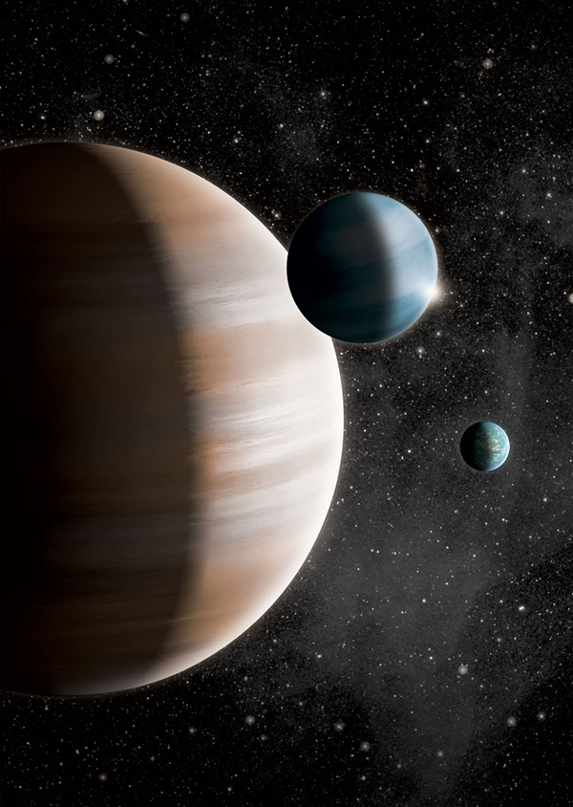
New research finds that exoplanets can be divided into three groups – terrestrials, gas giants, and mid-sized "gas dwarfs" – based on how their host stars tend to fall into three distinct groups defined by their compositions. All three are portrayed in this artist's conception. J. Jauch

New research following up on the Kepler discoveries shows that alien worlds, or exoplanets, can be divided into three groups — terrestrials, gas giants, and mid-sized “gas dwarfs” — based on how their host stars tend to fall into three distinct groups defined by their compositions. “We were particularly interested in probing the planetary regime smaller than four times the size of Earth because it includes three-fourths of the planets found by Kepler. That’s where you’ll find rocky worlds, which are the only kind that we would consider potentially habitable,” said lead author Lars A. Buchhave of the Harvard-Smithsonian Center for Astrophysics (CfA) in Cambridge, Massachusetts.

Kepler finds exoplanets using the transit method, looking for a star that dims as a planet passes in front of it from our point of view. We can learn the planet’s size from how much starlight it blocks. However, to determine the planet’s composition, we need to measure its mass so its density can be calculated. A rocky planet will be much denser than a gas giant. Unfortunately, the smaller a planet, the harder it is to measure its mass, especially for the dim and distant stars examined by Kepler.

Buchhave and his colleagues took a different approach. They measured the amount of elements heavier than hydrogen and helium, which astronomers collectively call metals, in stars with exoplanet candidates. Since a star and its planets form from the same disk of material, the metallicity of a star reflects the composition of the protoplanetary disk. The team took follow-up spectra of more than 400 stars hosting over 600 exoplanets. Then, they conducted a statistical test to see if the sizes of the planets fell into natural groups, along with the stellar metallicities.

They found two clear dividing lines — one at a size 1.7 times as large as Earth and the other at a size 3.9 times larger than Earth. They infer that these boundaries also mark changes in composition. Planets smaller than 1.7 Earths are likely to be completely rocky, while those larger than 3.9 Earths are probably gas giants. Planets between 1.7 and 3.9 times the size of Earth were dubbed gas dwarfs since they have thick atmospheres of hydrogen and helium. The rocky cores of gas dwarfs formed early enough to accrete some gas, although they did not grow as large as gas giants like Jupiter.

In addition, Buchhave and his collaborators discovered that the size of the largest rocky world isn’t fixed. The farther a planet is from its star, the larger it can grow before accumulating a thick atmosphere and turning into a gas dwarf. This suggests that some super-Earths can grow into true monsters. Finally, the team found that stars with small terrestrial worlds tended to have metallicities similar to the Sun. Stars hosting gas dwarfs tended to be slightly more metal-rich. Stars with gas giants contained the most metals — about 50 percent more than our Sun. “It seems that there is a ‘sweet spot’ of metallicity to get Earth-size planets, and it’s about the same as the Sun. That makes sense because at lower metallicities you have fewer of the building blocks for planets, and at higher metallicities you tend to make gas giants instead,” said Buchhave.

He emphasizes that metallicity is only one of many factors determining what kinds of planets will form around a given star. Also, their study was limited to relatively close-in planets since those were the easiest for Kepler to spot. They plan to extend their study to planets in wider orbits as that data becomes available.

By: Harvard-Smithsonian Center for Astrophysics, Cambridge, Massachusetts

Powerful magnetic fields challenge black holes' pull 4 June: Black holes are thought to dominate their surroundings by their extremely powerful gravitational pull. However, other forces that are usually considered to be weaker are also at work near these objects. These include forces exerted by the pressure of the infalling hot gas and magnetic forces. In a surprising twist, astronomers at the Max Planck Institute for Radio Astronomy (MPIfR) and Lawrence Berkeley National Laboratory (LBNL) have found that in fact magnetic forces can be as strong as gravity near supermassive black holes.

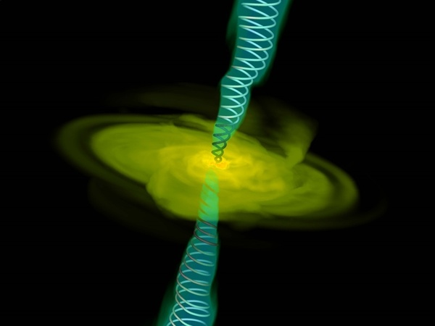
A computer simulation of gas (in yellow) falling into a black hole (too small to be seen). Twin jets are also shown with magnetic field lines.
Alexander Tchekhovskoy (LBNL)
Some black holes that are voraciously consuming interstellar gas also expel some of it in twin narrow outflows, or jets. This study focused on those supermassive black holes at the centres of galaxies that have observed radio-emitting jets. "We realised that the radio emission from a black hole's jets can be used to measure the magnetic field strength near the black hole itself," says study lead author Mohammad Zamaninasab (formerly at the MPIfR and supported by a grant from Deutsche Forschungsgemeinschaft, DFG). "Our real 'aha' experience came when we compared our magnetic force measurements to the force of gravity near black holes and found them to be comparable."
On a purely theoretical level, the possibility that magnetic fields may be as strong as gravity near black holes has been studied by state-of-the-art computer simulations. “When the infalling gas carries enough magnetic field in our simulations, then the magnetic field near the black hole gets stronger until it balances gravity," explains Alexander Tchekhovskoy of LBNL, a co-author of the study. “This fundamentally changes the behaviour of the gas near the black hole.” Surprisingly, the magnetic field strength around these exotic objects is comparable to the magnetic field produced in something more familiar: an MRI machine that you can find in your local hospital. Both supermassive black holes and MRI machines produce magnetic fields that are roughly 10,000 times stronger than Earth's surface magnetic field, which is what guides an ordinary compass.
The measurements of the magnetic field strength near the black hole were based on mapping what fraction of the radio emission is absorbed at different locations near the base of the jet. “Such observations existed for an order of hundred sources from earlier work of several international research teams using the Very Long Baseline Array, a network of radio telescopes spread across the United States," says co-author Tuomas Savolainen from MPIfR. “A large fraction of these measurements had just relatively recently become available thanks to a large observing program called MOJAVE, which monitors several hundred jets launched by supermassive black holes.”
The strength of the magnetic field near the black hole horizon also controls how powerful its jets are and, therefore, how luminous they appear at radio wavelengths according to current theories that treat black holes as a sort of spinning magnet. Thus, it is possible that the bright radio jets emanate from those black hole systems that have magnetic fields as strong as gravity. These results may lead to changes in how to interpret black hole observations. “If our ideas hold up to further scrutiny, then astronomers' expectations for how to measure black hole properties would need to be changed,” concludes Eric Clausen-Brown, also from MPIfR. “Our study also changes how powerful we expect black hole jets can be, and since these jets can impact their own galaxies and beyond, we may need to rethink how much of an environmental impact black holes can have.”
By: Max Planck Institute for Radio Astronomy, Bonn, Germany

CERN experiment takes us one step closer to discovering where all the antimatter went 6 June: New research published June 6 by researchers from CERN has brought scientists a step closer to understanding where all the antimatter has gone. This matter-antimatter asymmetry is one of the greatest challenges in physics, and at this moment in time, the universe seems to be composed entirely of matter — the only antimatter around is created by researchers at places like CERN. Yet theories predict that exactly equal amounts of matter and antimatter would have been created in the Big Bang. So where did all the antimatter go?

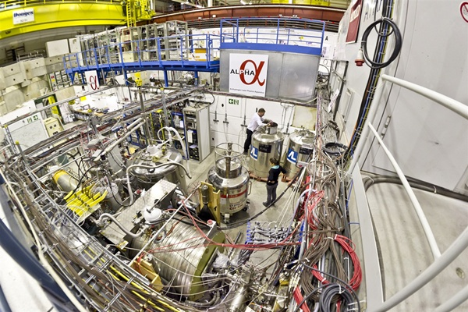
General view of the ALPHA experiment.
CERN
This new research, undertaken by the ALPHA experiment at CERN's Antiproton Decelerator (AD) in Geneva, is the first time that the electric charge of an anti-atom has been measured to high precision. Measuring the electric charge of antihydrogen atoms is a way to study any subtle differences between matter and antimatter that could account for the lack of antimatter in the universe. The ALPHA experiment reports a measurement of the electric charge of antihydrogen atoms, finding it to be compatible with zero to eight decimal places. This is the first time that the charge of an anti-atom has been measured to high precision and confirms scientists’ expectation that the charges of its constituents, the positron and antiproton, are equal and opposite.
"This is the very first study which has made a precise determination of a property of antihydrogen," said Mike Charlton, who leads the United Kingdom effort in ALPHA from Swansea University. “This advance was only possible using ALPHA's trapping technique, and we are optimistic that further developments of our program will yield many such insights in the future. We look forward to the restart of the Antiproton Decelerator program in August so that we can continue to study antihydrogen with ever increasing accuracy." "Though the result is not surprising, it is a fundamental test that matter and antimatter have equal and opposite electric charges,” said John Womersley from the United Kingdom’s Science and Technology Facilities Council (STFC). “It is reassuring that nature behaves as expected, but as scientists we should never take anything for granted, and measurements like this are therefore very important indeed."
Antiparticles should be identical to matter particles except for the sign of their electric charge. So while the hydrogen atom is made up of a proton with charge +1 and an electron with charge –1, the antihydrogen atom consists of a charge –1 antiproton and a charge +1 positron. Scientists know, however, that matter and antimatter are not exact opposites — nature seems to have a one part in 10 billion preference for matter over antimatter. However, they do not know why, so it is important to measure the properties of antimatter to great precision — the principal goal of CERN's AD experiments. ALPHA achieves this by using a complex system of particle traps that allow antihydrogen atoms to be produced and stored for long enough periods to make detailed studies. Understanding the matter-antimatter asymmetry is one of the greatest challenges in physics today. Any detectable difference between matter and antimatter could help solve the mystery and open a window to new physics.

To measure the charge of antihydrogen, the ALPHA experiment studied the trajectories of antihydrogen atoms released from the trap in the presence of an electric field. If the antihydrogen atoms had an electric charge, the field would deflect them, whereas neutral atoms would be undeflected. The result, based on 386 recorded events, gives a value of the antihydrogen electric charge as (–1.3±1.1±0.4) × 10^{–8}, the plus or minus numbers representing statistical and systematic uncertainties on the measurement.

By CERN, Geneva, Switzerland

New molecules around old stars 18 June: Using the European Space Agency’s (ESA) Herschel Space Observatory, astronomers have discovered that a molecule vital for creating water exists in the burning embers of dying Sun-like stars. When low- to middle-weight stars like our Sun approach the end of their lives, they eventually become dense white dwarf stars. In doing so, they cast off their outer layers of dust and gas into space, creating a kaleidoscope of intricate patterns known as planetary nebulae.

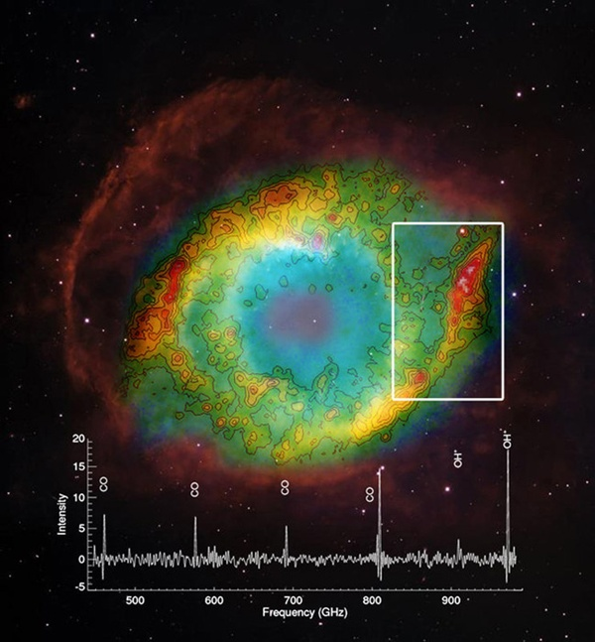
Herschel image of the Helix Nebula using the SPIRE instrument at wavelengths around 250 micrometers, superimposed on Hubble image of the nebula. The spectrum corresponds to the outer region of the Helix Nebula outlined on the SPIRE image. It identifies the OH+ molecular ion, which is needed for the formation of water. ESA’s Herschel space observatory is the first to detect this molecule in planetary nebulae – the product of dying Sun-like stars.
Hubble image: NASA/ESA/C.R. O’Dell (Vanderbilt University), M. Meixner & P. McCullough (STScI); Herschel image: ESA/Herschel/SPIRE/MESS Consortium/M. Etxaluze et al.

These actually have nothing to do with planets, but were named in the late 18th century by astronomer William Herschel because they appeared as fuzzy circular objects through his telescope, somewhat like the planets in our solar system. Over two centuries later, planetary nebulae studied with William Herschel’s namesake, the Herschel Space Observatory, have yielded a surprising discovery. Like the dramatic supernova explosions of weightier stars, the death cries of the stars responsible for planetary nebulae also enrich the local interstellar environment with elements from which the next generations of stars are born. While supernovae are capable of forging the heaviest elements, planetary nebulae contain a large proportion of the lighter “elements of life,” such as carbon, nitrogen, and oxygen made by nuclear fusion in the parent star.

A star like the Sun steadily burns hydrogen in its core for billions of years. However, once the fuel begins to run out, the central star swells into a red giant, becoming unstable and shedding its outer layers to form a planetary nebula. The remaining core of the star eventually becomes a hot white dwarf pouring out ultraviolet radiation into its surroundings. This intense radiation may destroy molecules that had previously been ejected by the star and that are bound up in the clumps or rings of material seen in the periphery of planetary nebulae. The harsh radiation was also assumed to restrict the formation of new molecules in those regions.

However, in two separate studies using Herschel, astronomers have discovered that a molecule vital to the formation of water seems to rather like this harsh environment and perhaps even depends upon it to form. The molecule, known as OH+, is a positively charged combination of single oxygen and hydrogen atoms. In one study, led by Isabel Aleman of the University of Leiden in the Netherlands, 11 planetary nebulae were analyzed, and the molecule was found in just three. What links the three is that they host the hottest stars, with temperatures exceeding 100,000º Celsius. “We think that a critical clue is in the presence of the dense clumps of gas and dust, which are illuminated by UV and X-ray radiation emitted by the hot central star,” said Aleman. “This high-energy radiation interacts with the clumps to trigger chemical reactions that lead to the formation of the molecules.”

Meanwhile, another study, led by Mireya Etxaluze of the Instituto de Ciencia de los Materiales de Madrid, Spain, focused on the Helix Nebula, one of the nearest planetary nebulae to our solar system at a distance of 700 light-years. The central star is about half the mass of our Sun but has a far higher temperature of about 120,000º C. The expelled shells of the star, which in optical images appear reminiscent of a human eye, are known to contain a rich variety of molecules.
Herschel mapped the presence of the crucial molecule across the Helix Nebula and found it to be most abundant in locations where carbon monoxide molecules, previously ejected by the star, are most likely to be destroyed by the strong UV radiation. Once oxygen atoms have been liberated from the carbon monoxide, they are available to make the oxygen–hydrogen molecules, further bolstering the hypothesis that the UV radiation may be promoting their creation.

The two studies are the first to identify in planetary nebulae this critical molecule needed for the formation of water, although it remains to be seen if the conditions would actually allow water formation to proceed. “The proximity of the Helix Nebula means we have a natural laboratory on our cosmic doorstep to study in more detail the chemistry of these objects and their role in recycling molecules through the interstellar medium,” said Etxaluze. “Herschel has traced water across the universe from star-forming clouds to the asteroid belt in our own solar system,” said Göran Pilbratt from ESA. “Now we have even found that stars like our Sun could contribute to the formation of water in the universe, even as they are in their death throes.”

By: ESA, Noordwijk, Netherlands

Source of these and further astronomy news items: www.astronomy.com/news

DID YOU KNOW?
Some important female astronomers Part 1: Caroline Herschel

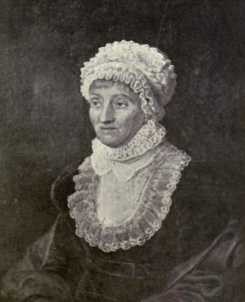 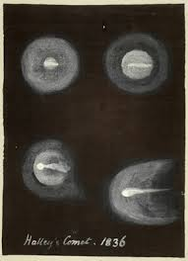 Drawing of Halley’s comet by Caroline
Herschel

“…however, important man becomes, he is nothing compared to the stars.” (Caroline Herschel)

The German-British sister of Sir William Herschel, who moved to stay with her brother to England as his housekeeper and assistant, was an astronomer in her own right. In fact, she was the first female astronomer to be widely recognised for her achievements.

Born in Germany in 1750, the fifth of six children, Caroline Lucretia was twelve years younger than William. The typhus she caught at the age of 10 stunted her growth and she grew to only four foot three inches in height. Her family decided that, as this deformity would mean she would never marry, she should become a house servant. Until her father died in 1767, she did so, working in the family’s kitchen. However, she was determined to lead a more fulfilling life and grabbed the opportunity offered her when William invited her to join him in England in 1772.

At this time, William was working as an organist and music teacher in Bath, and Caroline took several singing lessons a day from him, becoming quite a well known vocalist in the area. When William started developing his interest in astronomy, she became his assistant. In addition to her housekeeping responsibilities, her other roles included helping to grind and mount mirrors, meticulously recording his nocturnal observations, and accurately preparing his catalogues. She proved to be very skilled at all these astronomical activities, and it was probably a natural progression for her to become an active observer herself.

Later, moving with William to Datchet and then Slough, in 1782, she began her own observations, her most significant contribution to astronomy being the discovery of several comets during the 1780s and 1790s, the first in 1786 (C/1786 P1). This became known as the ‘first lady’s comet’ and made her famous. In all, she discovered 8 comets and several nebulae in addition to other celestial objects like the elliptical galaxy M110. These endeavours, and the work she did as assistant to her brother, did not go unrewarded. In 1787, she became the first woman to be given a wage for her work as a scientist, something rare even among men. George lll awarded her an annual salary of £50 for her ongoing work as Williams’s assistant. This fulfilled a longheld desire of hers to earn an independent wage.

However, recognising these achievements masks the fact that her life was not entirely happy. She was very close to her brother and resented his marriage in 1788. Observing on her own was, to some extent, a consequence of her escaping from her family situation while William spent time with his wife.

In addition to her observational work, in 1797, she also undertook the challenging task of compiling a cross-index of William’s observations with those in John Flamsteed’s star catalogue, a task made both necessary and difficult because of discrepancies found in Flamsteed’s catalogue and inconsistencies in the nature of the contents in the two volumes. The 1798 issue of the star catalogue contained an accurate index of every star observed by Flamsteed, a list of errors and omissions and a list of over 500 stars which had been identified more recently.

After William’s death in 1822, Caroline returned to Germany, but she continued with her astronomical work. In addition to continuing to verify William’s observations, she produced a catalogue of nebulae, many of which had first been observed by William and her, to assist her nephew John Herschel with his work. In 1828, aged 78, she was awarded the Gold Medal of the Royal Astronomical Society in recognition of her work, particularly on the catalogue. This was another first for a woman, one not repeated again until 1996. She died in 1848, aged 98, and is buried in Hanover, Germany.

Sources: Ridpath, I (Ed) 2007 Oxford dictionary of astronomy, www.en.wikipedia.org, www.womanastronomer.com, www.sheisanastronomer.org

For more information on the Hermanus Astronomy Centre and its activities, visit our website at www.hermanusastronomy.co.za

COMMITTEE MEMBERS
Pierre de Villiers (Chairperson, AECO & HBOP joint co-ordinator) 028 313 0109
Laura Norris (Treasurer) 028 316 4453
Peter Harvey (Secretary, including membership) 028 316 3486
Jenny Morris (Vice-chairperson & newsletter editor) 071 350 5560
Derek Duckitt (Website editor & monthly sky maps) 082 414 4024
Lynette Geldenhuys (Education co-ordinator) 028 316 2428
Deon Krige (Youth robotics project and astro-photography) 028 314 1045
Fanie Lombard (Events co-ordinator) 028 316 4091
Non-committee members with roles:
Pierre Hugo (Cosmology interest group co-ordinator) 028 312 1639
Johan Retief (HBOP joint co-ordinator) 028 315 1132
John Saunders (Youth club co-ordinator) 028 314 0543

