“The Southern Cross”

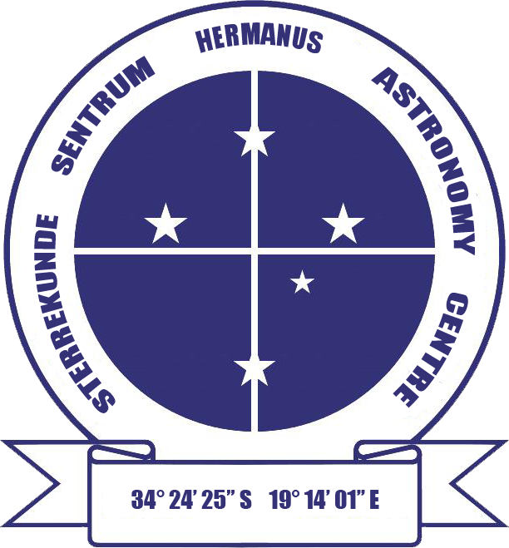

HERMANUS ASTRONOMY CENTRE NEWSLETTER

JUNE 2014

Welcome to this month’s issue of the newsletter which, we hope you find the content both interesting and enjoyable. We also welcome new member Karin de Bruin.

This issue includes a news item on important research undertaken at SALT (see ‘Astronomy news’) and the final part in the series on ‘Some unusual celestial objects (see ‘Did you know?’).

Sidewalk astronomy Note that the next events are scheduled, weather permitting, for this week on Friday 30 May and Saturday 31 May at Gearing Point from 6.30 pm. These include the second practical star-gazing session for the Hermanus Binocular Observation Programme group members.

WHAT’S UP?
Corvus and Crater Two small constellations whose brightest stars form distinctive keystone-like quadrilateral shapes can be seen towards the north this month. Corvus (the Crow), the brighter one, can be found to the left (north) of Spica (alpha Virginis) and Crater (the Cup), paler, but larger, lies to the left of Corvus, north of upside down Leo. Although neither of these constellations contains any remarkable stars or deep sky objects, they are linked in myth. The best known is from Greek mythology. A crow serving Apollo was sent to fetch water. Lazy, he was late returning with the cup which, in addition to water, also contained a water snake. The crow used the presence of the dangerous snake as an excuse for his late return, but Apollo did not believe him. Angry, he cast the crow, cup and snake (the nearby constellation Hydra) into the sky. As further punishment, Corvus is forever thirsty, Crater being nearby, but always out of reach.

LAST MONTH’S ACTIVITIES
Monthly centre meeting For logistical reasons, the presentation on Einstein, scheduled for 8 May, was postponed to June. Instead, the final part of the excellent BBC series ‘Orbit – Earth’s extraordinary journey’ was screened. Presenters Kate Humble and Helen Czerski completed the final months of their fascinating exploration of the effects, during a nominal year, of the tilt of Earth’s axis and its orbit round the Sun, on the planet’s climate and seasons.

Interest groups
Cosmology Sixteen people (13 members, 3 visitors) attended the meeting on 5 May. They watched the third pair of programmes in the DVD series ‘Black holes, tides and curved spacetime: understanding gravity’ presented by Dr Benjamin Schumacher from the University of Texas at Austin. The topics were: Part 7: ‘’Stars in their courses – orbital mechanics and Part 8: ‘What are tides? Earth and beyond’.

Astro-photography Three people attended the meeting held on 19 May. They worked on processing a Keyhole nebula image.

Hermanus Binocular Observation Programme (HBOP) Paper 8 of the series titled ‘What to look for’ was distributed to members towards the end of May. In his e-mail, Johan Retief continued: “This is essentially the last paper in this series. Hereafter, you are encouraged to do your own observing using the skills you have developed, the papers we have provided and the ‘Sky Map for the Month’ produced by the HAC. Paper 8 includes the last challenge for you and that is to observe the constellations Centaurus, Crux and Musca, finding all the double stars and deep sky objects within your binocular range. I have also attached Auke Slotegraaf's Deep Sky Challenge. This excellent document guides you in recording your observations and lists DSOs in the various constellations.”

The second practical star-gazing session will take place as part of the Sidewalk astronomy sessions scheduled for Friday 30 May and Saturday 31 May (see below).

If you are interested in obtaining the materials distributed to group members, please e-mail petermh@hermanus.co.za

Other activities
Educational outreach
Youth club The May meeting was organized and presented by SANSA staff.
Hermanus Youth Robotic Telescope Interest Group Unfortunately, the Las Cumbres telescopes are still not available for use until testing of updated software is complete.

Hopefully, the MONET telescope, which has been offline for several months, will become available for use towards the middle of the year.

For further information on both the MONET and Las Cumbres projects, please contact Deon Krige at deonk@telkomsa.net

THIS MONTH’S ACTIVITIES
Monthly centre meeting This month’s meeting will take place on 5 June. The presenter, Lia Labuschagne, Chair of the Cape Centre of ASSA, will be giving the presentation which was postponed from May. Her topic is ‘Einstein – the man (and a bit about his work)’.

An entrance fee of R20 will be charged per person for non-members and R10 for children, students and U3A members.

Interest group meetings
The Cosmology group meets meeting on the first Monday of the month at 7 pm at SANSA. This month’s meeting will take place on 2 June. The fifth pair of programmes in the 24 part DVD series ‘Black holes, tides and curved spacetime: understanding gravity’, presented by Dr Benjamin Schumacher from the University of Texas at Austin will be shown and discussed. The topics are: Part 9: ‘Nudge – perturbations of orbits’ and Part 10: ‘Resonance – surprises in the intricate dance’.

An entrance fee of R20 will be charged per person for non-members and R10 for children, students and U3A members. For further information on these meetings, or any of the group’s activities, please contact Pierre Hugo at pierre@hermanus.co.za

Astro-photography This group meets on the third Monday of each month. The next meeting will be on 16 June.

To find out more about the group’s activities and the venue for particular meetings, please contact Deon Krige at astronomy.hermanus@gmail.com

Sidewalk astronomy The next events are scheduled, weather permitting, for Friday 30 May and Saturday 31 May at Gearing Point from 6.30 pm. These will include practical star-gazing for members of HBOP.

FUTURE ACTIVITIES
Nothing is planned at present.
2014 MONTHLY MEETING DATES
Unless affected by public holidays, these meetings will take place on the first Thursday of each month at SANSA, beginning at 7 pm. Details are listed below.

5 June ‘Einstein – the man (and a bit about his work)’. Presenter: Lia
Labuschagne, ASSA, CT.
3 July ‘The astronomy of Stonehenge’. Presenter: Johan Retief, HAC
member.
7 August ‘The High Energy Stereoscopic System (HESS) in the Namibian
desert’. Presenter: Derek Duckitt, HAC committee member.
4 September ‘Astro-photography’. Presenter: Deon Krige, HAC committee
member.
2 October Topic: TBA Presenter: Pierre de Villiers, Chairperson, HAC
6 November ‘Milestones in radio astronomy: from the merry-go-round to the
SKA’. Presenter: Jenny Morris, Vice-chairperson, HAC committee.
5 December Xmas party.

OBSERVATORY PROJECT

Work continues to take place, both on completing the procedures required to obtain the lease for the site on Rotary Way from Overstrand Municipality and updating the architectural plans and related costings for submission to the National Lotteries Board.

Meanwhile, he ‘Friends of the Observatory’ campaign continues. We are very grateful to members who have already contributed to this, and hope that the generosity of the Centre’s membership continues. Both single donations and small, regular monthly donations, of any amount, are welcome.

Contributions can take the form of cash (paid at meetings), or online transfer, The Standard Bank details are as follows:
Account name – Hermanus Astronomy Centre
Account number – 185 562 531
Branch code – 051001
If you make an online donation, please include the word ‘pledge’, and your name, unless you wish to remain anonymous.

ASTRONOMY NEWS

SA, Japan scientists find stars on edge of Milky Way using Sutherland telescope 15 May: South African and Japanese astronomers have spotted the very first known stars in the outer edge of the Milky Way, a discovery they say will help test theories of how galaxies like ours were born and help unravel the mysteries of dark matter. The stars they have identified are called Cepheid variables, yellow stars with a pulsing brightness that scientists can use to very accurately calculate distances in space.
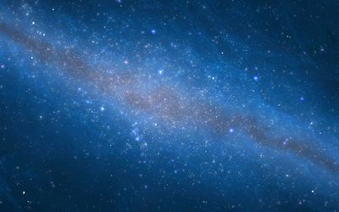
Picture: THINKSTOCK
The discovery is not only a coup for local scientists, who published their findings on 14 May in the prestigious international journal Nature, but it also validates the international community’s investment in telescopes at the South African Astronomical Observatory’s (SAAO) site at Sutherland.
The work was done using observations made at the Southern African Large Telescope (SALT) and the Japanese Infrared Survey Facility (IRSF). SALT is the biggest optical telescope in the southern hemisphere, and was funded by an international consortium. It got off to a slow start after its official launch in 2005, first struggling with technical issues and then battling with slow internet connectivity. It has been an important part of the government’s strategy to invest in science projects in which SA has a natural advantage: it capitalises on the fact that the dry, cold air of Sutherland minimises atmospheric distortions, and it is far from polluting light sources, making it an ideal place to observe stars.
Most of the stars in our galaxy are distributed in a flat disk, beyond which hydrogen gas flares out to great distances. Until now, scientists had no idea that this region of flaring hydrogen also contained stars, said study co-author professor Patricia Whitelock, an astronomer at the University of Cape Town (UCT) and the SAAO. The Cepheids that Prof Whitelock and her colleagues studied were first observed in a large survey done by a group of Polish scientists. "We set out to observe these stars because we thought they were something else," she said. "We thought they were from a galaxy merging with ours, the Sagittarius dwarf galaxy, but were amazed when we did the SALT observations to find they had to be part of our Milky Way," she said.
The scientists used the IRSF to measure the stars’ brightness, and used SALT to calculate their velocity, said the study’s lead author, Prof Michael Feast, also from UCT and the SAAO. The Cepheids’ velocity was just a few kilometres a second: if they had been part of the Sagittarius dwarf galaxy, they would have been moving at hundreds of kilometres a second, he said.

By: Tamar Kahn, www.bdlive.co.za

Globular clusters rotate at heart 12 May: Astronomers from the University of Texas at Austin and Germany’s Max Planck Institute for Extraterrestrial Physics (MPE) recently found a surprise when studying some of the oldest star clusters in our galaxy. The stars at the centres of these clusters are rotating around a common axis. It was previously thought any central rotation would have been long erased, leaving the central stars to random orbits.

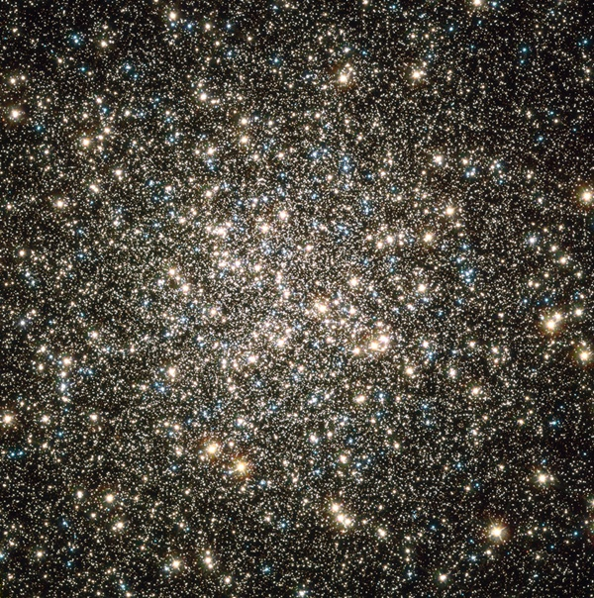
Central region of globular cluster M13 as seen by Hubble Space Telescope.
NASA/ESA/Hubble Heritage Team (STScI/AURA)

Globular clusters are ancient collections of up to a million old stars with simple chemical compositions, tightly bound together by gravity. They orbit most galaxies, including our Milky Way. Due to these clusters’ old age and fairly spherical shape with a strong concentration of stars toward the centre, they have historically been viewed as simple systems. However, new observations keep revealing surprising results.

The team, led by MPE’s Maximilian Fabricius and including Texas’ Eva Noyola, observed 11 globular clusters from the University of Texas at Austin’s McDonald Observatory with the Harlan J. Smith Telescope. They found that all of the clusters show this central rotation. This result is “astonishing,” Fabricius said. “We did not expect this. Originally, we observed these globular clusters to measure their central velocity dispersions” — that is, the random motions of stars within a cluster. “Theory and numerical simulations of globular clusters indicate that any central rotation should be erased on relatively short timescales,” said Noyola. “Because these globular clusters were formed billions of years ago, we would expect that any rotation signature would have been eradicated by now. Even though previous measurements showed some rotation in a handful of systems, they only probed the motion of stars in the outer regions.”

The astronomers are about halfway through their project of studying 27 of the Milky Way’s approximately 150 globular clusters. Their findings raise interesting questions about the formation history and evolution of globular clusters. None of the current theoretical models predicts such a ubiquitous and strong rotation. However, it is important to note that the 11 globular clusters studied so far do not include any so-called ‘core-collapsed’ globular clusters. Core collapse is a process that might eradicate rotation. Future observations of the remaining 16 clusters the team plans to study will shed light on this and other questions, such as a possible correlation between rotation and the position of a globular cluster inside our galaxy.
By: McDonald Observatory at University of Texas, Austin, Max Planck
Institute For Extraterrestrial Physics, Garching, Germany

Venus Express gets ready to take the plunge 19 May: After eight years in orbit, the European Space Agency’s (ESA) Venus Express has completed routine science observations and is preparing for a daring plunge into the planet’s hostile atmosphere. The spacecraft was launched on a Soyuz-Fregat from the Russian Baikonur Cosmodrome in Kazakhstan on 9 November 2005, and arrived at Venus on 1 April 2006. It has been orbiting Venus in an elliptical 24-hour loop that takes it from a distant 66,000 km over the south pole, affording incredible global views, to an altitude of around 250km above the surface at the north pole, close to the top of the planet’s atmosphere.

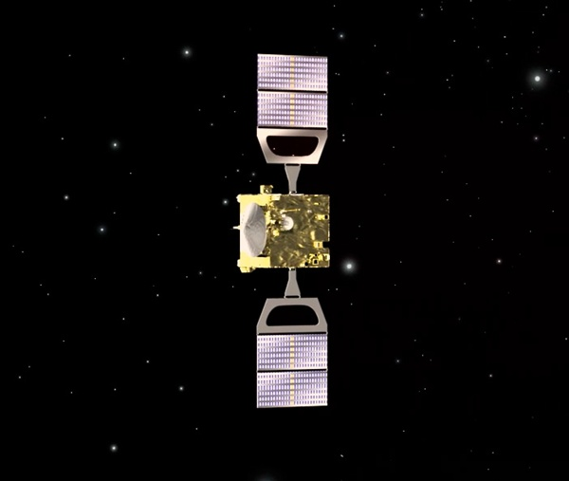

With a suite of seven instruments, the spacecraft has provided a comprehensive study of the ionosphere, atmosphere, and surface of Venus. “Venus Express has taught us just how variable the planet is on all timescales and, furthermore, has given us clues as to how it might have changed since its formation 4.6 billion years ago,” said Håkan Svedhem from ESA. “This information is helping us decipher how Earth and Venus came to lead such dramatically different lives, but we’ve also noticed that there are some fundamental similarities.”

Separated at birth? Venus has a surface temperature of over 450°Celsius, far hotter than a normal kitchen oven, and an extremely dense choking mixture of noxious gases for an atmosphere. However, from the mission’s infrared survey of the chemical composition of the rocky surface, scientists have learned that Venus might have once had a plate tectonics system like Earth and even an ocean of water.

Just like Earth, Venus is losing parts of its upper atmosphere to space, and Venus Express measured twice as many hydrogen atoms escaping out of the atmosphere than oxygen. Because water is made of two hydrogen atoms and one oxygen atom, the observed escape indicates that water is being broken up in the atmosphere. Today, the total amount of water on Earth is 100,000x that on Venus, but, because the two planets are about the same size and formed at the same time, both may have had similar amounts of the precious liquid in their early years.

Meanwhile, the spacecraft’s cameras have tracked thousands of features in the cloud tops some 70 km above the planet’s surface, including an enormous swirling vortex at the planet’s south pole that shares similarities with hurricanes on Earth. The spacecraft also recorded bursts of lightning (identified by their electromagnetic signature) generated in clouds of sulphuric acid.

Studies of the planet’s ‘super-rotating’ atmosphere (it whips around the planet in just 4 Earth days, much faster than the 243 days the planet takes to complete one rotation about its axis) also turned up some intriguing surprises. In one study, average wind speeds were found to have increased from roughly 300 km/h to 400 km/h over a period of six Earth years. Conversely, a separate study found that the rotation of the planet had slowed by 6.5 minutes since NASA’s Magellan measured it, which completed its five-year mission at Venus 20 years ago. It remains unknown if there is a relationship between the increasing wind speeds and the slowing rotation.

Magellan’s radar survey of the planet revealed that its surface was heavily altered in the past by a large number of volcanoes. However, Venus Express has provided tantalising hints that the planet may well be still geologically active today. One study found numerous lava flows that must have been created no more than 2.5 million years ago, just yesterday on geological timescales, and perhaps much more recently.

Indeed, measurements of sulphur dioxide in the upper atmosphere have shown large variations over the course of the mission. Although peculiarities in the atmospheric circulation may produce a similar result, it is the most convincing argument to date of present-day active volcanism.

Final swansong Now, after eight years in orbit, the fuel supplies necessary to maintain the elliptical orbit are running low and will soon be exhausted. Thus, routine science operations concluded this week, and the spacecraft is being prepared for one final mission: to make a controlled plunge deeper into the atmosphere than ever before attempted. “We have performed previous short ‘aerodrag’ campaigns where we’ve skimmed the thin upper layers of the atmosphere at about 165km, but we want to go deeper, perhaps as deep as 130km, maybe even lower,” said Patrick Martin of the Venus Express mission. “It is only by carrying out daring operations like these that we can gain new insights, not only about usually inaccessible regions of the planet’s atmosphere, but also how the spacecraft and its components respond to such a hostile environment.”

This ‘experimental ‘aerobraking’ phase is planned for 8 June to 11 July, during which time some limited science measurements with the spacecraft’s magnetic field, solar wind, and atom analyzing instruments will be possible. Also, temperature and pressure sensors will record the conditions that the spacecraft is experiencing. “The campaign also provides the opportunity to develop and practice the critical operations techniques required for aerobraking, an experience that will be precious for the preparation of future planetary missions that may require it operationally,” said Paolo Ferri, head of mission operations. Aerobraking can be used as a way of getting into orbit around planets without having to carry quite so much fuel, thus reducing the launch mass.

It is possible that the remaining fuel in Venus Express will be exhausted during this phase or that the spacecraft does not survive these risky operations. However, if the spacecraft is still healthy afterwards, its orbit will be raised again and limited operations will continue for several more months, fuel permitting Yet, by the end of the year, it is likely that Venus Express will have made its final descent into the atmosphere of the planet, bringing a fantastic scientific endeavour to an end. “Venus Express has penetrated deeper into the mysteries of this veiled planet than anyone ever dreamed and will no doubt continue to surprise us down to the last minute,” said Håkan.

By: ESA, Noordwijk, Netherlands

Hubble shows Jupiter’s Great Red Spot is smaller than ever measured 16 May: Jupiter’s trademark Great Red Spot, a swirling anti-cyclonic storm larger than Earth, has shrunk to its smallest size ever measured. According to Amy Simon of NASA’s Goddard Space Flight Centre in Greenbelt, Maryland, recent NASA Hubble Space Telescope observations confirm that the Great Red Spot now is approximately 16,500 km across. Astronomers have followed this downsizing since the 1930s.
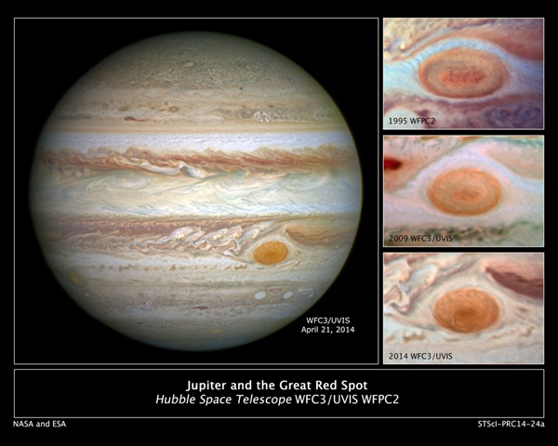
Historic observations as far back as the late 1800s gauged the storm to be as large as 41,000 km on its long axis. NASA Voyager 1 and Voyager 2 flybys of Jupiter in 1979 measured it to be 23,300 km across. In 1995, a Hubble photo showed the long axis of the spot at an estimated 21,000 km across. And in a 2009 photo, it was measured at 17,900 km across.

Beginning in 2012, amateur observations revealed a noticeable increase in the rate at which the spot is shrinking - by 930 km per year - changing the shape of the Great Red Spot from an oval to a circle. “In our new observations, it is apparent very small eddies are feeding into the storm,” said Simon. “We hypothesized these may be responsible for the accelerated change by altering the internal dynamics and energy of the Great Red Spot.” Simon’s team plans to study the motions of the small eddies and the internal dynamics of the storm to determine whether these eddies can feed or sap momentum entering the upwelling vortex, resulting in this yet unexplained shrinkage.

By: NASA Headquarters, Washington, D.C.

NASA's WISE findings poke hole in black hole ‘Doughnut’ theory 23 May: A survey of more than 170,000 supermassive black holes, using NASA’s Wide-field Infrared Survey Explorer (WISE), has astronomers re-examining a decades-old theory about the varying appearances of these interstellar objects. The unified theory of active supermassive black holes, first developed in the late 1970s, was created to explain why black holes, though similar in nature, can look completely different. Some appear to be shrouded in dust, while others are exposed and easy to see.
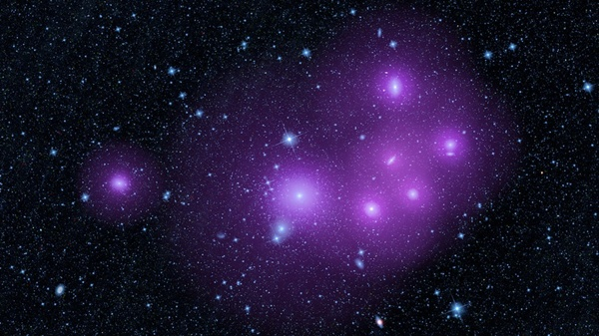
This enhanced image shows galaxies clumped together in the Fornax cluster, located 60 million light-years from Earth. The picture was taken by WISE, but has been artistically enhanced to illustrate the idea that clumped galaxies will, on average, be surrounded by larger halos of dark matter (represented in purple).
NASA/JPL-Caltech
The unified model answers this question by proposing that every black hole is surrounded by a dusty, doughnut-shaped structure called a torus. Depending on how these “doughnuts” are oriented in space, the black holes will take on various appearances. For example, if the doughnut is positioned so that we see it edge-on, the black hole is hidden from view. If the doughnut is observed from above or below, face-on, the black hole is clearly visible.
However, the new WISE results do not corroborate this theory. The researchers found evidence that something other than a doughnut structure may, in some circumstances, determine whether a black hole is visible or hidden. The team has not yet determined what this may be, but the results suggest the unified, or doughnut, model does not have all the answers. “Our finding revealed a new feature about active black holes we never knew before, yet the details remain a mystery,” said Lin Yan of NASA’s Infrared Processing and Analysis Centre (IPAC), based at the California Institute of Technology in Pasadena. “We hope our work will inspire future studies to better understand these fascinating objects.”
Every galaxy has a massive black hole at its heart. The new study focuses on the ‘feeding’ ones, called active supermassive black holes, or active galactic nuclei. These black holes gorge on surrounding gas material that fuels their growth. With the aid of computers, scientists were able to pick out more than 170,000 active supermassive black holes from the WISE data. They then measured the clustering of the galaxies containing both hidden and exposed black holes - the degree to which the objects clump together across the sky.
If the unified model was true, and the hidden black holes are simply blocked from view by doughnuts in the edge-on configuration, then researchers would expect them to cluster in the same way as the exposed ones. According to theory, since the doughnut structures would take on random orientations, the black holes should also be distributed randomly. It is like tossing a bunch of glazed doughnuts in the air - roughly the same percentage of doughnuts always will be positioned in the edge-on and face-on positions, regardless of whether they are tightly clumped or spread far apart.
However, WISE found something totally unexpected. The results showed the galaxies with hidden black holes are more clumped together than those of the exposed black holes. If these findings are confirmed, scientists will have to adjust the unified model and come up with new ways to explain why some black holes appear hidden. “The main purpose of unification was to put a zoo of different kinds of active nuclei under a single umbrella,” said Donoso. Now, that has become increasingly complex to do as we dig deeper into the WISE data.”
Another way to understand the WISE results involves dark matter. Dark matter is an invisible substance that dominates matter in the universe, outweighing the regular matter that makes up people, planets, and stars. Every galaxy sits in the centre of a dark matter halo. Bigger halos have more gravity and, therefore, pull other galaxies toward them.
Because WISE found that the obscured black holes are more clustered than the others, the researchers know those hidden black holes reside in galaxies with larger dark matter halos. Though the halos themselves would not be responsible for hiding the black holes, they could be a clue about what is occurring. “The unified theory was proposed to explain the complexity of what astronomers were seeing,” said Stern. “It seems that simple model might have been too simple. As Einstein said, models should be made ‘as simple as possible, but not simpler.’”
By: Jet Propulsion Laboratory, Pasadena, California

Source of these and further astronomy news items: www.astronomy.com/news

DID YOU KNOW?
Some unusual celestial objects Part 9: Planetary nebulae

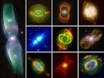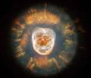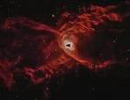
Montage of planetary Eskimo nebula Red spider nebula
nebula

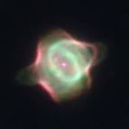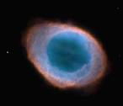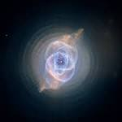
Stingray nebula- youngest Ring nebula – example Cat’s eye nebula
known planetary nebula of an elliptical planetary
nebula

The term planetary nebula is an inaccurate one, as it refers not to planets, but to the bright, expanding cloud of glowing gas and dust surrounding a medium sized star of around one solar mass, ie like that of the Sun, as it passes through its death throes. When such a star, now a swollen red giant, runs out of helium to burn, having already used up its hydrogen stores, it starts dying. During this process, the lack of an active central nuclear core results in the outer areas of the star becoming increasingly disorganised and unstable. The gases and dust are easily blown away by stellar winds and expulsion resulting from pulsations within the gaseous matter itself. The material ejected from the star typically occurs at speeds of around 10 km/sec. The ejected gas is then ionised by ultraviolet radiation from the hot core of the star, forming glowing shells with surround the dying core. As mass is lost and the matter in the outer layers forming the nebula is lost to interstellar space, the core is progressively exposed, eventually becoming a white dwarf.

These emission nebulae are typically 0.5–1 light year across, and the amount of ejected material 01.0 solar masses or more. Densities within the gaseous shells are highest when nebulae are young and material have yet to be lost to expansion and physical loss to the surrounding interstellar medium. Radiation from the centre heats the gases to an average of about 10,000K, although, close to the core, temperatures can reach from 16,000-26,000K. The nebular stage can last from tens of thousands to up to 100,000 years, a relatively short episode in the typical stellar lifetime of several billion years. They are generally faint objects, most not visible to the naked eye.

The first planetary nebula was discovered in 1764 by Charles Messier. The Dumbbell Nebula in the constellation Vulpecula (the Fox) is listed as M27 in his catalogue of nebulous objects. The misnaming of these objects dates back to the 1780s. Amongst his other observational achievements, William Herschel observed over 2,000 nebulae. To him, with the telescope quality of the time, they looked similar in appearance to the planet Uranus, and he was the one who named them planetary nebulae. Even after their stellar origin had been realised, the name, which had been widely adopted by astronomers, stuck. They would be more accurately known as stellar-remnant nebulae, but, so far, this has not happened.

The true nature and source of planetary nebulae was not known until the first spectroscopic observations were made in the mid-19th century when, in 1864, the English amateur astronomer William Huggins, the pioneer of spectroscopy, started using a prism to disperse the light from celestial objects.

About 3,000 planetary nebulae are known to exist in the Milky Way, a very small number out of around 200 billions stars. This rarity is explained by their short lifetimes. They are found mostly near the plane of the galaxy, the greatest concentration being near the galactic centre. Planetary nebulae vary widely in shape and appearance, about a fifth being roughly spherical. Many have very complex forms. The three main types are spherical, elliptical and bipolar, but a large number of shapes have been identified. These include rings, dumbbells, disks, helical, and a variety of irregular forms. Those with bipolar shapes tend to be younger, this form reflecting the fact that the mechanism by which the ejecta is produced is via paired lobes or cylinders. In contrast, spherical shapes are more common in older nebulae whose material has been more evenly distributed over time. Apart from such structural differences in form, the various shapes are also believed to reflect the differing angles at which the nebulae are viewed from Earth. In addition to their bipolar sources, nebular matter is also distorted by remaining magnetic fields and/or the gravitational effect of nearby stars. The end result of these effects is a visual feast of differing shapes and colours, images of which have been enriched by the added access to the infra-red and ultra-violet spectra provided by space telescopes, particularly Hubble.

Like the nebulae of supernovas, planetary nebulae play a very important role galactic evolution, as they return material to the interstellar medium, matter which forms the basis for new stars within a galaxy. They also liberate the chemical products of neucleosynthesis eg carbon, nitrogen.

Sources: Ridpath, I (Ed) 2007 Oxford dictionary of astronomy 2nd ed, Astronomy (Dorling Kindersley – Eyewitness companions,www.en.wikipedia.org

For more information on the Hermanus Astronomy Centre and its activities, visit our website at www.hermanusastronomy.co.za

COMMITTEE MEMBERS
Pierre de Villiers (Chairperson, AECO & HBOP joint co-ordinator) 028 313 0109
Laura Norris (Treasurer) 028 316 4453
Peter Harvey (Secretary, including membership) 028 316 3486
Jenny Morris (Vice-chairperson & newsletter editor) 071 350 5560
Derek Duckitt (Website editor & monthly sky maps) 082 414 4024
Lynette Geldenhuys (Education co-ordinator) 028 316 2428
Deon Krige (Youth robotics project and astro-photography) 028 314 1045
Fanie Lombard (Events co-ordinator) 028 316 4091
Non-committee members with roles:
Pierre Hugo (Cosmology interest group co-ordinator) 028 312 1639
Johan Retief (HBOP joint co-ordinator) 028 315 1132
John Saunders (Youth club co-ordinator) 028 314 0543

