Asteroid 260824 Hermanus = 2005 PC24
Discovered 2005 Aug. 9 by D.E. Trilling at Cerro Tololo, Chile.
The village Hermanuspietersfontein, later shortened to Hermanus, was founded in honour of a man who taught Dutch to farmers’ children. This minor planet is named in recognition of the Hermanus Astronomy Centre’s enthusiasm for astronomy and their dedication to educational outreach in South Africa.
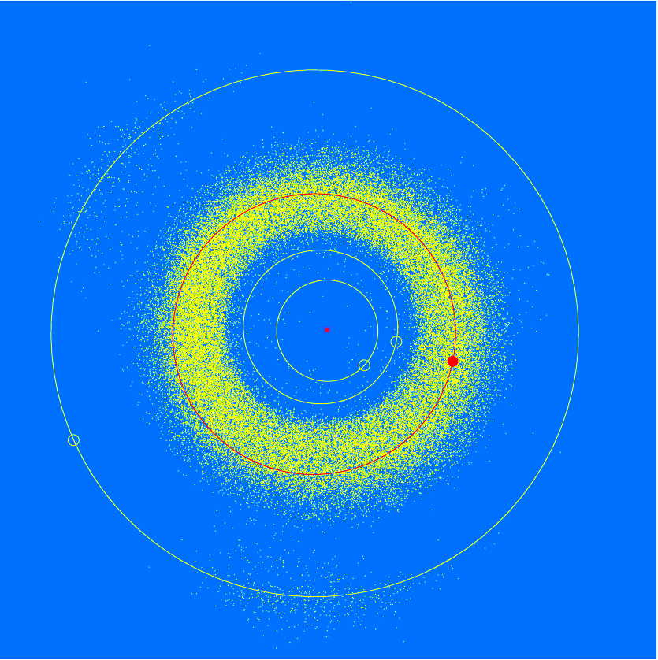
Semi-major axis 2.79 AU Eccentricity 0.095 Inclination 5.13 deg Diameter 1–2 km
